MULTIPLYING METHODS: DISTRIBUTIVE PROPERTY

Recognizing Patterns
Below are 4 different expanded expressions. What do they have in common?

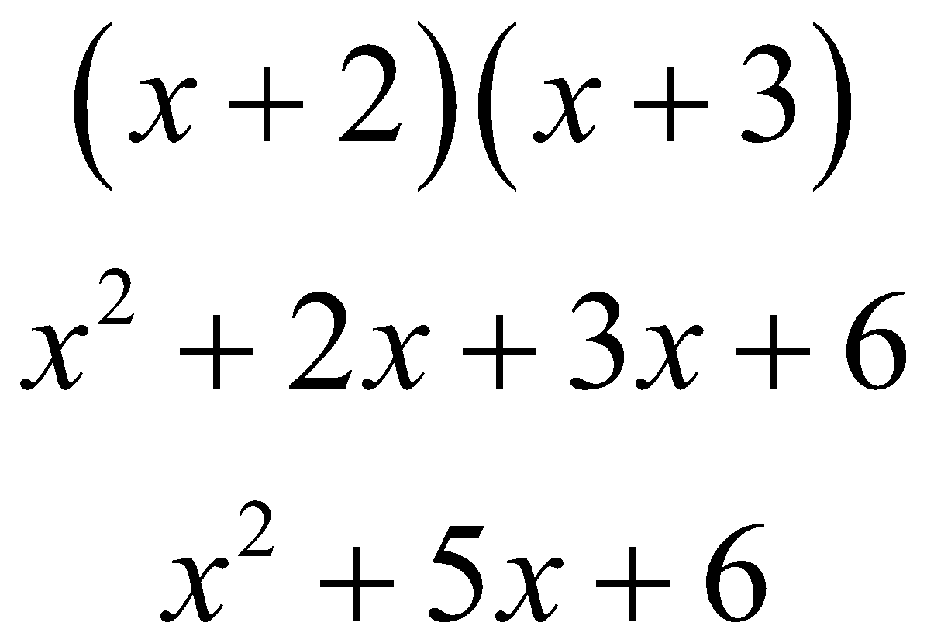 | 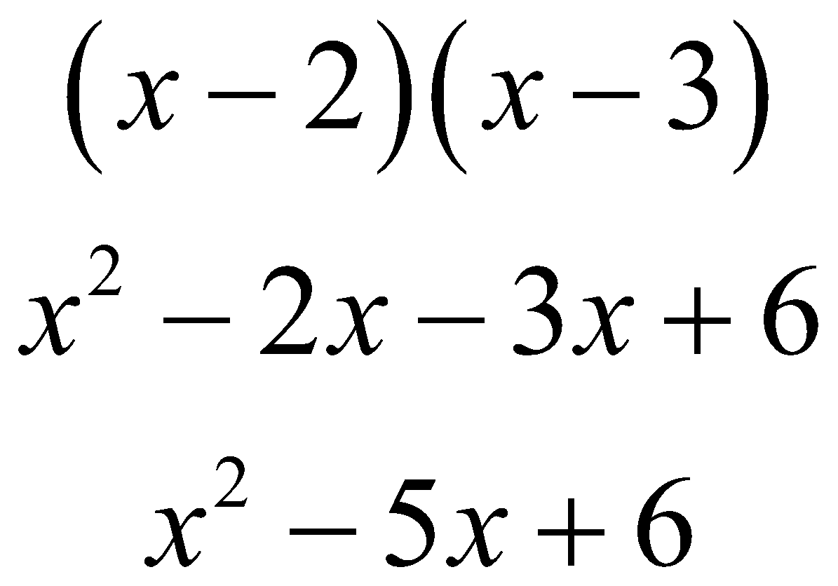
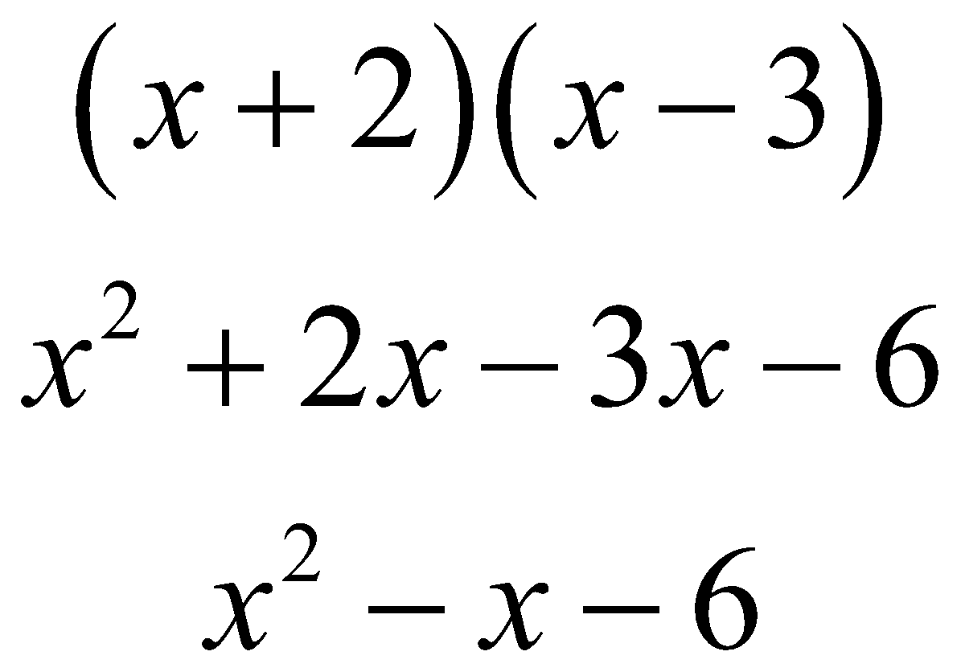 | 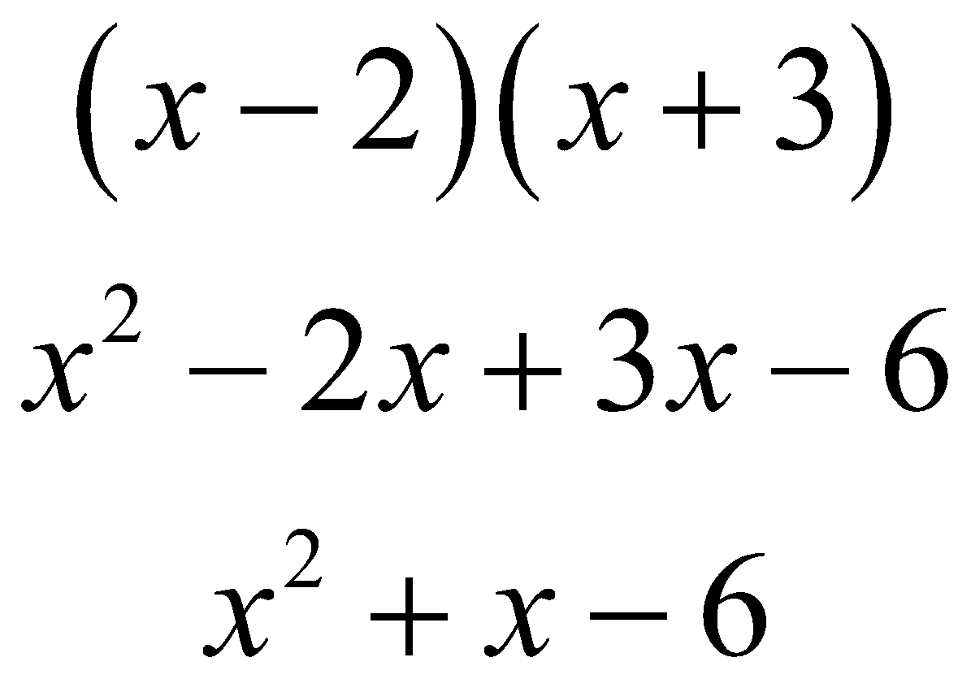

Verbalizing
Generalize what you observed above. Explain what is happening in the pattern you see.

Applying
Use your generalization to multiply: (x – 2) (x² + 5x – 3).

MULTIPLYING METHODS: BOX METHOD

Recognizing Patterns
Below are 4 different expanded expressions. What do they have in common?

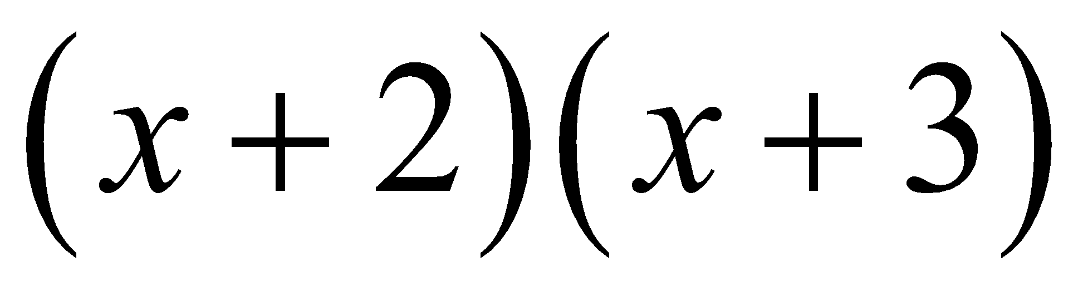  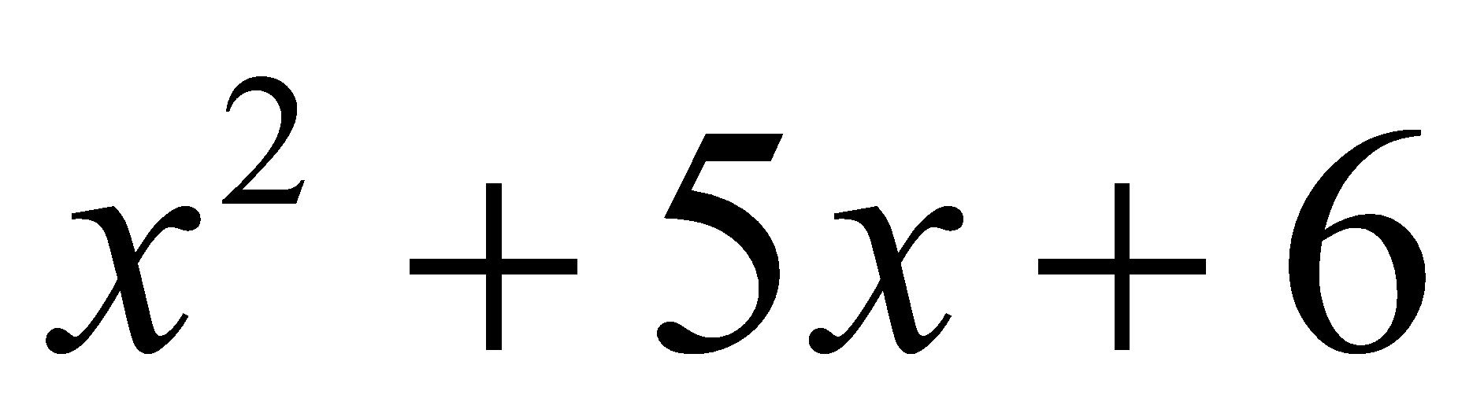 | 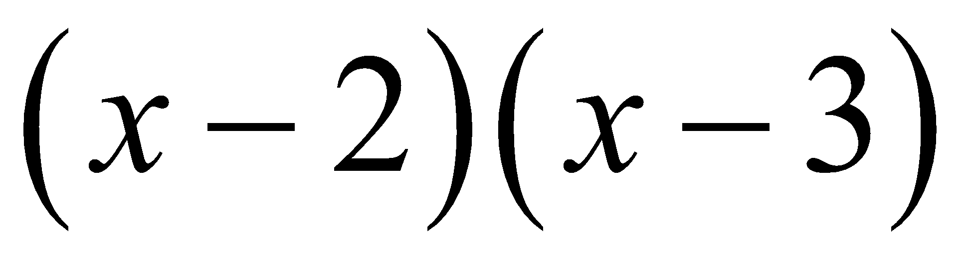  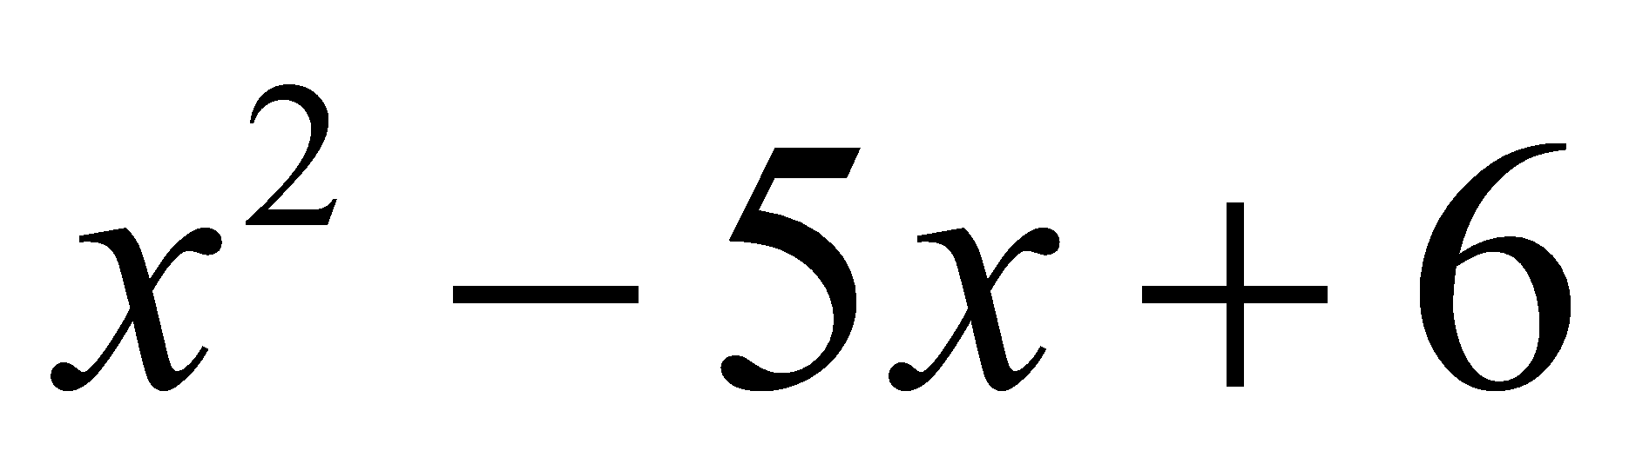
   | x | + 2
  x | x² | + 2x
  + 3 | + 3x | + 6
   | x | – 2
  x | x² | – 2x
  – 3 | – 3x | + 6
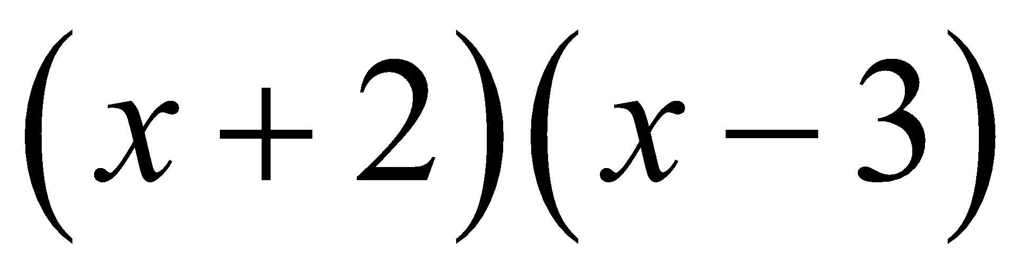  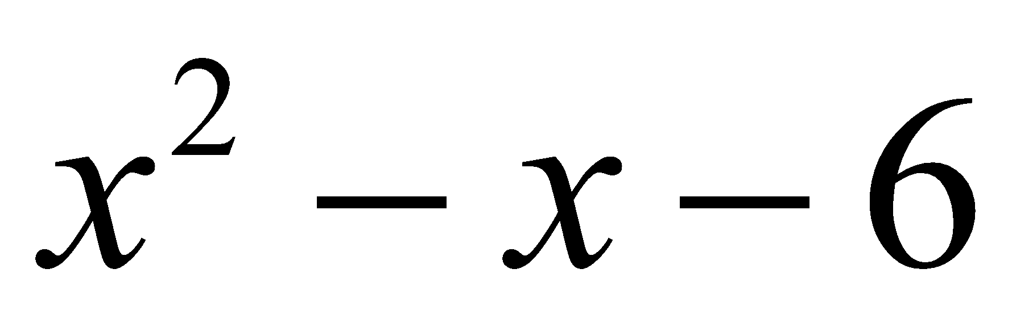 | 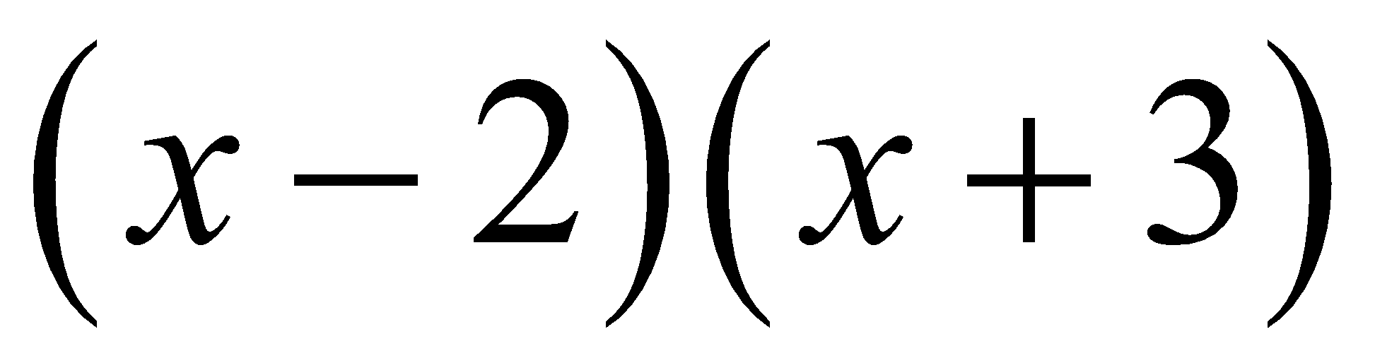  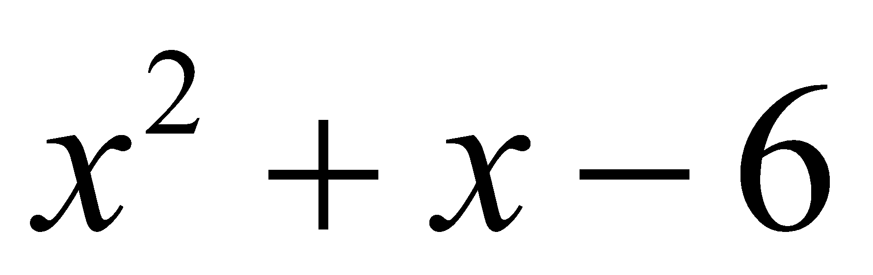
   | x | + 2
  x | x² | + 2x
  – 3 | – 3x | – 6
   | x | – 2
  x | x² | – 2x
  + 3 | + 3x | – 6

Verbalizing
Generalize what you observed above. Explain what is happening in the pattern you see.

Applying
Use your generalization to multiply: (x – 2) (x² + 5x – 3).

MULTIPLYING METHODS: VERTICAL (STANDARD) MULTIPLICATION

Recognizing Patterns
Below are 4 different expanded expressions. What do they have in common?

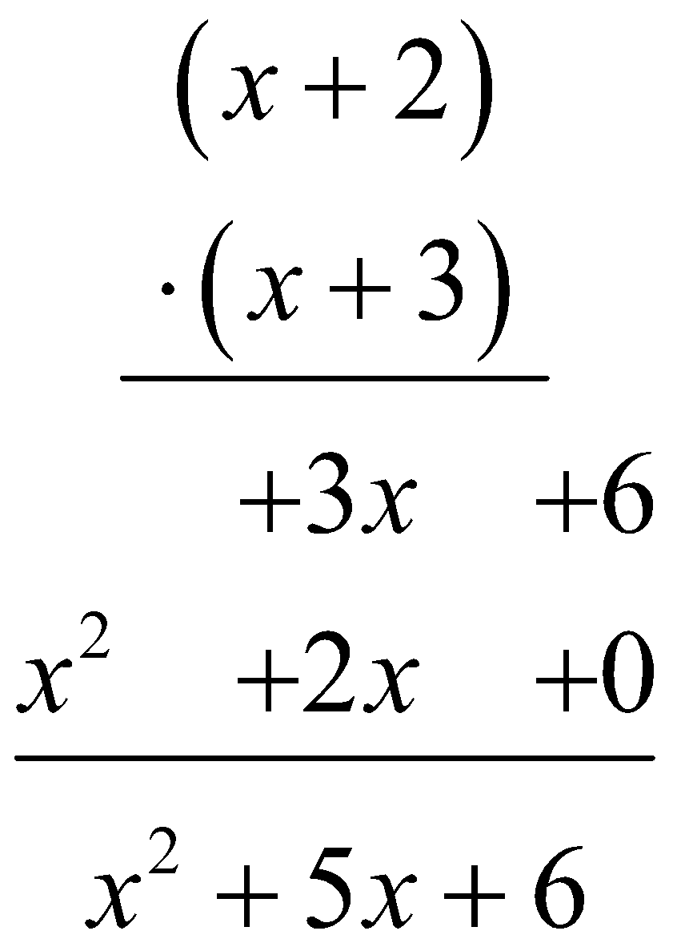 | 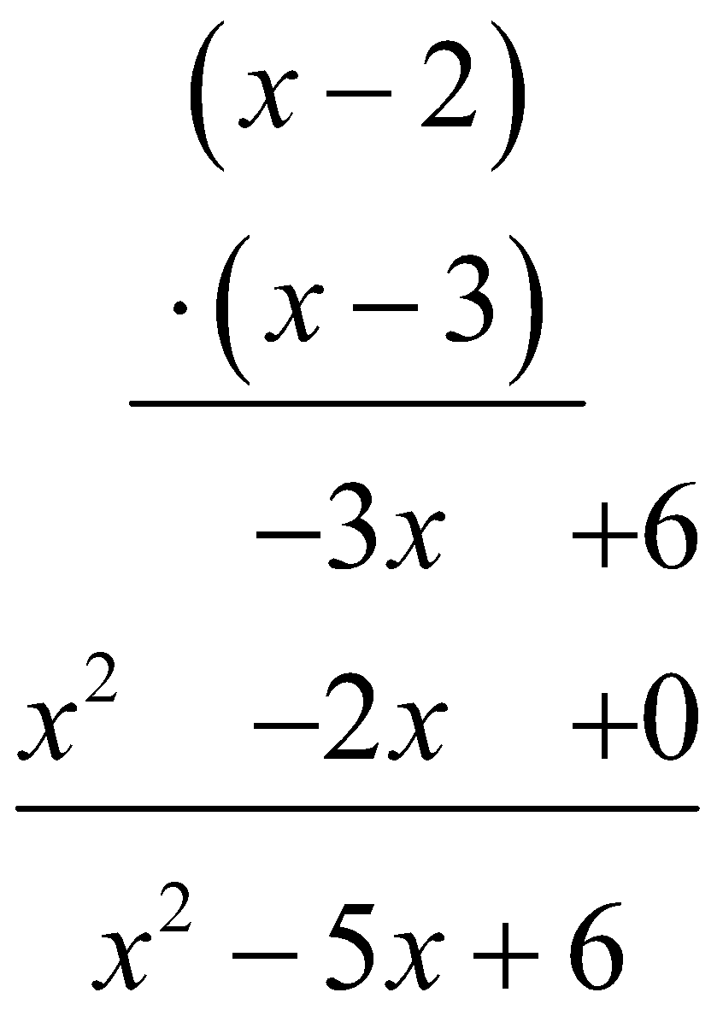
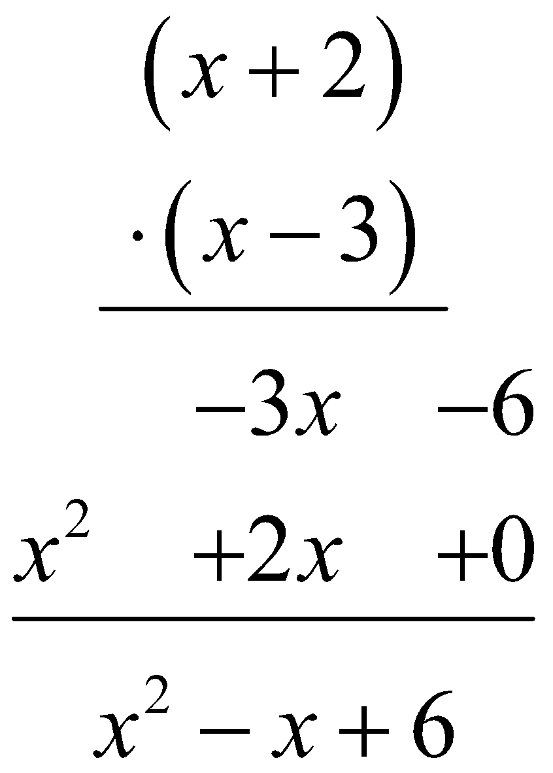 | 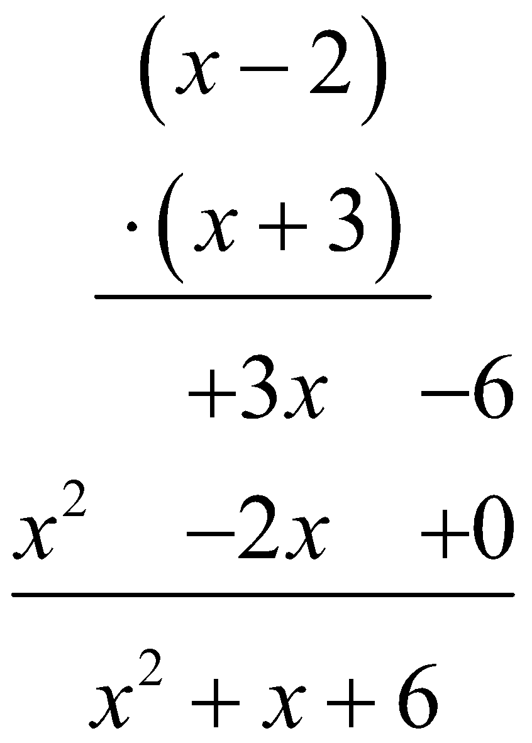

Verbalizing
Generalize what you observed above. Explain what is happening in the pattern you see.

Applying
Use your generalization to multiply: (x – 2) (x² + 5x – 3).

MULTIPLYING METHODS: GEOMETRIC AREA (ALGEBRA TILES)

Recognizing Patterns
Below are 4 different expanded expressions. What do they have in common?
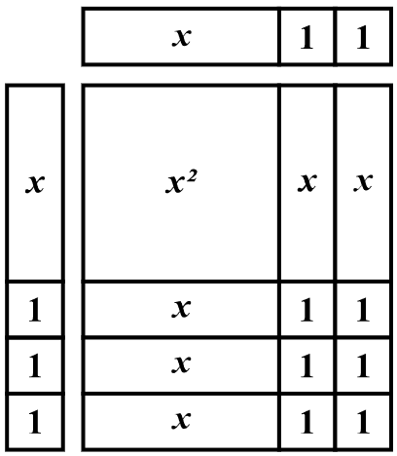 | 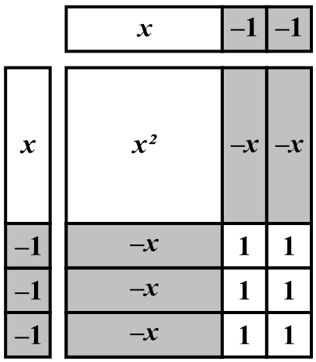
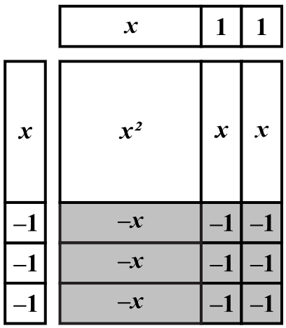 | 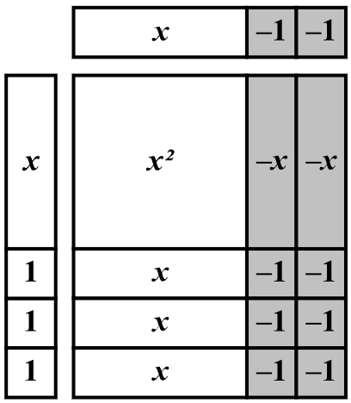

Verbalizing
Generalize what you observed above. Explain what is happening in the pattern you see.

Applying
Use your generalization to multiply: (x – 2) (x² + 5x – 3).

