MULTIPLYING METHODS: DISTRIBUTIVE PROPERTY

Recognizing Patterns
Below are 4 different expanded expressions. What do they have in common?

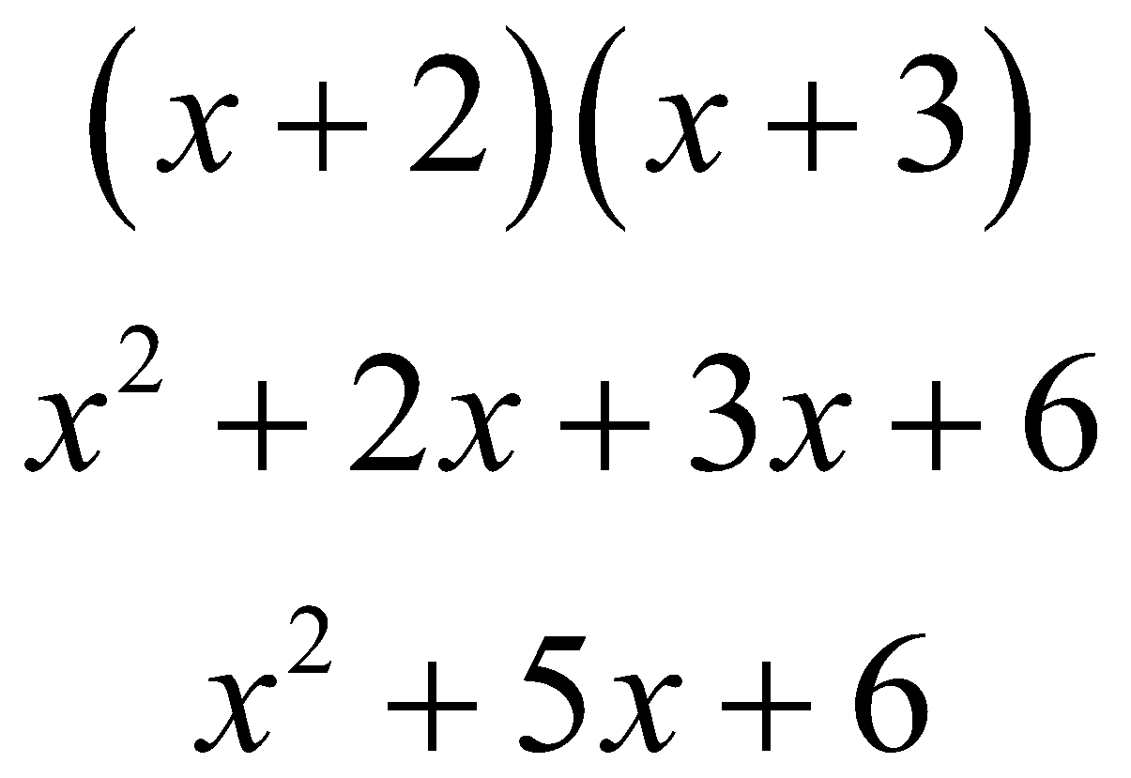 | 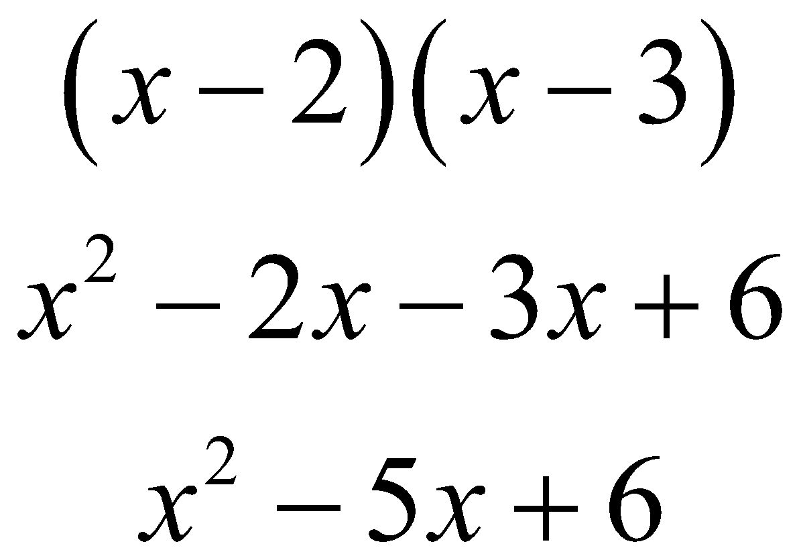
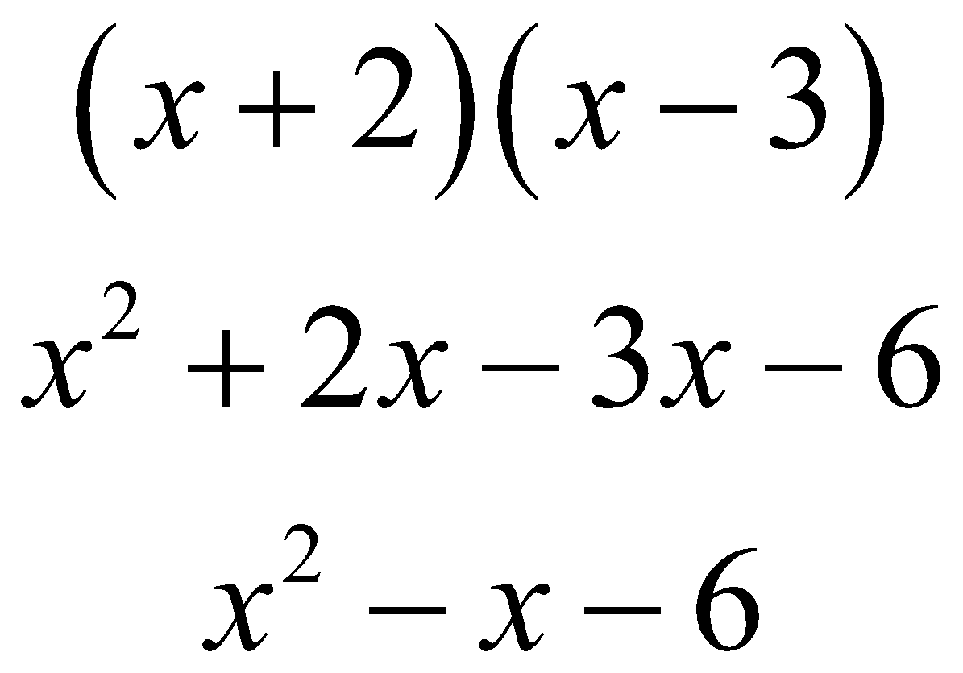 | 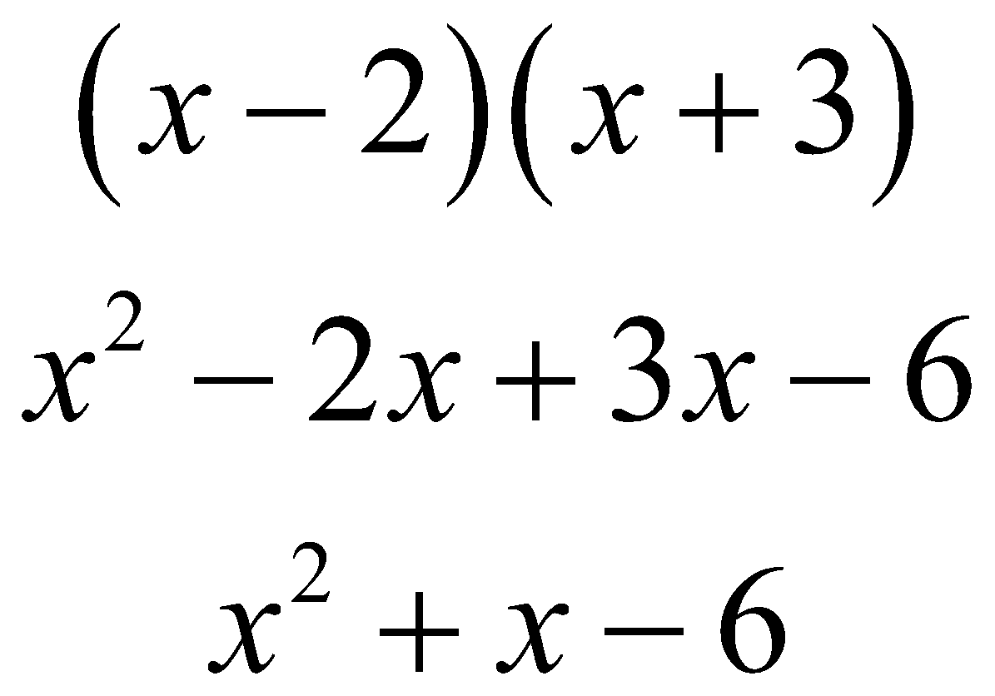

Verbalizing
Generalize what you observed above. Explain what is happening in the pattern you see.

Applying
Use your generalization to multiply: (x – 2) (x² + 5x – 3).

MULTIPLYING METHODS: BOX METHOD

Recognizing Patterns
Below are 4 different expanded expressions. What do they have in common?

x + 2  x x² + 2x  + 3 + 3x + 6 | x – 2  x x² – 2x  – 3 – 3x + 6
x + 2  x x² + 2x  – 3 – 3x – 6 | x – 2  x x² – 2x  + 3 + 3x – 6

Verbalizing
Generalize what you observed above. Explain what is happening in the pattern you see.

Applying
Use your generalization to multiply: (x – 2) (x² + 5x – 3).

MULTIPLYING METHODS: VERTICAL (STANDARD) MULTIPLICATION

Recognizing Patterns
Below are 4 different expanded expressions. What do they have in common?

Verbalizing
Generalize what you observed above. Explain what is happening in the pattern you see.

Applying
Use your generalization to multiply: (x – 2) (x² + 5x – 3).

MULTIPLYING METHODS: GEOMETRIC AREA (ALGEBRA TILES)

Recognizing Patterns
Below are 4 different expanded expressions. What do they have in common?

Verbalizing
Generalize what you observed above. Explain what is happening in the pattern you see.

Applying
Use your generalization to multiply: (x – 2) (x² + 5x – 3).

