Death is in the Air
http://spartacus-educational.com/EXnormans10.htm
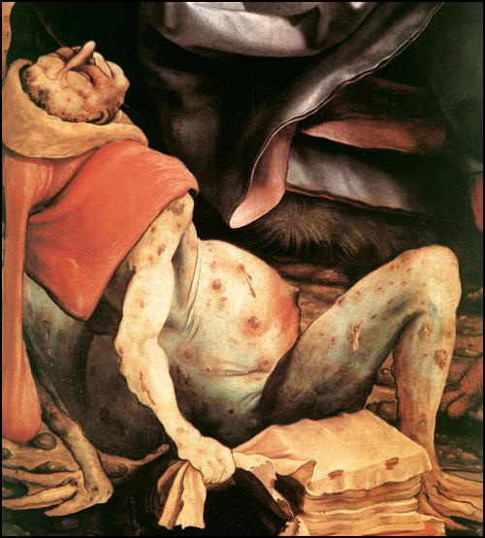
(Source 1) Matthias Grünewald, detail from The Temptation of St Anthony (c. 1512)

(Source 2) Michele di Piazze, letter (October, 1347)

The sailors brought in their bones a disease so violent that whoever spoke a word to them was infected and could in no way save himself from death... Those to whom the disease was transmitted by infection of the breath were stricken with pains all over the body and felt a terrible lassitude. There then appeared, on a thigh or an arm, a pustule like a lentil. From this the infection penentrated the body and violent bloody vomiting began. It lasted for a period of three days and there was no way of preventing its ending in death.

(Source 3) Letter sent by a group of doctors from Oxford to the Lord Mayor of London (c. 1350)

If an ulcer appears... near the ear or the throat, take blood from the arm on that side, that is, from the vein between the thumb and the first finger... But if you have an ulcer in the groin, then open a vein in the foot between the big toe and its neighbour... At all events, bloodletting should be carried out when the plague first strikes.

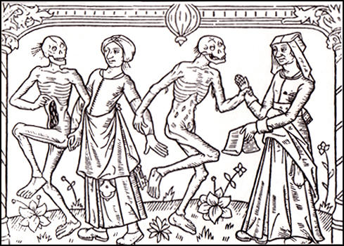
(Source 4) Dance of Death (1492)

(Source 5) Henry Knighton, Chronicle (c. 1398)

The King of Tharsis, seeing so sudden and unheard of death among his subjects, set out with a large number of nobles towards the Pope... He proposed to be baptised a Christian, believing that God's vengeance had fallen upon his people by reason of their evil lack of faith. But, after twenty days' journey, hearing that the plague had created a great havoc among Christians... turned and went no farther on that way, but hastened home unto his own country.

(Source 6) Giovanni Boccaccio, Decameron (c. 1360)

It first betrayed itself by the emergence of certain tumours in the groin or the armpits, some of which grew as large as a common apple, others as an egg... merely by speech or association with the sick was the disease communicated to the healthy... any that touched the clothes of the sick... seemed to catch the disease... Many died daily or nightly in the public streets. Of many others, who died at home, the departure was hardly observed by their neighbours, until the stench of the bodies carried the news.

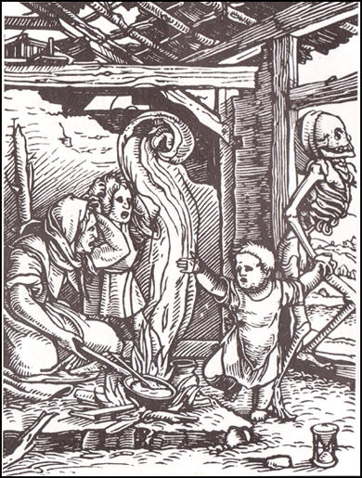
(Source 7) Woodcut, The Child (c.1524)

(Source 8) John Fordun, Chronicle of the Scottish Nation (c. 1380)
In the year 1350, there was, in the kingdom of Scotland, a great plague... nearly a third of mankind died... By God's will, this evil led to a strange kind of death, insomuch that the flesh of the sick was somehow puffed out and swollen... Now this attacked everywhere, especially the common people - seldom the magnates.

(Source 9) Edward IV's Plague Medicines (c. 1480)
A medicine for the plague... Take an egg that is newly laid, and make a hole in either end, and blow out all that is within. And lay it to the fire and let it roast till it may be ground to powder, but do not burn it. Then take a quantity of good treacle, and mix it with chives and good ale. And then make the sick drink it for three evenings and three mornings.

(Source 10) Robert of Avesbury, Chronicle (c. 1360)

In 1349 over six hundred men came to London from Flanders... Each wore a cap marked with a red cross in front and behind. Each had in his right hand a scourge with three nails. Each tail had a knot and through the middle of it there were sometimes sharp nails fixed. They marched naked in a file one behind the other and whipped themselves with these scourges on their naked bleeding bodies.

(Source 11) Giovanni Boccaccio, Decameron (c. 1360)

Some did not shut themselves in, but went about, some carrying flowers in their hands, some fragrant herbs... which they frequently smelled, thinking it good to comfort the brain with such odours.

(Source 12) Ralph of Shrewsbury, the Bishop of Bath, wrote a letter about the Black Death to all the priests in his diocese in January 1349.

The plague... has left many parish churches... without parson or priest to care for their parishioners... Therefore, to provide for the salvation of souls... you should at once publicly command and persuade all men that, if they are on the point of death and cannot secure the services of a priest, then they should make confession to each other... if no man is present, then even to a woman.

