BELL RINGER

Image 1
March on Washington
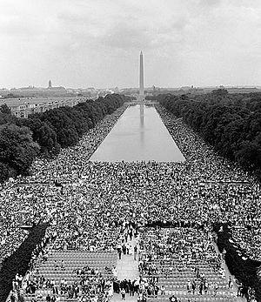
Source: United States Marine Corps. (1963). View from Lincoln Memorial, August 28, 1963 [Photograph]. Wikimedia Commons. https://commons.wikimedia.org/wiki/File:IhaveadreamMarines.jpg

Image 2
Standing Rock Dakota Access Pipeline Protest in San Francisco
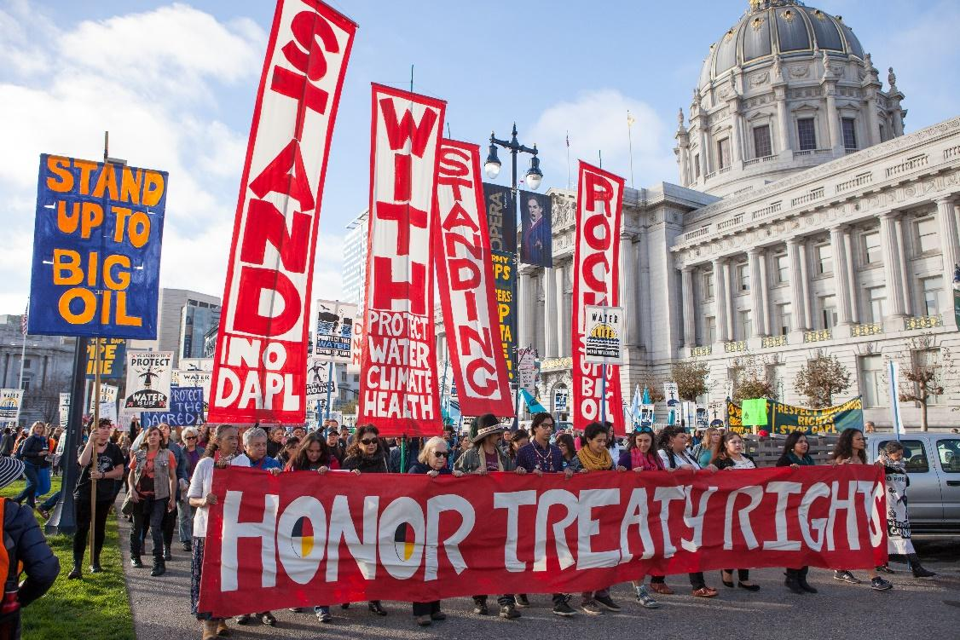
Source: Pax Ahimsa Gethen. (2016). Stand with Standing Rock SF Nov 2016 [Image]. Wikimedia Commons. https://commons.wikimedia.org/wiki/File:Stand_with_Standing_Rock_SF_Nov_2016_11.jpg

Image 3
Women’s Suffrage Picket Line
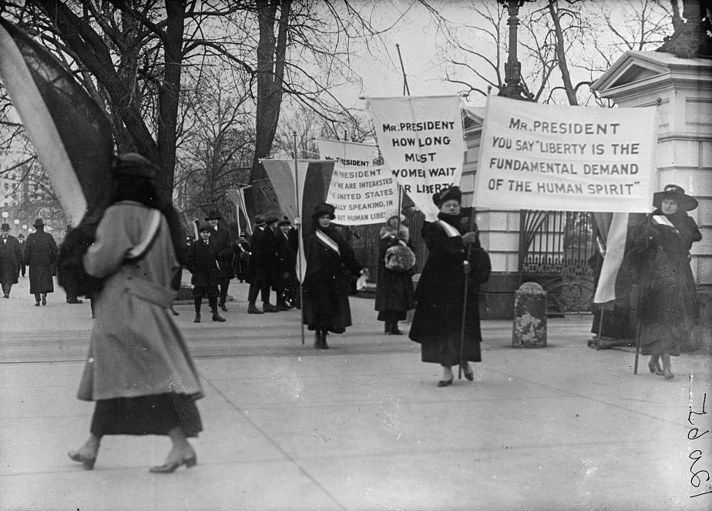

Harris & Ewing. (1917). Woman suffrage picket parade [Image]. Wikimedia Commons. https://commons.wikimedia.org/wiki/File:WOMAN_SUFFRAGE_PICKET_PARADE10337v.jpg

Image 4
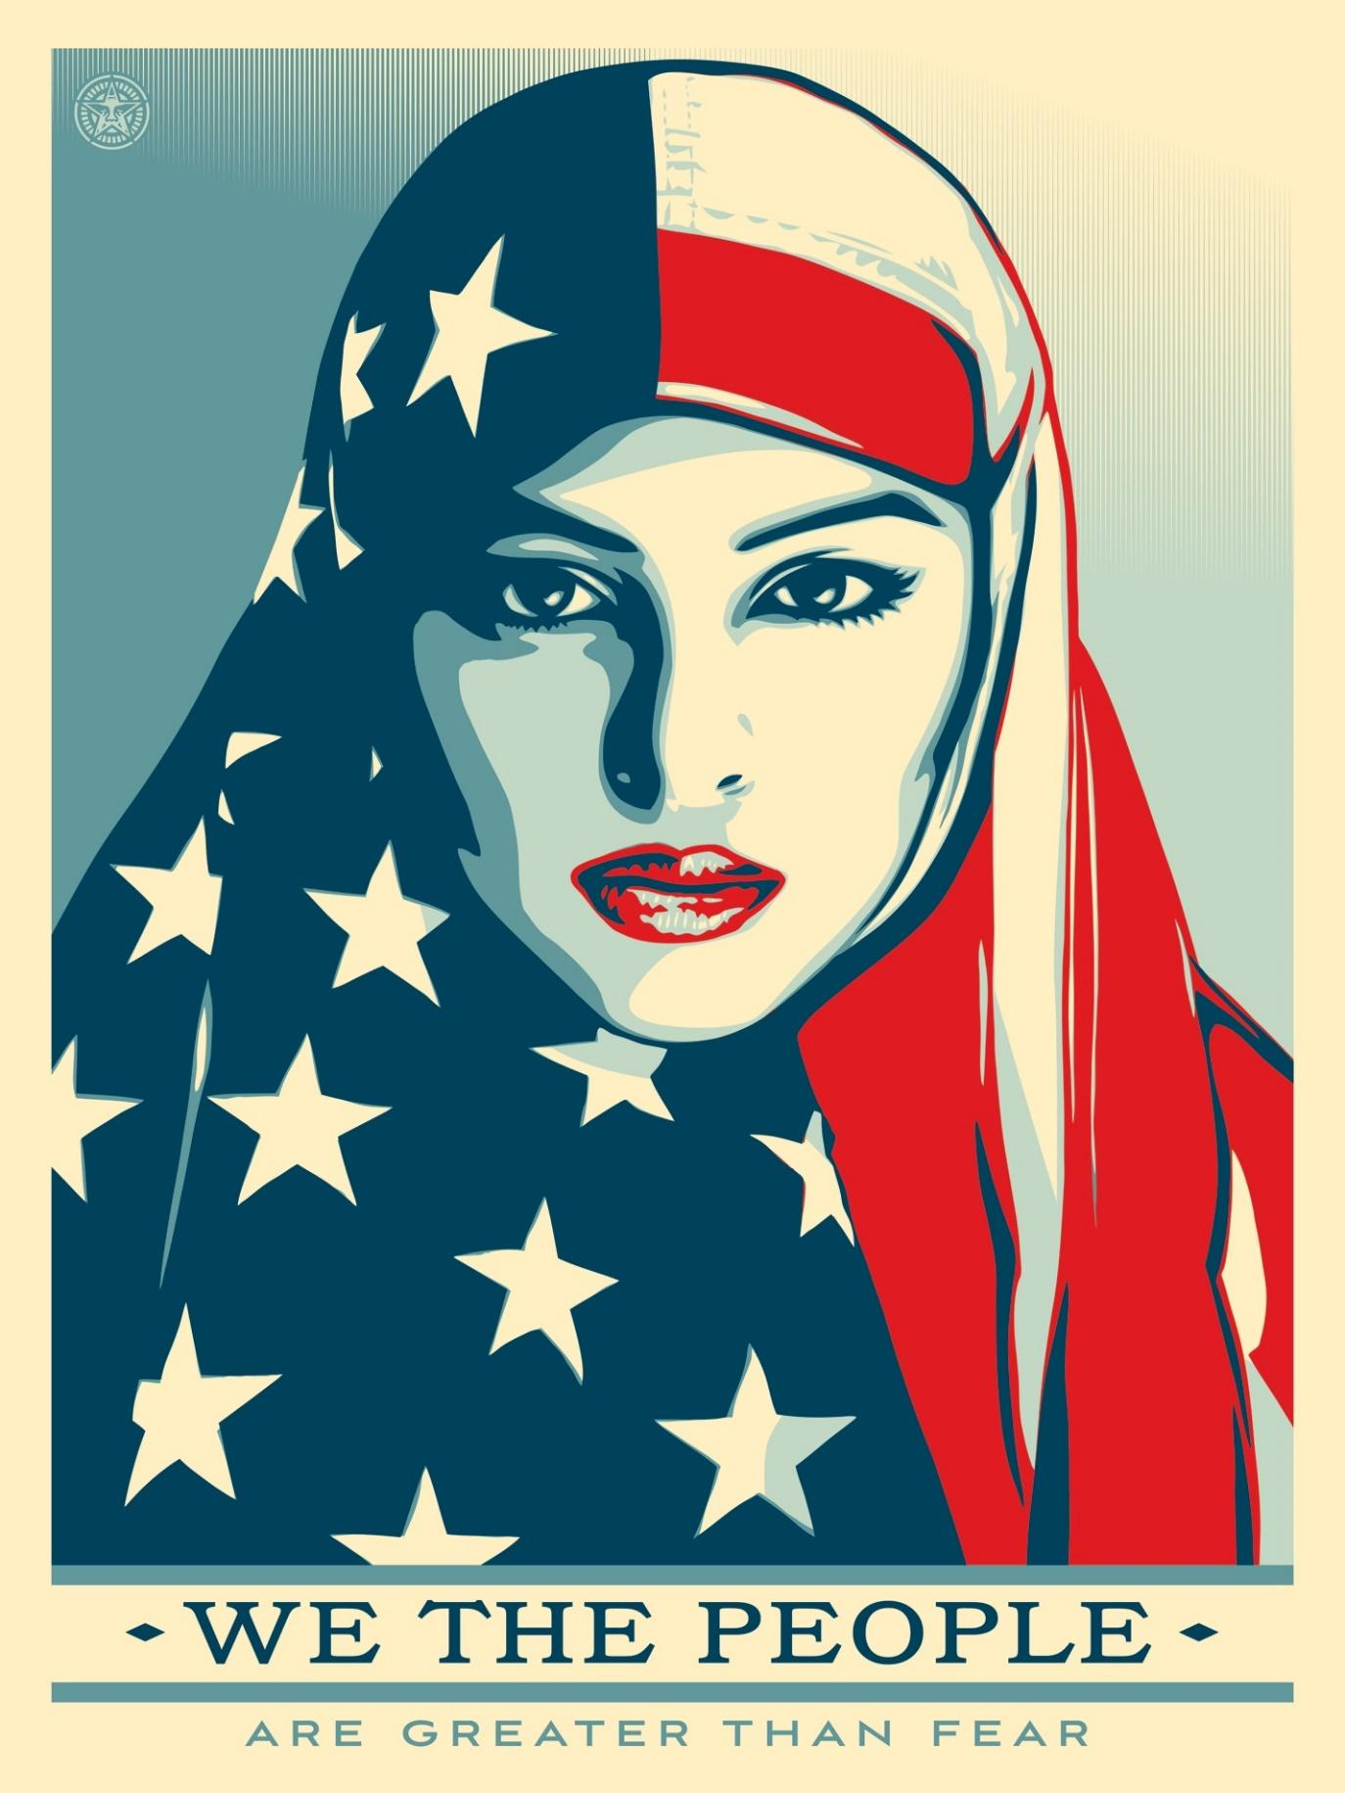
We the People are Greater than Fear Campaign

Source: Fairey, S. (2017). We the people – “Greater than fear” [Image]. Amplifier. https://amplifier.org/free-downloads/

Directions
Respond to the following questions.
- What are some common examples of resistance or rebellion?

- Why would the colonists want to resist British rule?

