BELL RINGER

# Image 1

March on Washington

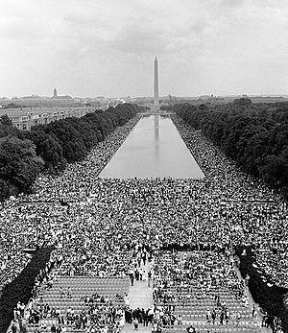

Source: United States Marine Corps. (1963). View from Lincoln Memorial, August 28, 1963 [Photograph]. Wikimedia Commons. https://commons.wikimedia.org/wiki/File:IhaveadreamMarines.jpg

# Image 2

Standing Rock Dakota Access Pipeline Protest in San Francisco

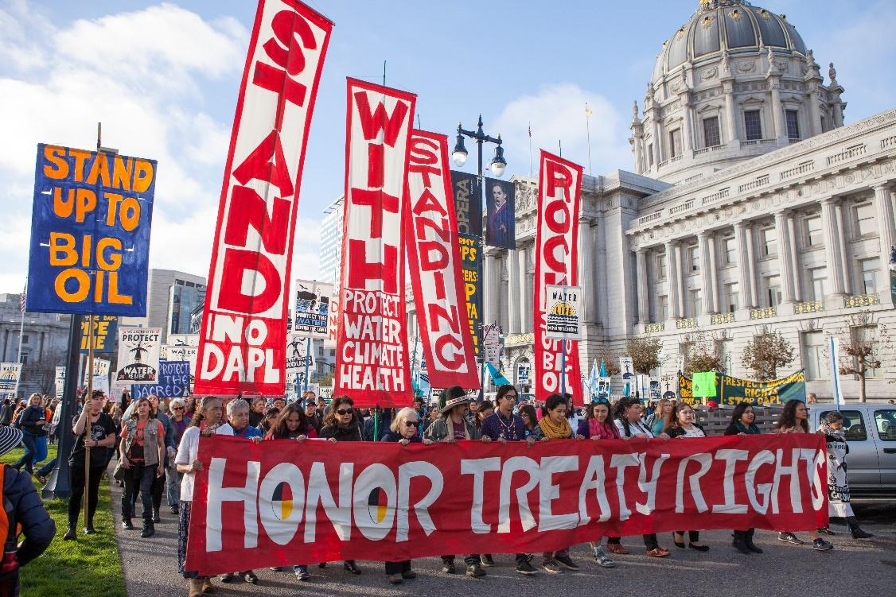

Source: Pax Ahimsa Gethen. (2016). Stand with Standing Rock SF Nov 2016 [Image]. Wikimedia Commons. https://commons.wikimedia.org/wiki/File:Stand_with_Standing_Rock_SF_Nov_2016_11.jpg

# Image 3

Women’s Suffrage Picket Line

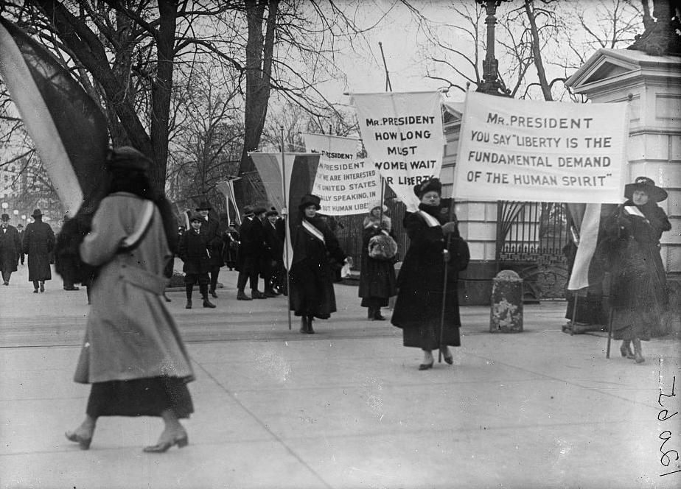

### Harris & Ewing. (1917). Woman suffrage picket parade [Image]. Wikimedia Commons. <https://commons.wikimedia.org/wiki/File:WOMAN_SUFFRAGE_PICKET_PARADE10337v.jpg>

# Image 4

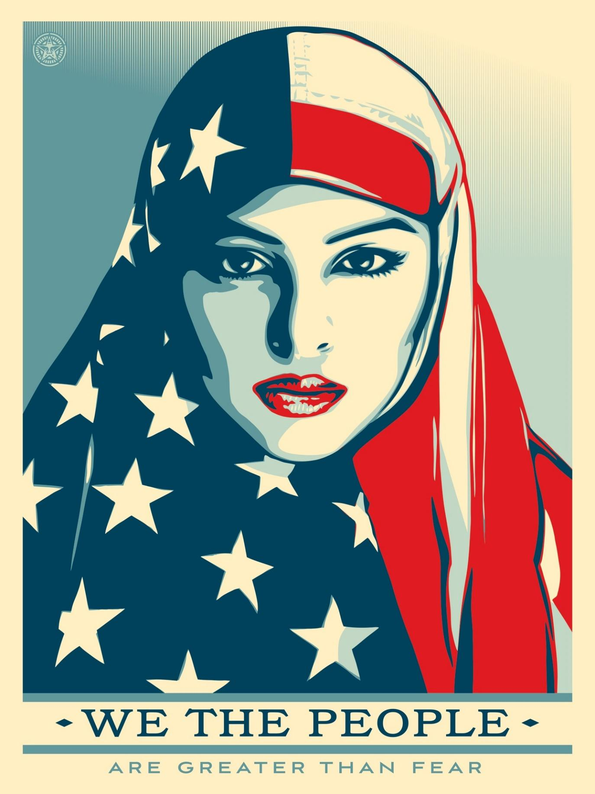We the People are Greater than Fear Campaign

### Source: Fairey, S. (2017). We the people – “Greater than fear” [Image]. Amplifier. https://amplifier.org/free-downloads/

# Directions

Respond to the following questions.

1. What are some common examples of resistance or rebellion?
2. Why would the colonists want to resist British rule?