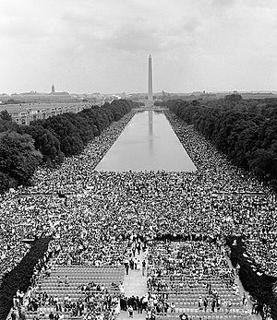
March on Washington
United States Marine Corps. (1963). I have a dream marines [Image]. In Wikimedia Commons. Retrieved from https://commons.wikimedia.org/wiki/File:IhaveadreamMarines.jpg

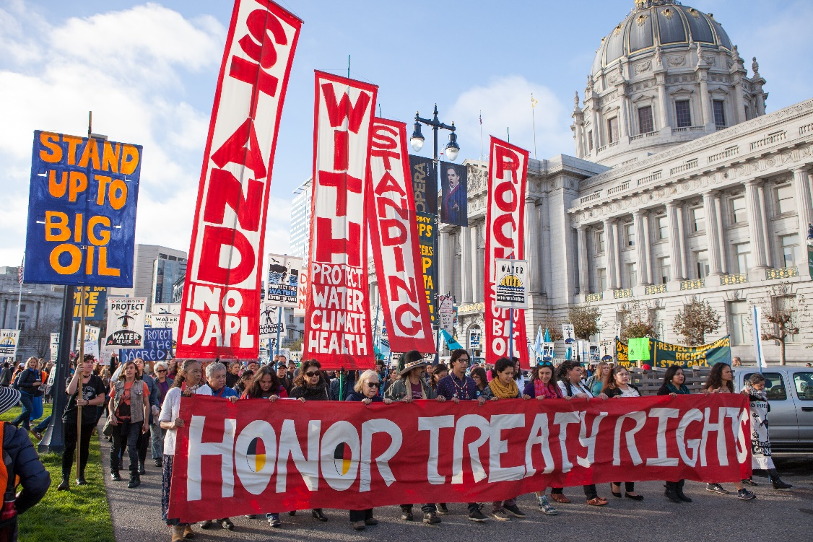
Standing Rock Dakota Access Pipeline Protest in San Francisco
Pax Ahimsa Gethen. (2016). Stand with Standing Rock SF Nov 2016. In Wikimedia Commons. Retrieved from https://commons.wikimedia.org/wiki/File:Stand_with_Standing_Rock_SF_Nov_2016_11.jpg

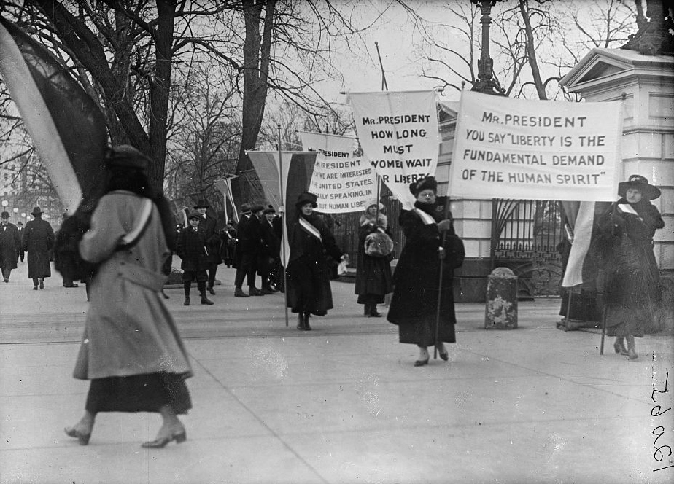
Women’s Suffrage Picket Line
Harris & Ewing. (1917). Woman suffrage picket parade10337v [Image]. In Wikimedia Commons. Retrieved from https://commons.wikimedia.org/wiki/File:WOMAN_SUFFRAGE_PICKET_PARADE10337v.jpg

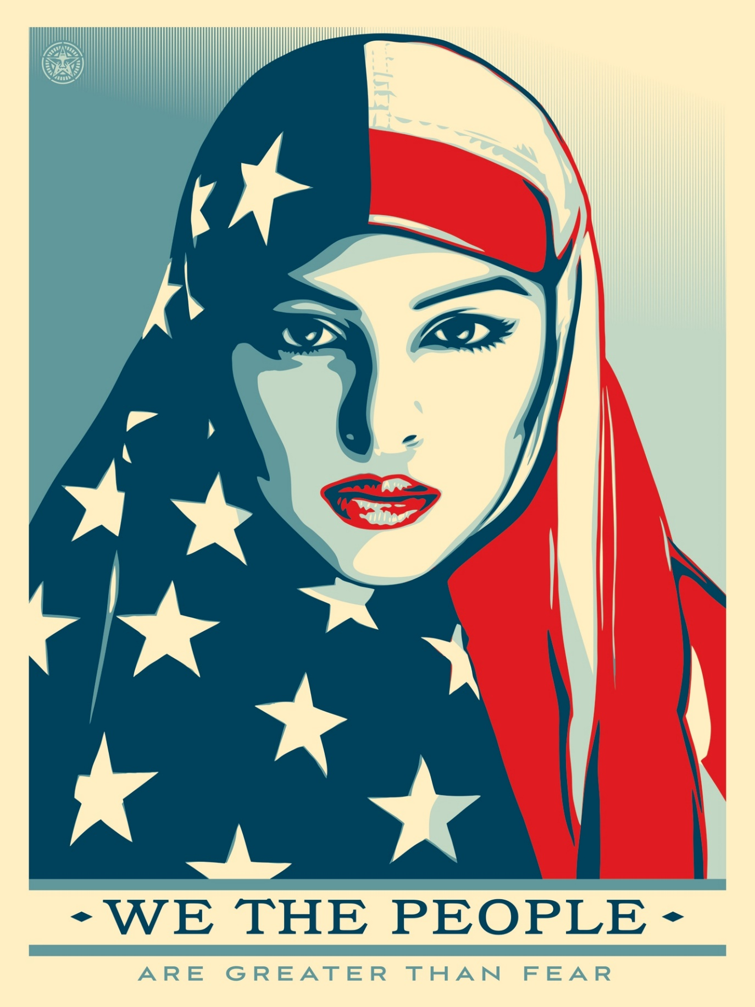
We the People Campaign – Greater than Fear
Fairey, S. (2017). Greater than fear. In Amplifier We the People Campaign. Retrieved from https://amplifier.org/downloads/people-shepard-fairey/

