PRIMARY SOURCES AND H.I.P.P. ANALYSIS

Bloody Massacre Perpetrated in Kings Street in Boston, engraving print by Paul Revere, Jr.
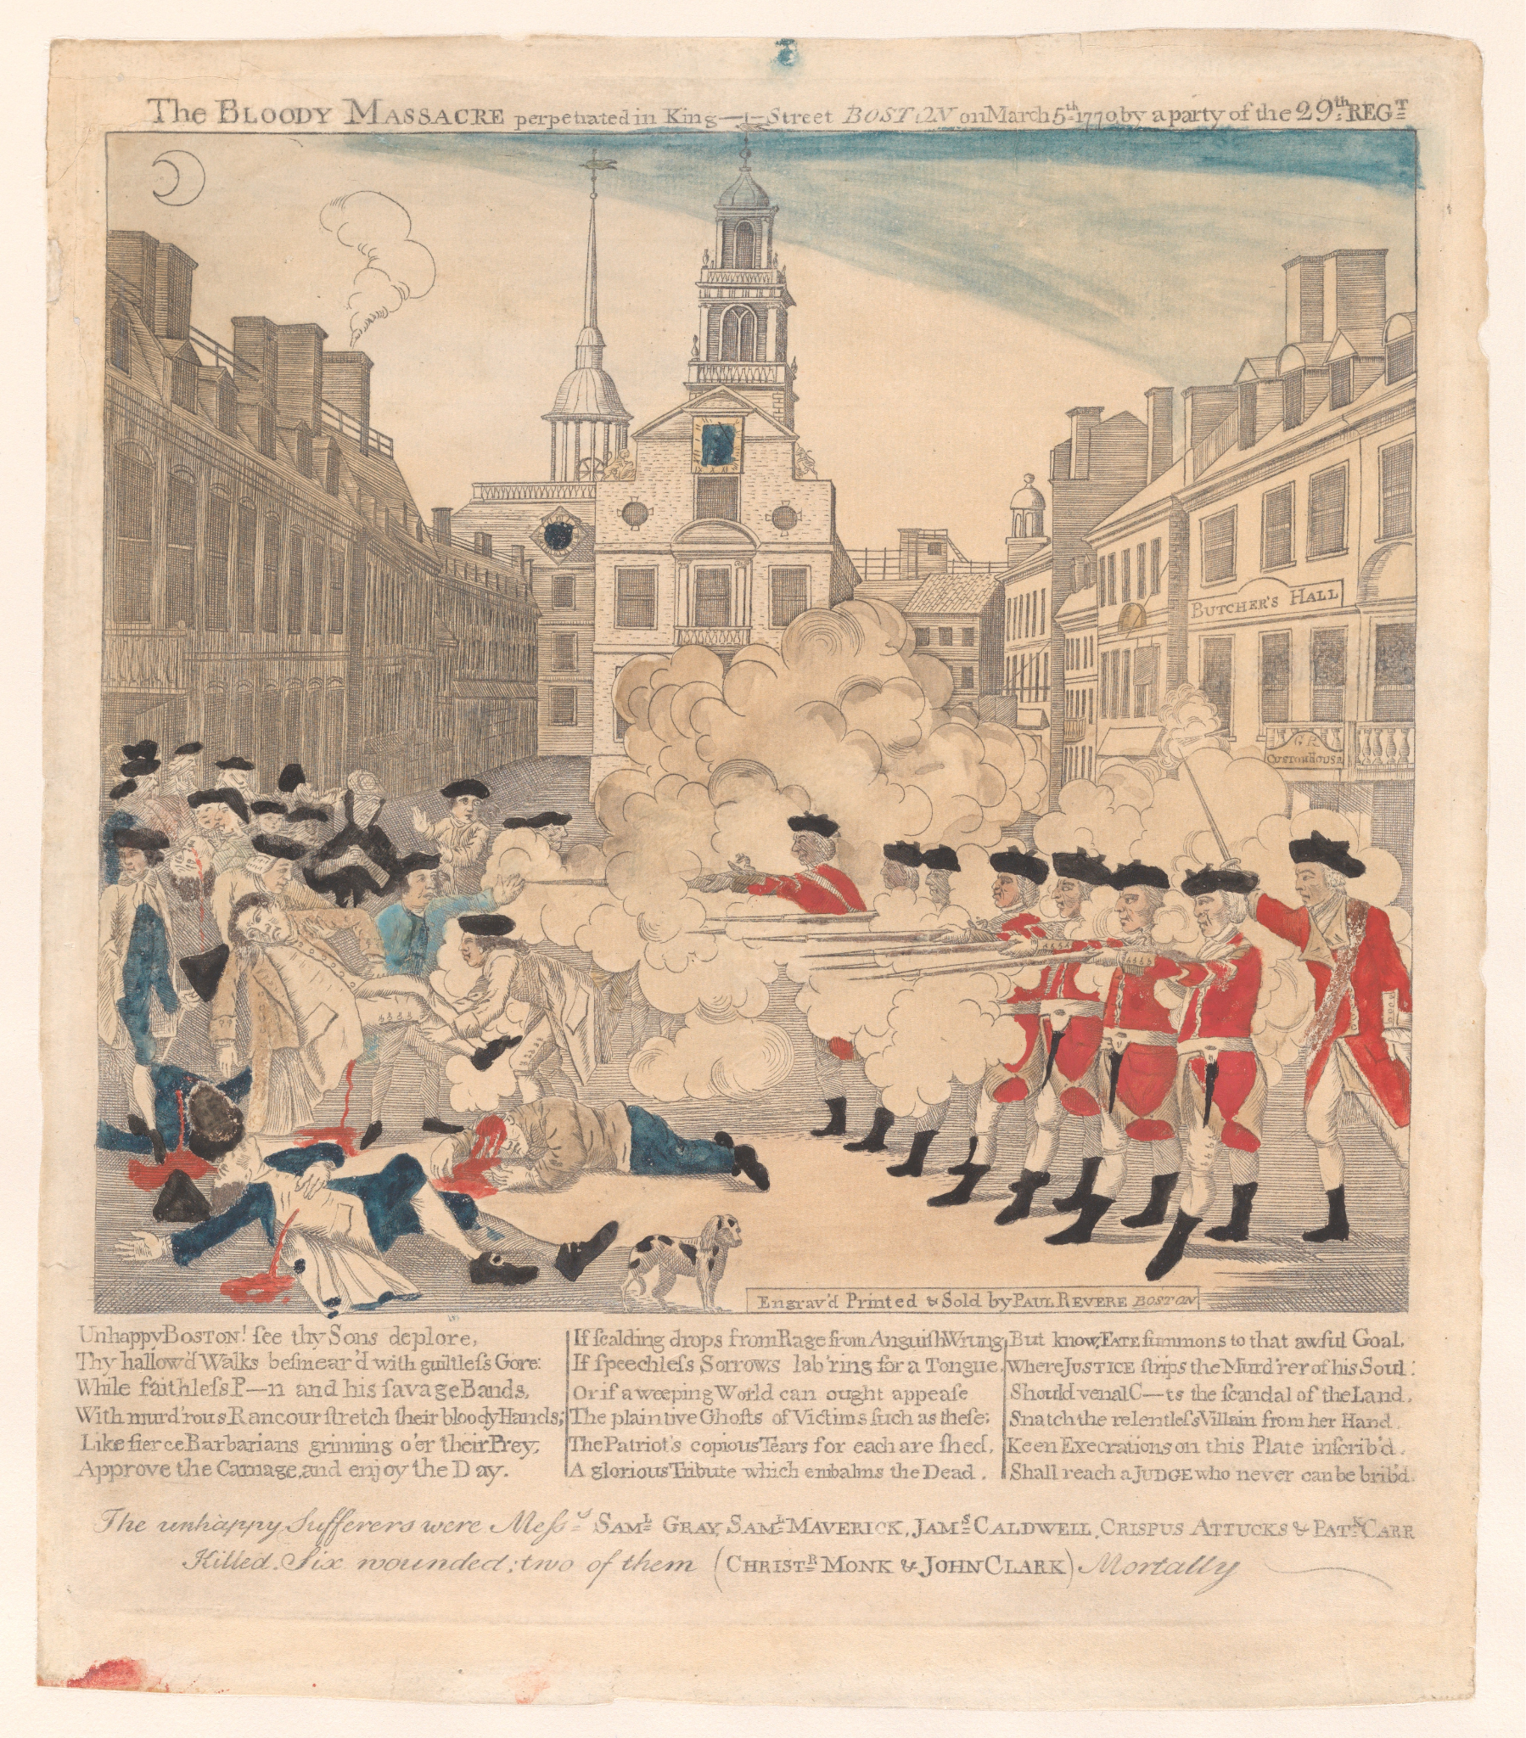

Source: Revere, P., Jr. (1770). The Boston Massacre, or, the bloody massacre perpetrated in King Street, Boston on March 5, 1770 by a party of the 29th Regiment [Print]. The Metropolitan Museum of Art. https://www.metmuseum.org/art/collection/search/365208

“Give Me Liberty or Give Me Death” Speech by Patrick Henry
Background information:
In the wake of escalating tensions between the Patriots and the Redcoats, Henry delivered this stirring address before more than 100 delegates, including George Washington, Thomas Jefferson, and many of the statesmen who would go on to sign the Declaration of Independence. Following the bloody Boston Massacre and the British Parliament’s authoritarian imposition of the Intolerable Acts—which closed the Boston Harbor and stripped New England Colonists of their right to self-govern—American leaders deliberated whether to continue their pursuit of peace, or as a final recourse, to take up arms in the rebellion.
(The White House, 2025)
Excerpt from the speech:
. . . Sir, we have done everything that could be done to avert the storm which is now coming on. We have petitioned; . . .and have implored its interposition to arrest the tyrannical hands of the ministry and Parliament. Our petitions have been slighted. . .and we have been spurned, with contempt, from the foot of the throne! In vain, after these things, may we indulge the fond hope of peace and reconciliation?
There is no longer any room for hope. If we wish to be free. . .we must fight! I repeat it, sir, we must fight! . . . Will it be when we are totally disarmed, and when a British guard shall be stationed in every house? . . . The millions of people, armed in the holy cause of liberty, and in such a country as that which we possess, are invincible by any force which our enemy can send against us . . . There is no retreat but in submission and slavery! Our chains are forged! Their clanking may be heard on the plains of Boston! The war is inevitable—and let it come! I repeat it, sir, let it come.
. . . The war is actually begun! . . . What is it that gentlemen wish? What would they have? Is life so dear, or peace so sweet, as to be purchased at the price of chains and slavery? Forbid it, Almighty God! I know not what course others may take; but as for me, give me liberty or give me death!
—Patrick Henry, 1775

Henry, P. (n.d.). Give me liberty, or give me death! [Speech transcript]. The White House. https://www.whitehouse.gov/patrick-henry-speech-give-me-liberty-or-give-me-death/ (Original work published 1775)

H.I.P.P.
Respond to the following questions using the H.I.P.P. acronym as a guide. If you need more space, use the back of the paper.
Guided Questions | Source Analysis: Engraving | Source Analysis: Speech
H
Historical Context

What events were occurring during the document’s creation?

I
Intended Audience

To whom is the author speaking in the document?

P
Point of View

What is the author’s perspective? What role in society did the author have?

P
Purpose

What is the author trying to accomplish with the document?

