Free Response (Sample responses)

*This problem is intended to be solved* ***without*** *the use of a calculator.*

Consider the curve defined by the equation .

**(a)** On the axes provided, sketch a slope field for the given differential equation at the nine points indicated.

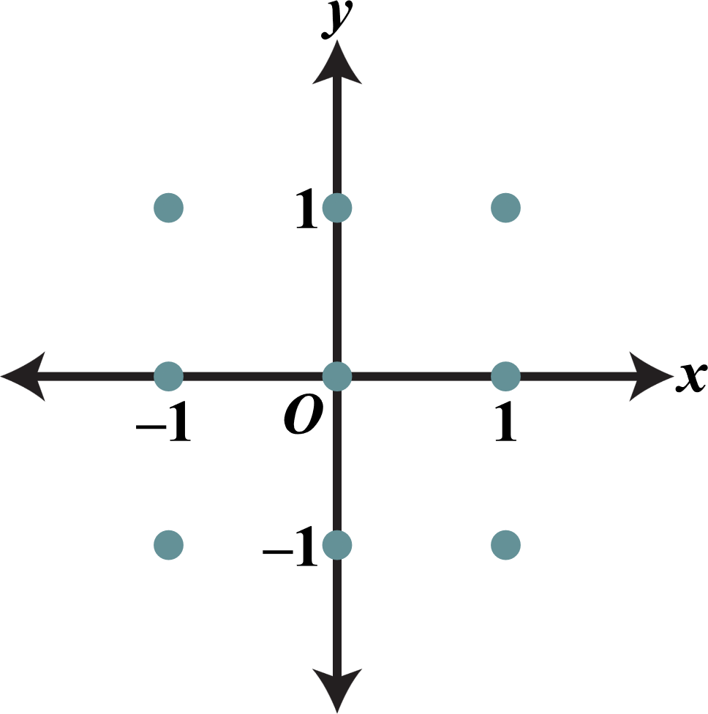

**(b)** There is a horizontal line with equation *y* = *c* that satisfies this differential equation. Find the value of *c*.

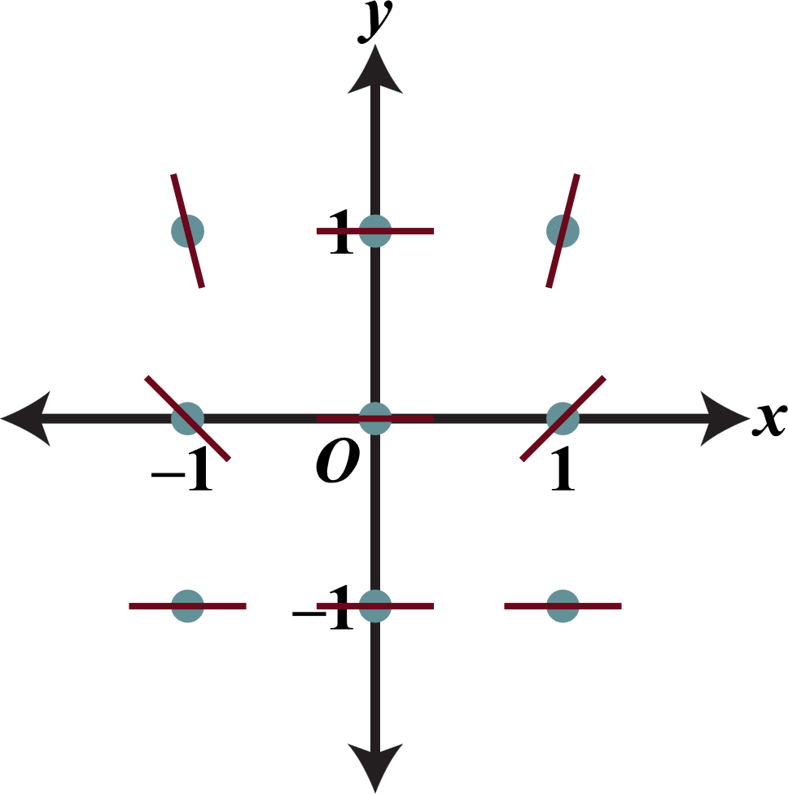**(c)** Find the particular solution  to the differential equation with the initial condition .

**(a)**

|  |  |  |
| --- | --- | --- |
|  |  |  |
|  |  |  |
|  |  |  |

**+1:** zero slopes

**+1:** all other slopes

**+2:**

**(b)** *c* quals –1 because the slope when *y* = –1 is constantly zero and the slope of *y* = *c* would also be constantly zero.

**(c)** 



**+1:** *c* = –1

**+1:** separates variables

**+2:** antiderivatives

**+1:** constant of integration

**+1:** uses initial condition

**+1:** answer

**+6:**

**Note:** If missing constant of integration, maximum of 3/6 points: 1-2-0-0-0.

**Note:** If no separation of variables, 0/6 points.