Free Response

*This problem is intended to be solved* ***without*** *the use of a calculator.*

Consider the curve defined by the equation .

**(a)** On the axes provided, sketch a slope field for the given differential equation at the nine points indicated.

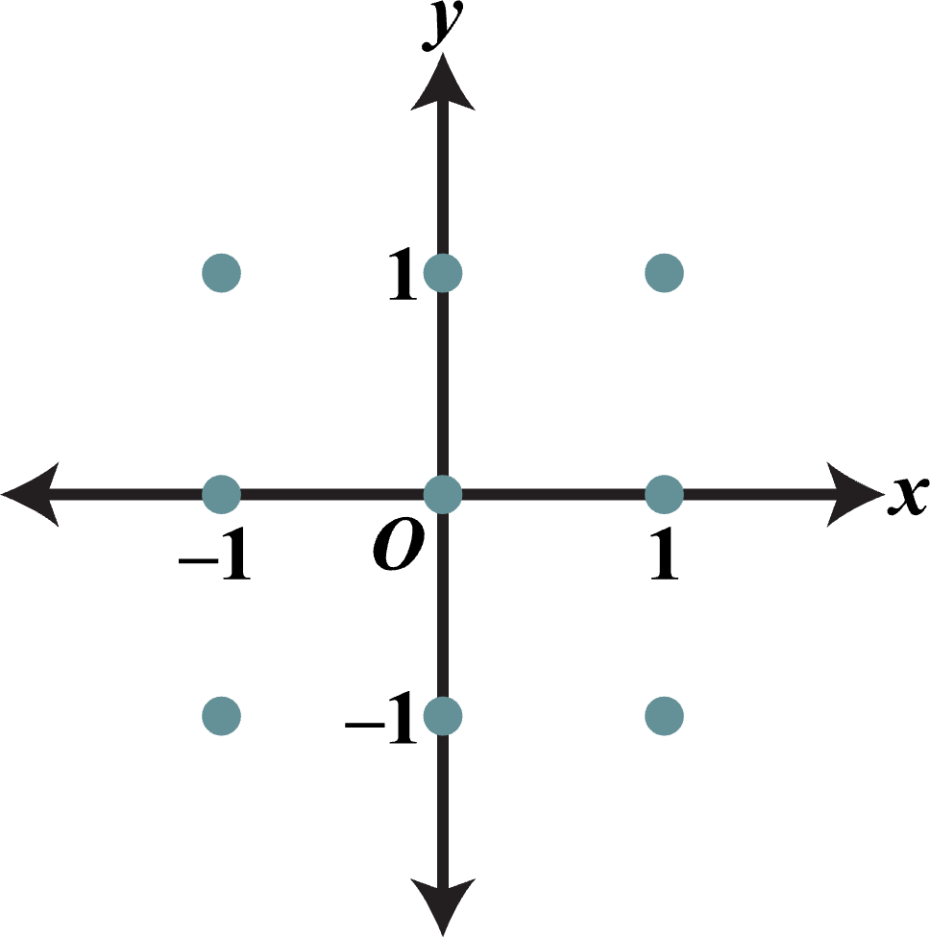

**(b)** There is a horizontal line with equation *y* = *c* that satisfies this differential equation. Find the value of *c*.

**(c)** Find the particular solution  to the differential equation with the initial condition .