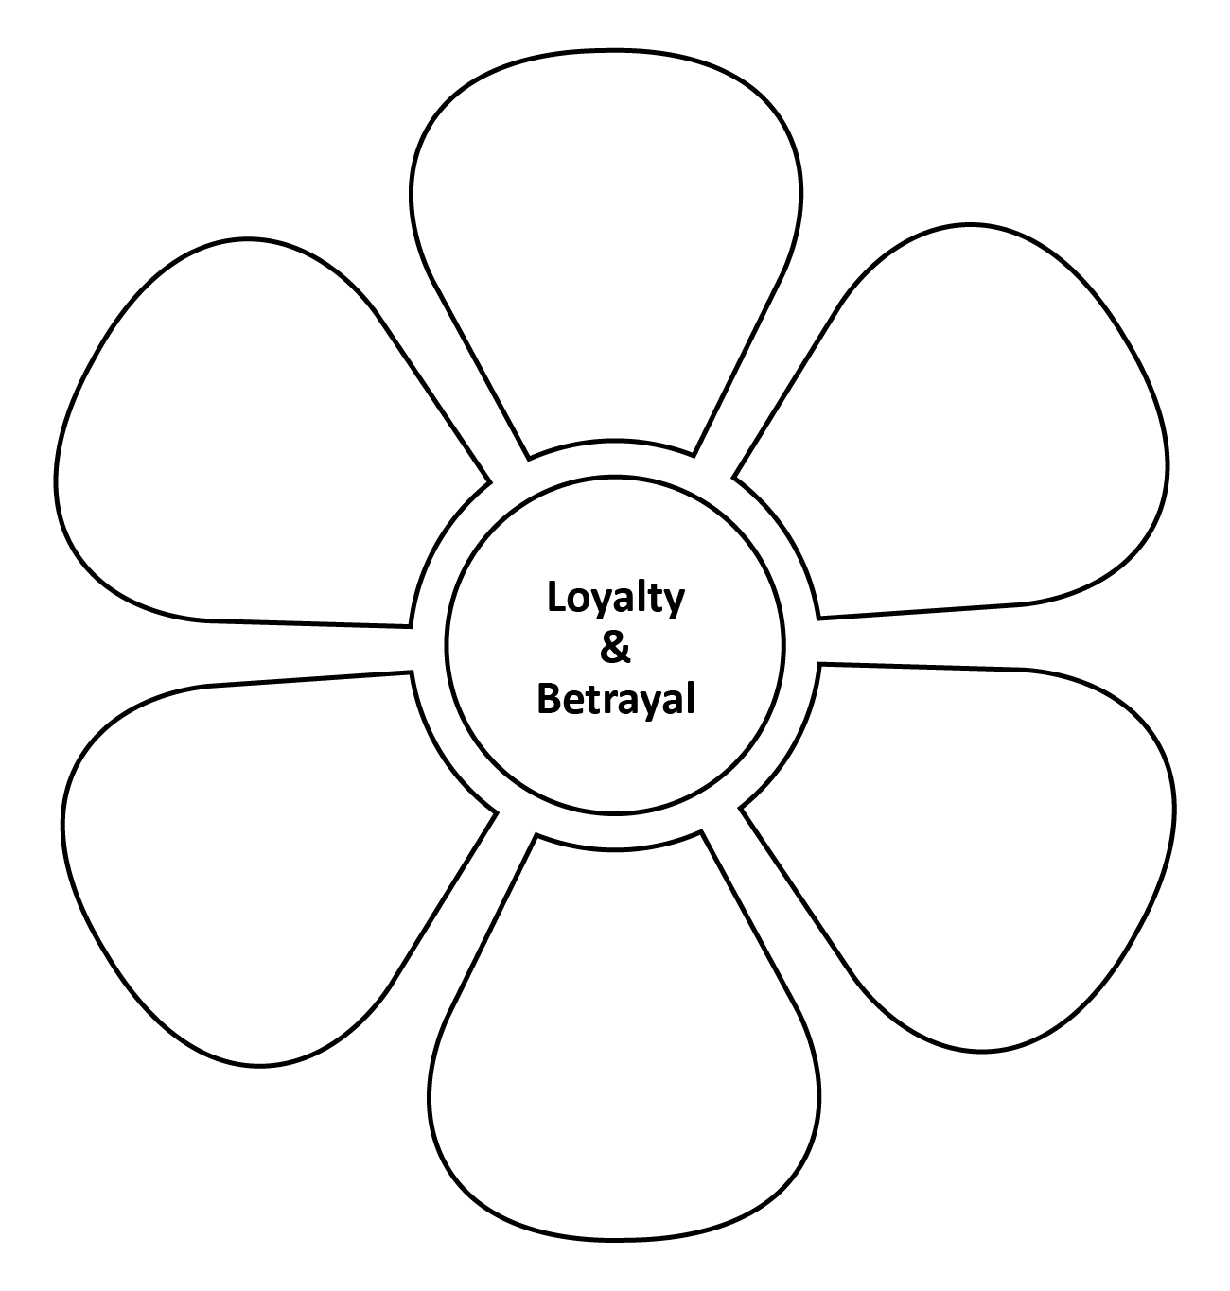

Where there is great love, there are always miracles.

—Willa Cather

In time, we hate that which we often fear. —William Shakespeare

Lack of loyalty is one of the major causes of failure in every walk of life.

—Napoleon Hill

The strength of a family, like the strength of an army, lies in its loyalty to each other. —Mario

Puzo

Anger and hatred hinder good counsel.

Love is the absence of judgement. —Dalai Lama

Walking with a friend in the dark is better than walking alone in the light. —Helen

Keller

Loyalty is what we seek in friendship.

—Cicero

Hatred is blind, as well as love.

—Oscar Wilde

Trust can take years to build but only a second to break.

You don’t earn loyalty in a day. You earn it day-by-day. —Jeffrey Gitomer

It is easier to forgive an enemy than to forgive a friend. —William Blake



Fear makes the wolf bigger than he is. —German Proverb



Tolerance is giving to every other human being every right which you claim for yourself.

—Robert Ingersoll

A small spark can start a great fire. —Emmet Fox

A man is known by the company he keeps.

—Aesop

People who live in glass houses shouldn’t throw stones.

A bully is always a coward.

Happiness can exist only in acceptance.

—George Orwell

No man is an island. —John Donne

The worst loneliness is not being comfortable with yourself.

—Mark Twain

If you are afraid of something, you give it power over you.

It is easy to be brave from a distance.

—Aesop

Courage is not the absence of fear, it is the conquest of it. —William Danforth

*Oscar, W. (1905). De profundis. Putnam’s Sons.*

*Cather, W. (1927). Death comes for the archbishop. Alfred A. Knopf.*

*Shakespeare, W. (1623). Antony and Cleopatra.*

*Donne, J. (1624). No man is an island.*

*Hill, N. (1937). Think and grow rich. Duke Classics.*

*Gitomer, J. (1998). Customer satisfaction is worthless, customer loyalty is priceless. Bard Press.*

*Blake, W. (1820). Chapter 4. In Jerusalem: The emanation of the giant albion.*

*Puzo, M. (1969). The godfather. G.P. Putnam’s Sons.*

*Fox, E. (1941). Find and use your inner power. Harper and Row.*

*Danforth, W. H. (1953). I dare you! William H. Danforth.*

*Aesop. (1919). The kid and the wolf. In The Aesop for Children.*

*Ingersoll, R. G. (1882). Liberty of man, woman and child: Lecture. C.S. Baldwin.*