Explore the Score
Question 1
Yesenia is preparing for soccer season by running a total of 36 miles per week. If she runs four days a week, how many miles on average does she run each day?
(A) 4
(B) 6
(C) 9
(D) 12
(E) 36

Question 2
A cheerleader’s final score is determined solely by the average of 8 judges’ scores, which are worth 10.0 points each. If Chelsea has an average of exactly 8.8 points from the first 6 judges, how many points must she average from the last 2 judges to earn exactly a final score of 9.0?
(F) 9.9
(G) 9.6
(H) 9.5
(J) 9.4
(K) 9.2

Question 3
During football season, the concession stand sells 30 bags of popcorn at $3 per bag, 50 hot dogs at $5 each, 80 soft drinks at $2 per drink, and 180 candy bars at $1 each. What is the average amount charged per item?
(A) $2.00
(B) $2.25
(C) $2.50
(D) $2.75
(E) $3.00

Question 4
An archer hit a target 9 times. For each arrow, her scores, in order, were 6, 3, 5, 8, 7, 4, 8, 9,
and 8. She discovered a scoring error on the 9th shot, and her score on that shot was corrected to 10. Which of the following measures of central tendency changed as a result of the correction?
I. Mean
II. Median
III. Mode

(F) I only
(G) II only
(H) I and II only
(J) II and III only
(K) I, II, and III

Question 5
The frequency histogram below shows the distribution of the heights, in inches, of 15 basketball players.
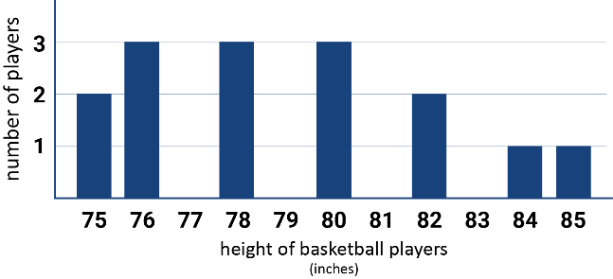
Using the data from the frequency history gram, what is the sum of the mean and the median of this distribution?
(A) 156
(B) 157
(C) 158
(D) 159
(E) 160

