CITY PROJECT EXAMPLE
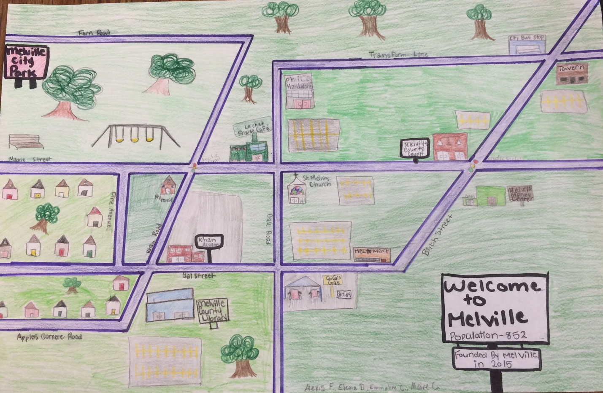

- Melville county court is corresponding to the Mel Mart
- Le Chat Fraise Café is vertical to the St. Melving Church
- Tavern is alternate interior to the Melville county court
- Le Chat Fraise Café is alternate exterior to GiGi’s Gas

