ENCRYPTION CHAT STATIONS

Substitution Ciphers
Description: A substitution cipher takes a plaintext message and swaps each letter with another letter or symbol.
3 Facts / Stats / Characteristics:
- The “key” for Caesar cipher represents how many spaces the alphabet should be rotated.
- Double letter patterns, one letter words, and vowel placement make this method vulnerable.
- Susceptible to brute force and frequency analysis attacks.
https://www.csfieldguide.org.nz/en/chapters/coding-encryption/substitution-ciphers/
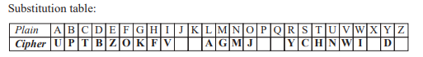
Examples:
https://en.wikipedia.org/wiki/Substitution_cipher

Caesar Ciphers

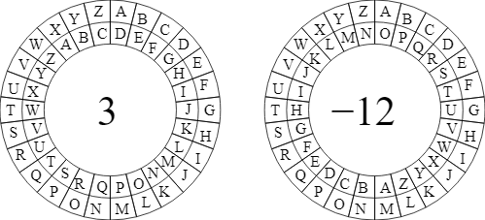
Image credited to https://cscx.org/caesar

Atbash Ciphers
https://en.wikipedia.org/wiki/Pigpen_cipher
Information about the security:
https://en.wikipedia.org/wiki/Substitution_cipher#Security
Applications:
Passing secret notes to your friends at school
Not suitable for:
Monetary transactions
Trade secrets
Classified information
Anything related to health/safety or other personal information

Language Substitution
Language substitution is a method of protecting sensitive information by communicating in a language that is unknown to eavesdroppers.
Facts / Stats / Characteristics:
- Relies on the cipher language being secret
Example: “...United States service members during the World Wars who used their knowledge of Native American languages as a basis to transmit coded messages” (from https://en.wikipedia.org/wiki/Code_talker).
Applications:
Informal conversations
Alien invasions
Counterintelligence
Limitations:
After the success of code talkers in World War II, it’s much more difficult to pull this off in high profile scenarios.

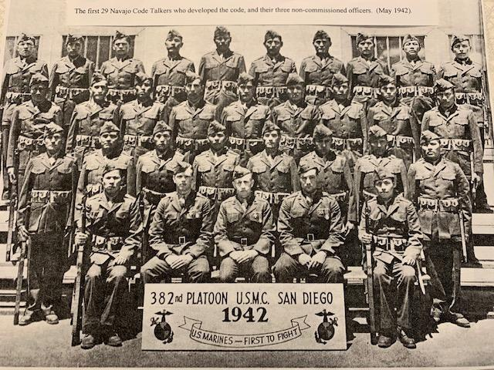
https://fronterasdesk.org/content/1005301/navajo-code-talkers-miracle-ended-world-war-ii

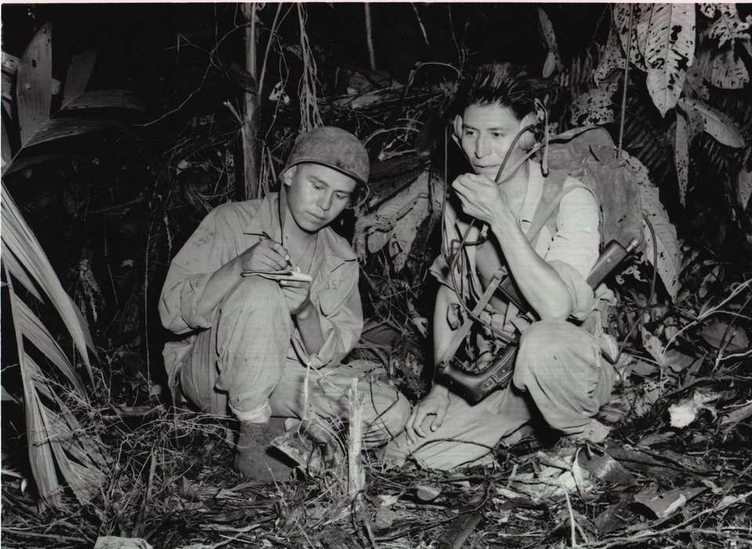 https://www.nationalww2museum.org/war/articles/american-indian-code-talkers

Symmetric Encryption
Symmetric encryption uses a secret shared between two parties as a key to encrypt data. It is “symmetric” because each person in the communication uses the key to encode and decode messages.

https://www.csfieldguide.org.nz/en/chapters/coding-encryption/storing-passwords-securely/
Examples:
https://en.wikipedia.org/wiki/One-time_pad
Examples of popular symmetric-key algorithms include Twofish, Serpent, AES (Rijndael), Camellia, Salsa20, ChaCha20, Blowfish, CAST5, Kuznyechik, RC4, DES, 3DES, Skipjack, Safer, and IDEA.
(from https://en.wikipedia.org/wiki/Symmetric-key_algorithm#Implementations)

Applications:
Digital signatures
Data Hashing
Communication

Limitations:
- Protecting a single shared secret is difficult because of hackers and the way information is proliferated on the internet.
- Breaking symmetric encryption receives a lot of attention and interest from hackers. There are many tools and techniques available to assist in “discovering” the shared secret.
- Establishing a shared secret requires a pre-existing, safe way to communicate.

Asymmetric Encryption (aka Public-key cryptography)
Asymmetric encryption uses a combination of private and public keys from two parties to encrypt data. It is “asymmetric” because each person in the communication uses a different key to encode and decode messages.

https://www.csfieldguide.org.nz/en/chapters/coding-encryption/the-key-distribution-problem/

Facts / Stats / Characteristics:
- Anyone can use the public key to encrypt.
- Only the private key holder can decrypt an encoded message.
Examples:
Diffie-Hellman Key Exchange
RSA encryption algorithm
Elliptic curve cryptography
Applications:
- Internet security. Almost all safety and security on the internet is implemented with public-key cryptography.
- Robust digital signatures
- Digital currency
Limitations:
- Can be challenging to understand
- Keeping private keys safe can be difficult

