MAPS OF INDIA

India Population Density Map

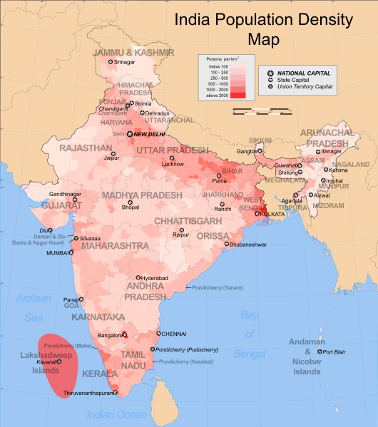
source: India population density map 2006. Wikimedia commons. Map retrieved from: https://commons.
wikimedia.org/wiki/File:India_population_density_map_en.svg

MAPS OF INDIA

India Physical Map

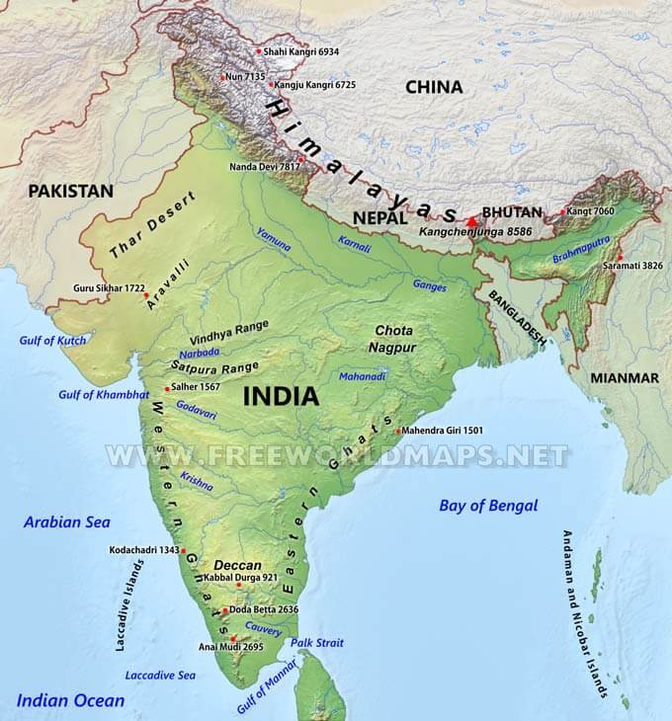
source: India physical map (n.d.) FreeWorldMaps.net. Retrieved from: http://www.freeworldmaps.net/asia/india/map.html

MAPS OF INDIA

India’s Railway System

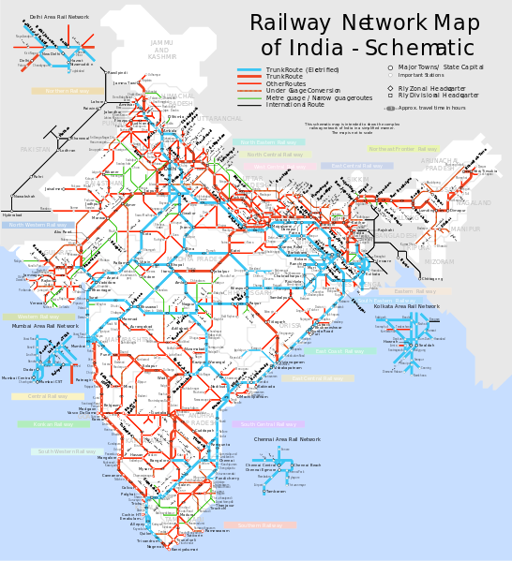
source: India railway schematic map (2006). Wikimedia Commons. Retrieved from: https://commons.wikimedia.org/wiki/File:
India_ railway_schematic_map.svg

MAPS OF INDIA

India’s Flood Zones

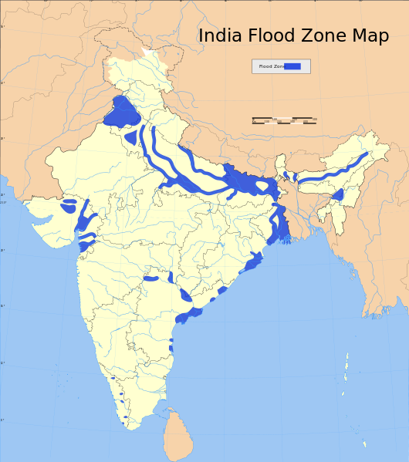
source: India flood zone map (2006). Wikimedia Commons. Retrieved from: https://commons.wikimedia.org/wiki/File:India_flood_zone_map.svg

