SUGGESTED CHILDREN’S BOOKS ABOUT AUTHORS
Fulton, Lynn. (2018). She Made a Monster: How Mary Shelley Created Frankenstein. Knopf Books for Young Readers.
Rinker, Sherry Duskey. (2017). Big Machines: The Story of Virginia Lee Burton. Clarion Books.
Higgins, Carter. (2020). A Story is to Share: How Ruth Krauss Found Another Way to Tell a Story. Harry N. Abrams.
McAlister, Caroline. (2017). John Ronald’s Dragons: The Story of J.R.R. Tolkien. Roaring Brook Press.
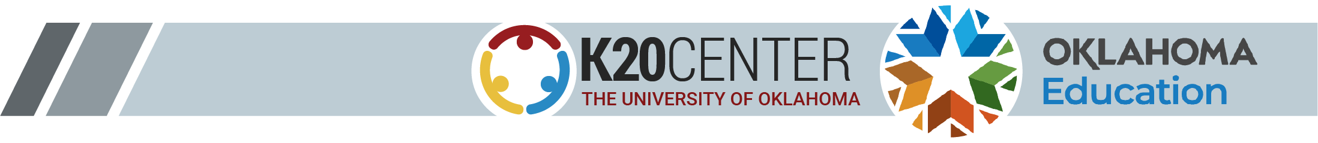
Slade, Suzanne. (2020). Exquisite: The Poetry and Life of Gwendolyn Brooks. Harry N. Abrams.

