HONEYCOMB HARVEST

Existencialismo
Irracionalidad
y
lo Absurdo
Friedrich Nietzsche (1844-1900)
Ansiedad
y
Autenticidad
Existencia
Søren Kierkegaard (1813-1855)
Filosofía como estilo de vida
Contextualización
El Público
Libertad

Martin Heidegger (1889-1976)
El conocimiento de la libertad personal y la responsabilidad de tomar decisiones honestas pueden causar incomodidad. Pero es importante soportar la incomodidad para vivir una vida sincera y encontrar sentido a las experiencias y decisiones individuales.
Enfatiza la necesidad de afrontar con autenticidad las incertidumbres de la vida y de crear un sentido personal a través del contacto activo con la existencia. Este tema central del existencialismo se centra en la experiencia individual del ser y en las profundas cuestiones de significado, libertad, elección y responsabilidad que se derivan de ella.
Simone de Beauvoir
(1908-1986)
Aboga por el compromiso activo y la plena integración de los principios filosóficos, centrándose en la importancia de la elección individual, la autenticidad y la responsabilidad personal, mientras se da forma a la propia vida y se busca un sentido
Llama la atención sobre la profunda influencia de las condiciones, contextos y experiencias individuales de la existencia humana, resaltando la importancia de reconocer y afrontar estos factores a la hora de navegar por la libertad y la responsabilidad para encontrar un verdadero sentido y propósito.
Jean-Paul Sartre (1905-1980)
Forma de investigación filosófica que explora la cuestión de la existencia humana y plantea preguntas relacionadas con el significado, la finalidad y el valor de la existencia humana.
Resalta la capacidad de las personas para compartir su vida mediante una toma de decisiones autónoma, centrándose en la responsabilidad que conlleva la creación de un significado y una identidad personal.
Albert Camus (1913-1960)

Examina las contradicciones de la existencia humana, resaltando la sensación de falta de sentido que resulta de enfrentarse a las incertidumbres de la vida. Este tema aboga por que los individuos se enfrenten a estas dificultades mientras tratan de encontrar un propósito en medio del misterio de la vida.
Albert Camus se centra en la tensión inherente a la búsqueda de sentido por parte de la humanidad en un mundo indiferente.
El modo en que uno se encuentra con la realidad es una decisión.
-Martin Heidegger
El concepto de Friedrich Nietzsche de “llegar a ser lo que uno es” enfatizaba su creencia en el poder transformador de vivir filosóficamente, creyendo que la filosofía debe dar forma a la vida y no ser abstracta.
Simone de Beauvoir sostiene que una persona debe afirmarse a sí misma para superar las expectativas sociales y crear una vida con sentido. También resalta el modo en que los contextos sociales, culturales e históricos configuran las experiencias y posibilidades de una persona.
Siempre habrá piedras en el camino frente a nosotros. Serán piedras de tropiezo o peldaños; todo depende de cómo las usamos.
-Friedrich Nietzsche
Søren Kierkegaard exploró la experiencia personal del individuo, enfatizando la angustia existencial, el estrés, la preocupación, la originalidad y la creación de un significado personal en medio de las incertidumbres de la vida, con enfoque en el miedo y el estrés y las complejidades de la existencia.
Jean-Paul Sartre afirma que los seres humanos son libres y deben asumir la plena responsabilidad de sus decisiones en un mundo sin sentido. Sostiene que los individuos luchan contra el peso de su libertad y la responsabilidad de crear sus propios valores y sentido, pero la única forma de superarlo es asumirlo y apropiarse de su existencia.
Es mejor intentar algo y fracasar que no intentar nada y tener éxito. El resultado puede ser el mismo, pero tú no lo serás. Siempre crecemos más a través de las derrotas que de las victorias.
- Søren Kierkegaard
La filosofía de Martin Heidegger se centró en la existencia humana dentro del mundo, destacando la interconexión de los individuos con su medio ambiente y el significado de su existencia en él.

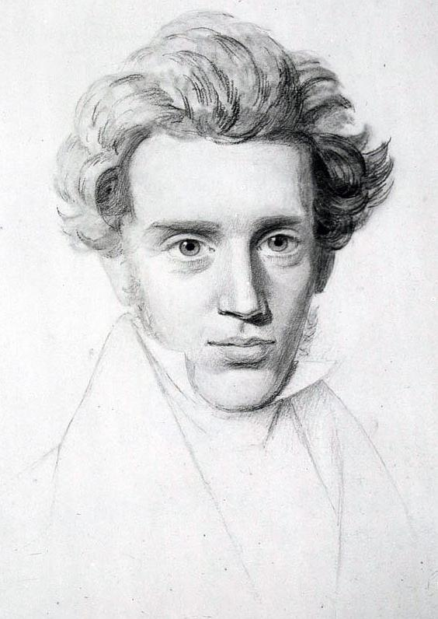
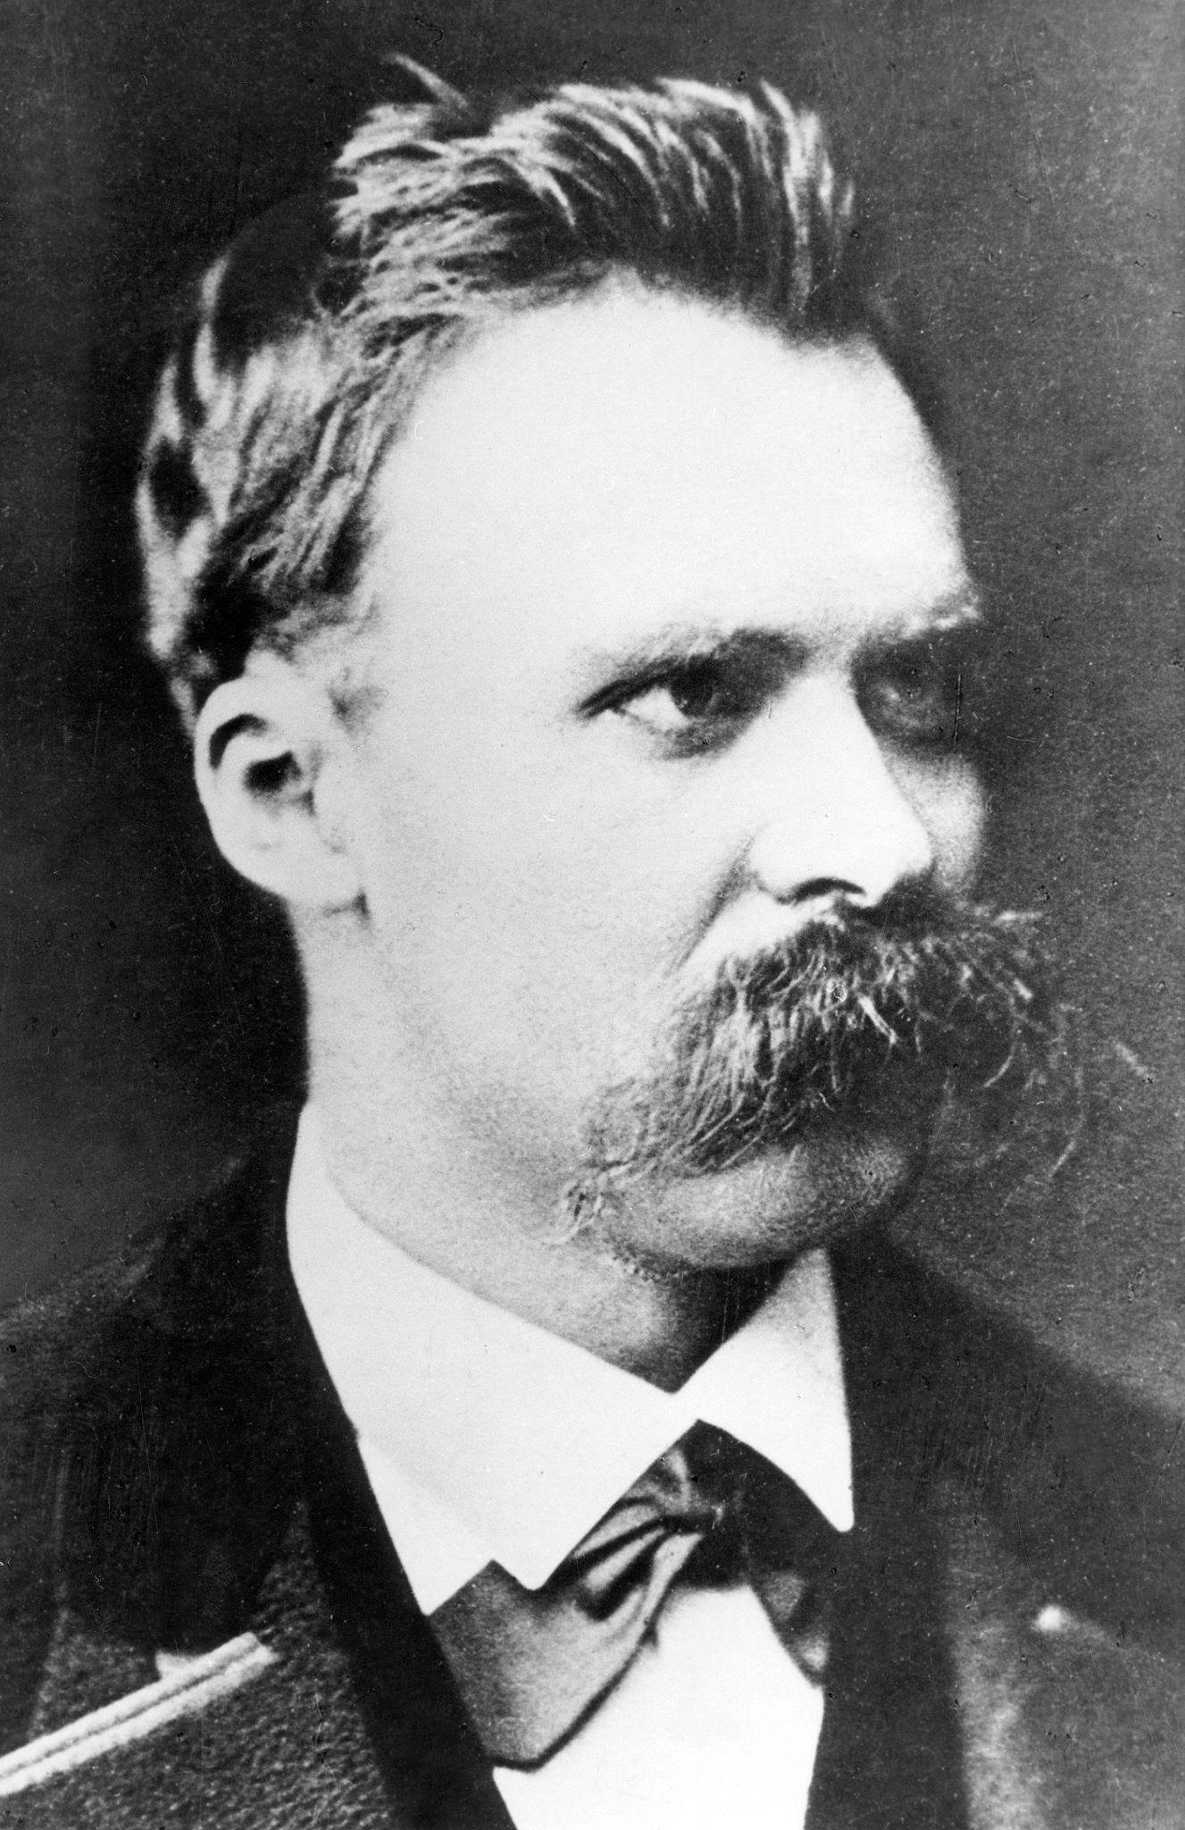
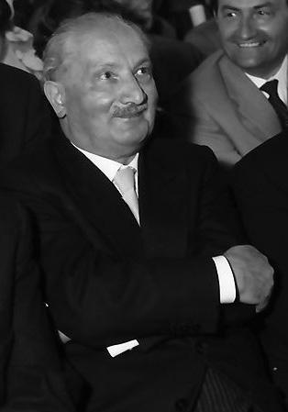
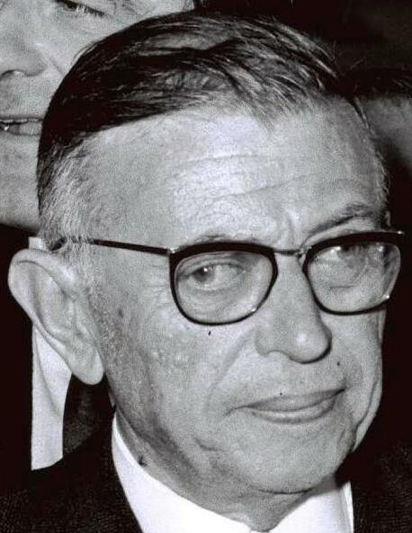
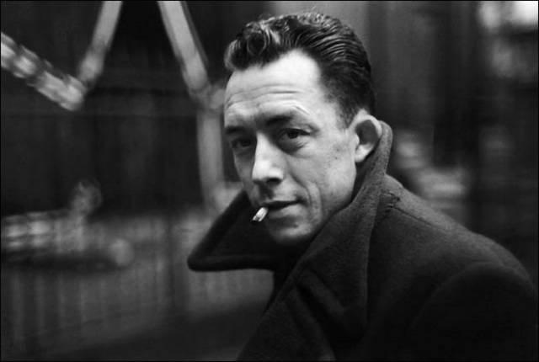
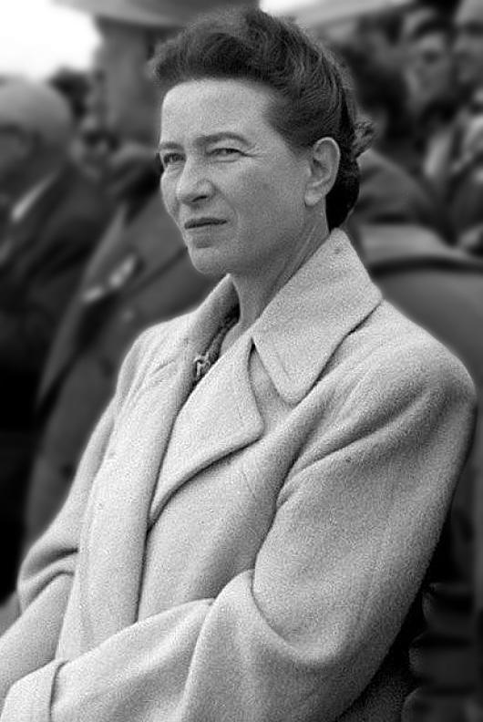

La Libertad es lo que haces con lo que te han hecho.
-Jean-Paul Sartre

La vida no tiene sentido, pero vale la pena vivirla, siempre que reconozcas que no tiene sentido.
-Albert Camus

No se trata de que las mujeres simplemente arrebaten el poder de las manos de los hombres, ya que eso no cambiaría nada en el mundo. Se trata precisamente de destruir esa noción de poder.
-Simone de Beauvoir

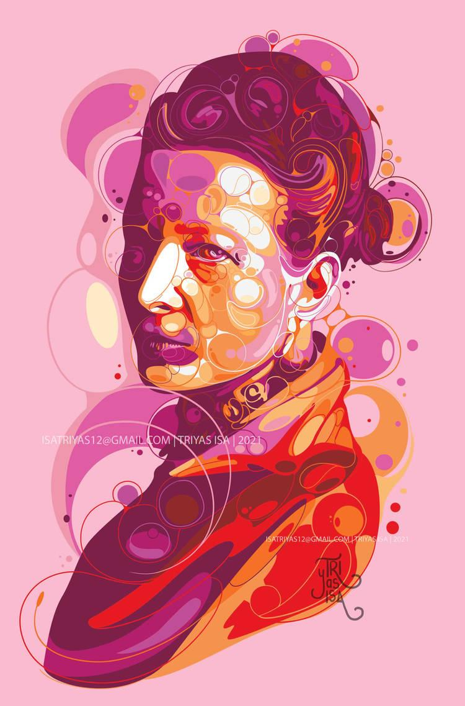
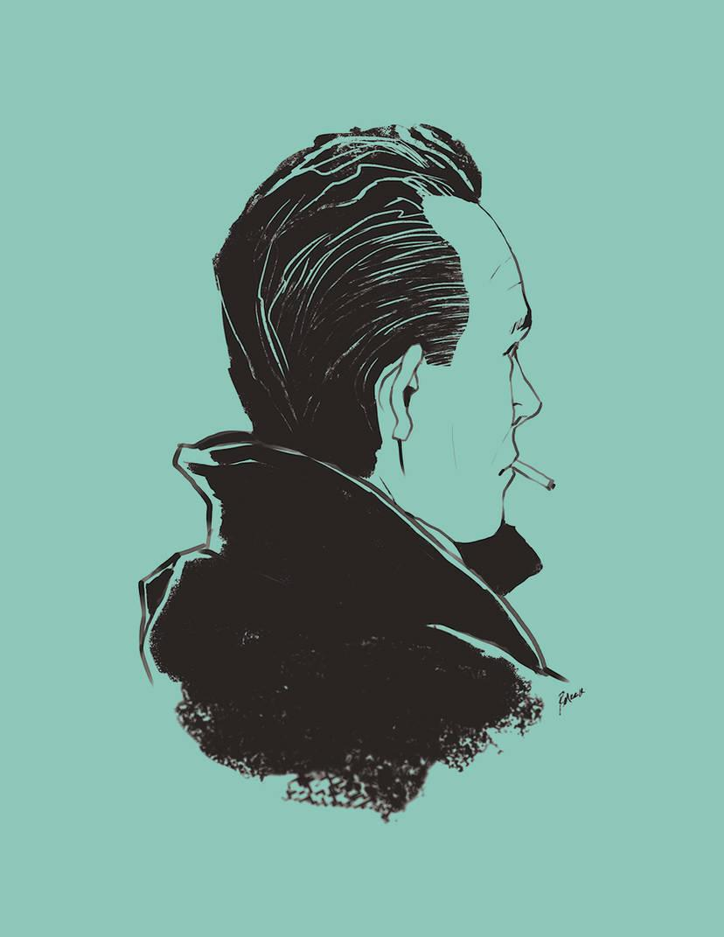
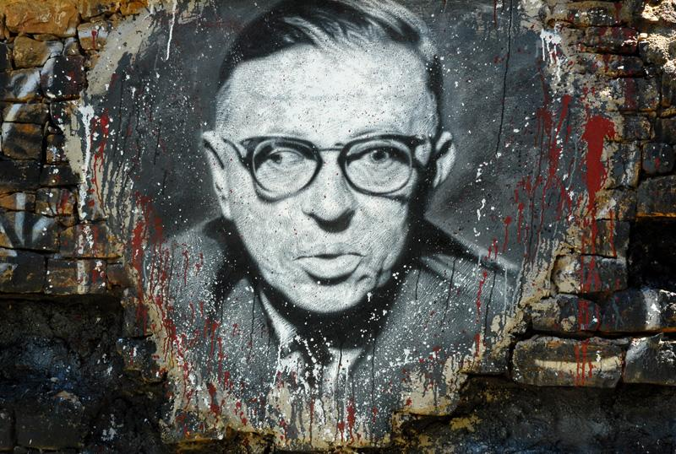
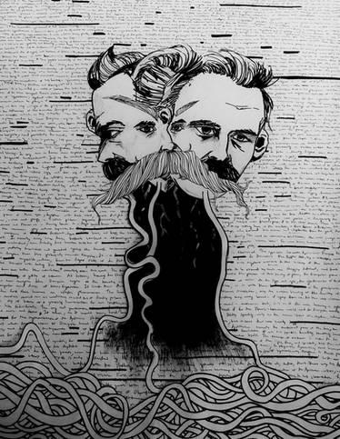

Fuentes:
DietrichLiao. (2008). Albert Camus. flickr. https://www.flickr.com/photos/mitmensch0812/2513316191.
ehrmann, thierry. (2008). Jean-Paul Sartre, painted portrait - DDC_7519. flickr. https://www.flickr.com/photos/home_of_chaos/2612647693.
fitore. (2023). Fear and Trembling - Soren Kierkegaard. Deviant Art. https://www.deviantart.com/fitore/art/Fear-and-Trembling-Soren-Kierkegaard-989120799.
Hijazo, A. (2019a). Simone de Beauvoir in Beijing 1955. Wikimedia Commons. https://commons.wikimedia.org/wiki/File:Simone_de_Beauvoir_in_Beijing_1955.jpg
Hijazo, A. (2019b). Søren Kierkegaard (1813-1855) - (cropped). Wikimedia Commons. https://en.wikipedia.org/wiki/S%C3%B8ren_Kierkegaard
MRCLD. (2022). Jean Paul Sartre and Simone De Beauvoir welcomed by Avraham Shlonsky and Leah Goldberg (cropped). Flickr - Government Press Office (GPO) - Wikimedia Commons. https://commons.wikimedia.org/wiki/File:Flickr_-_Government_Press_Office_(GPO)_-_Jean_Paul_Sartre_and_Simone_De_Beauvoir_welcomed_by_Avraham_Shlonsky_and_Leah_Goldberg.jpgps
Nietzsche. (s.f.). Deviant Art. https://www.deviantart.com/tag/nietzsche?page=2.
Racconish. (2014). Heidegger 3 (1960). Wikimedia Commons. https://commons.wikimedia.org/wiki/File:Heidegger_3_(1960).jpg
reymonstruo. (2014). Albert Camus 2. Deviant Art. https://www.deviantart.com/reymonstruo/art/Albert-Camus-2-455494350.
triyasisa. (2021). Simone de Beauvoir. Deviant Art. https://www.deviantart.com/tag/simonedebeauvoir
Volpagoe. (2023). Friedrich Wilhelm Nietzsche. Wikimedia Commons. https://commons.m.wikimedia.org/wiki/File:Friedrich_Wilhelm_Nietzsche.jpg.

