HONEYCOMB HARVEST

Existentialism
Irrationality
&
Absurdity
Friedrich Nietzsche (1844-1900)
Anxiety
&
Authenticity
Existence
Søren Kierkegaard (1813-1855)
Philosophy as a Way of Life
Situatedness
The Crowd
Freedom

Martin Heidegger (1889-1976)
The knowledge of personal freedom and the responsibility to make honest choices can cause discomfort. However, it is important to support the discomfort in order to live a sincere life and find meaning in individual experiences and decisions.
Emphasizes the need to confront life’s uncertainties authentically and to create personal meaning through active engagement with existence. This central theme in existentialism focuses on the individual's experience of being and the profound questions of meaning, freedom, choice, and responsibility that arise from it.
Simone de Beauvoir
(1908-1986)
Advocates for the active engagement and full integration of philosophical principles, focusing on the importance of individual choice, authenticity, and personal responsibility, while shaping one’s own life and searching for meaning.
Draws attention to the very deep influence of individual conditions, contexts, and experiences of human existence, highlighting the importance of acknowledging and confronting these factors in navigating freedom and responsibility to find real meaning and purpose.
Jean-Paul Sartre (1905-1980)
A form of philosophical inquiry that explores the issue of human existence and asks questions related to the meaning, purpose, and value of human existence.
Highlights peoples’ ability to share their life through autonomous decision-making, focusing on the responsibility built into creating personal meaning and identity.
Albert Camus (1913-1960)

Examines the contradictions in human existence, highlighting the sense of meaninglessness that results from confronting life’s uncertainties. This theme advocates for individuals to confront these difficulties while trying to find purpose in the middle of the mystery of life.
Albert Camus focuses on the inherent tension between humanity’s search for meaning in an indifferent world.
How one encounters reality is a choice.
-Martin Heidegger
Friedrich Nietzsche’s
concept of “becoming who you are” emphasized his belief in the transformative power of living philosophically, believing that philosophy should shape one’s life and not be abstract.
Simone de Beauvoir argues that a person must assert themselves in order to overcome societal expectations and create a meaningful life. She also highlights ways social, cultural, and historical contexts shape a person’s experiences and possibilities.
There will always be rocks in the road ahead of us. They will be stumbling blocks or stepping stones; it all depends on how you use them.
-Friedrich Nietzsche
Søren Kierkegaard explored the individual’s personal experience, emphasizing the existential angst, stress, worry, originality, and the creation of personal meaning in the middle of life’s uncertainties with a particular focus on fear and stress and the complexities of existence.
Jean-Paul Sartre claims that humans are free and must take full responsibility for their choices in a world without meaning. He argues that individuals struggle with the weight of their freedom and the responsibility to create their own values and meaning, but the only way to overcome this is to embrace it and take ownership of their existence.
It is better to try something and fail than to try nothing and succeed. The result may be the same, but you won't be. We always grow more through defeats than victories.
- Søren Kierkegaard
Martin Heidegger’s philosophy focused on human existence within the world, emphasizing the interconnectedness of individuals with their environment and the significance of their existence within it.

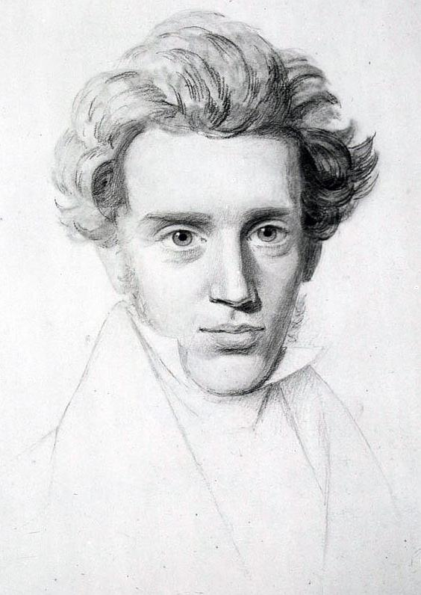
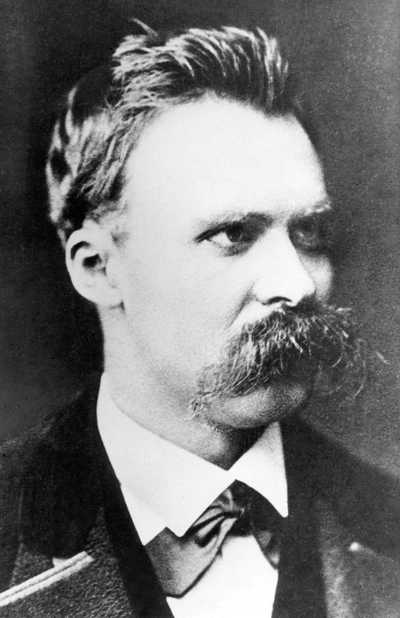
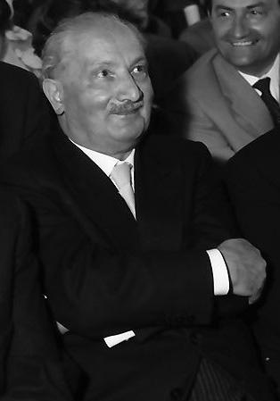
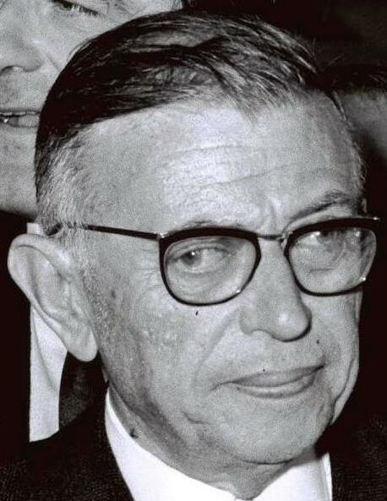
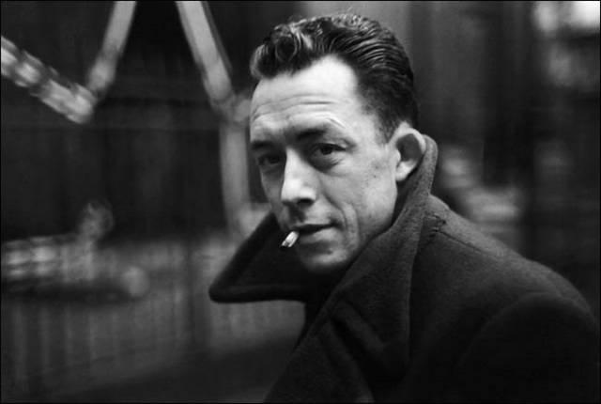
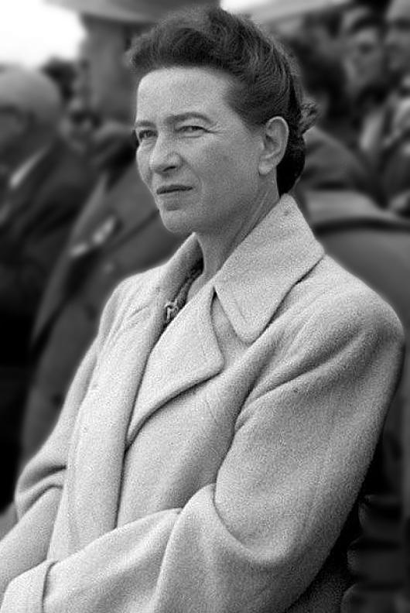

Freedom is what you do with what's been done to you.
-Jean-Paul Sartre

Life is meaningless, but worth living, provided you recognize it's meaningless.
-Albert Camus

The point is not for women simply to take power out of men’s hands, since that wouldn’t change anything about the world. It’s a question precisely of destroying that notion of power.
-Simone de Beauvoir

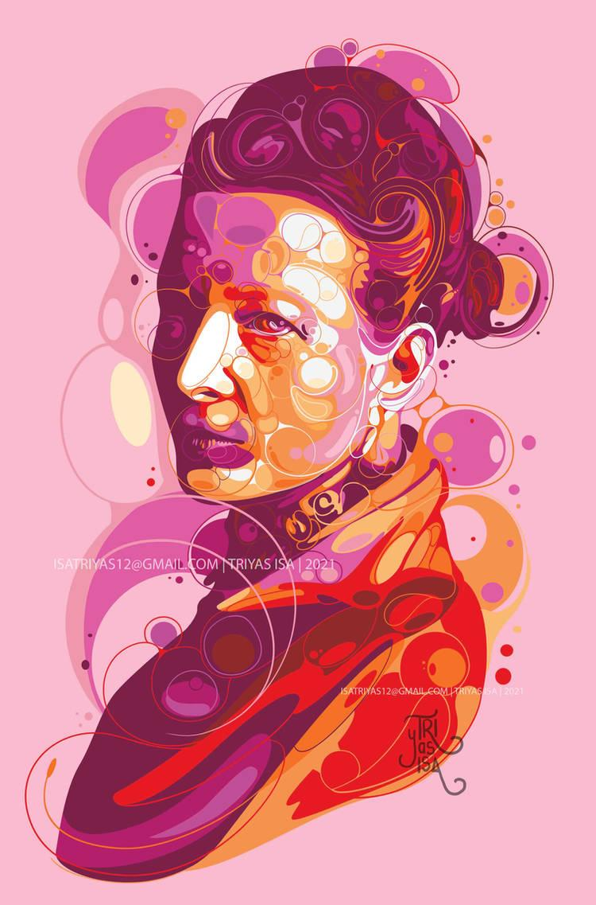
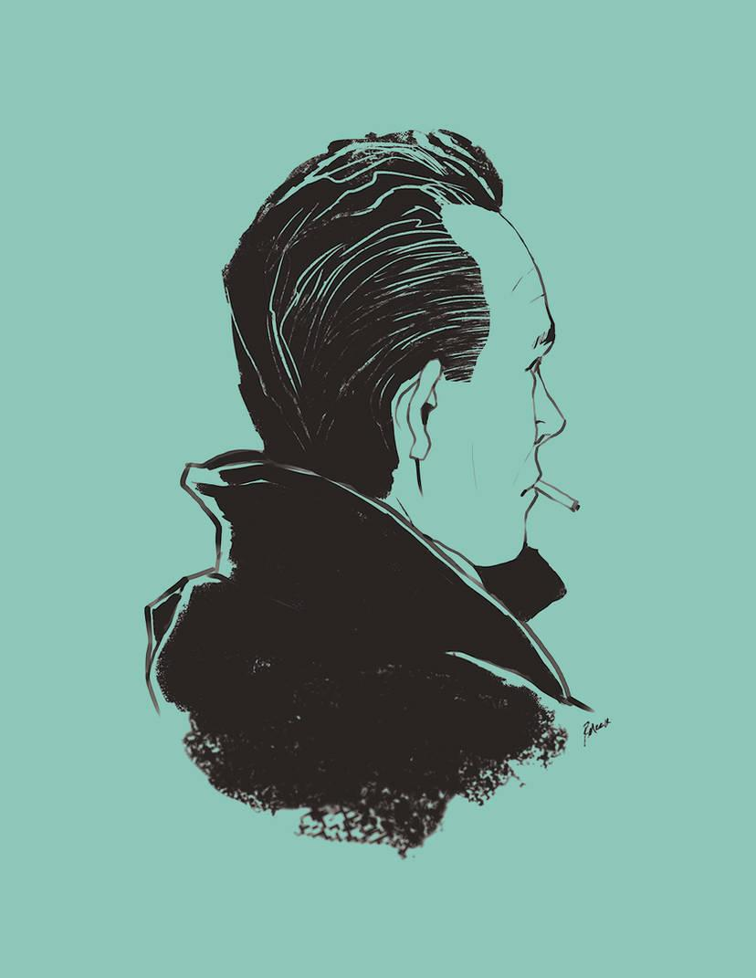
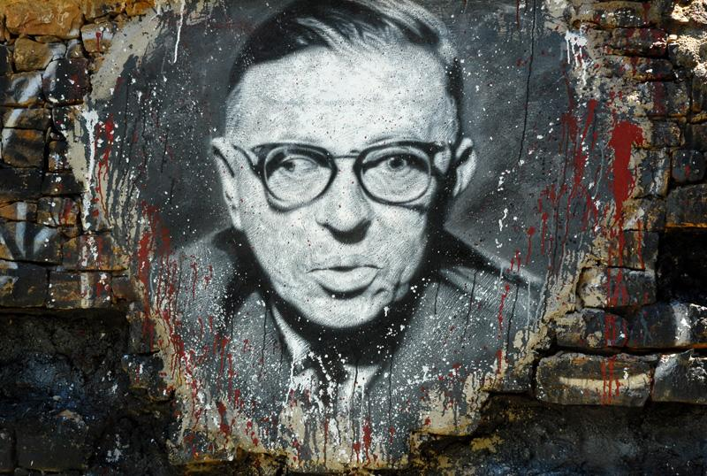
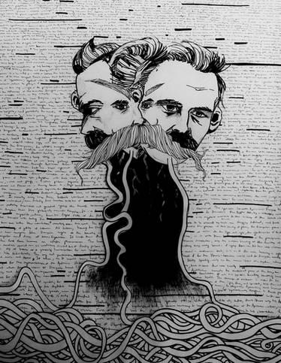

Sources:
DietrichLiao. (2008). Albert Camus. flickr. https://www.flickr.com/photos/mitmensch0812/2513316191.
ehrmann, thierry. (2008). Jean-Paul Sartre, painted portrait - DDC_7519. flickr. https://www.flickr.com/photos/home_of_chaos/2612647693.
fitore. (2023). Fear and Trembling - Soren Kierkegaard. Deviant Art. https://www.deviantart.com/fitore/art/Fear-and-Trembling-Soren-Kierkegaard-989120799.
Hijazo, A. (2019a). Simone de Beauvoir in Beijing 1955. Wikimedia Commons. https://commons.wikimedia.org/wiki/File:Simone_de_Beauvoir_in_Beijing_1955.jpg
Hijazo, A. (2019b). Søren Kierkegaard (1813-1855) - (cropped). Wikimedia Commons. https://en.wikipedia.org/wiki/S%C3%B8ren_Kierkegaard
MRCLD. (2022). Jean Paul Sartre and Simone De Beauvoir welcomed by Avraham Shlonsky and Leah Goldberg (cropped). Flickr - Government Press Office (GPO) - Wikimedia Commons. https://commons.wikimedia.org/wiki/File:Flickr_-_Government_Press_Office_(GPO)_-_Jean_Paul_Sartre_and_Simone_De_Beauvoir_welcomed_by_Avraham_Shlonsky_and_Leah_Goldberg.jpgps
Nietzsche. (n.d.). Deviant Art. https://www.deviantart.com/tag/nietzsche?page=2.
Racconish. (2014). Heidegger 3 (1960). Wikimedia Commons. https://commons.wikimedia.org/wiki/File:Heidegger_3_(1960).jpg
reymonstruo. (2014). Albert Camus 2. Deviant Art. https://www.deviantart.com/reymonstruo/art/Albert-Camus-2-455494350.
triyasisa. (2021). Simone de Beauvoir. Deviant Art. https://www.deviantart.com/tag/simonedebeauvoir
Volpagoe. (2023). Friedrich Wilhelm Nietzsche. Wikimedia Commons. https://commons.m.wikimedia.org/wiki/File:Friedrich_Wilhelm_Nietzsche.jpg.

