IT’S OPTIC-AL GRAPHIC ORGANIZER
Image | It’s OPTIC-al
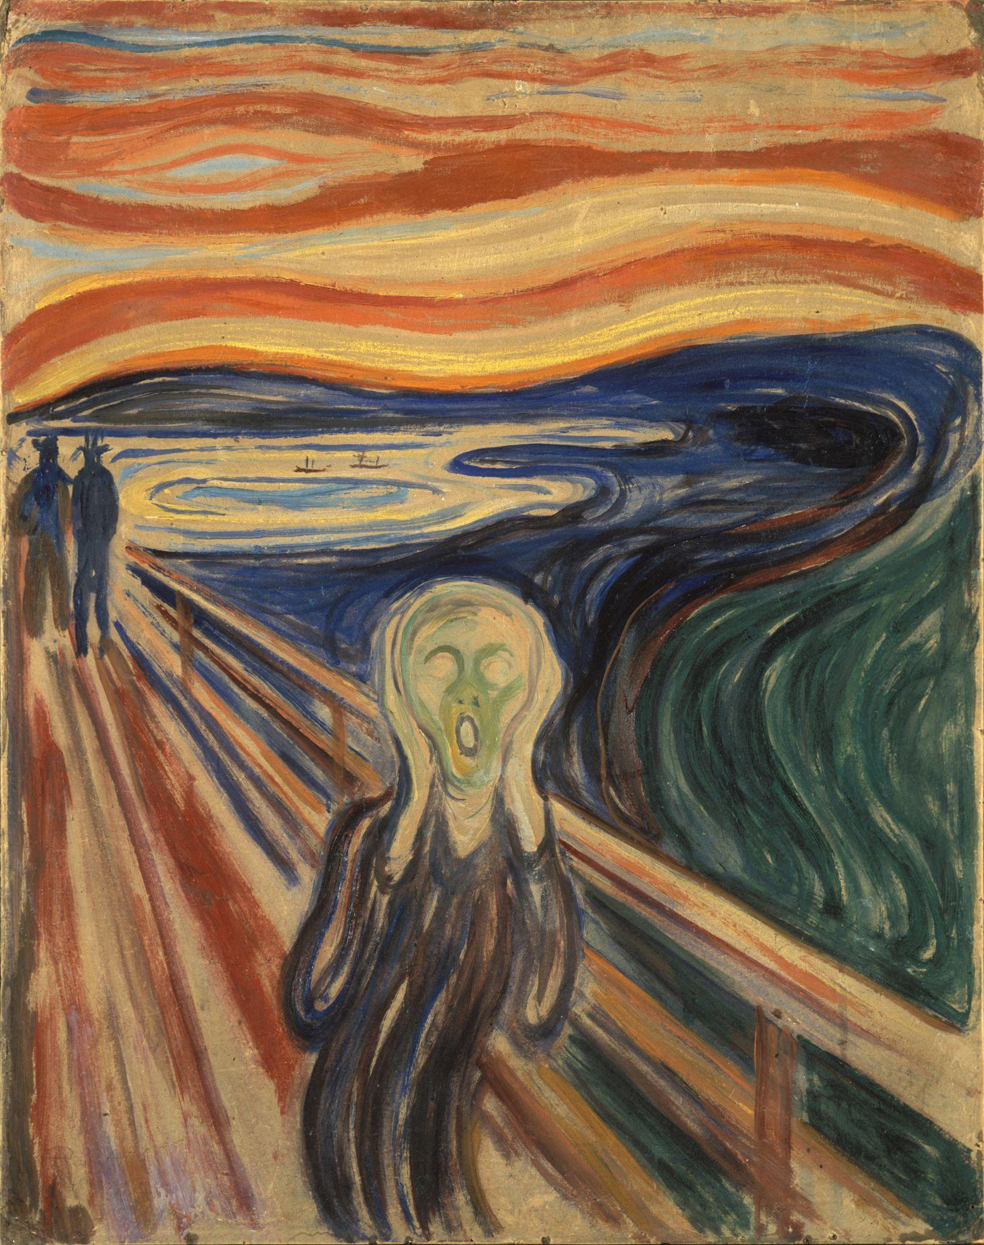  Munch, E. (2021). Edvard Munch - The Scream - Google Art Project. Wikimedia Commons. Retrieved February 2, 2024, from https://commons.wikimedia.org/wiki/File:Edvard_Munch_-_The_Scream_-_Google_Art_Project.jpg. | O  Observations | What do you notice or observe in this piece of art?
 | P  Parts | What are the parts of this artwork? What are the details?
 | T  Title | What does the title tell you about the artwork? How does it relate to what you see?
 | I  Interrelationships | How do the parts of the painting work together to convey the artist’s message?
 | C  Conclusions | What does this artwork convey? What can you tell from the artwork (time period, artist, etc.)?

IT’S OPTIC-AL GRAPHIC ORGANIZER
Image | It’s OPTIC-al
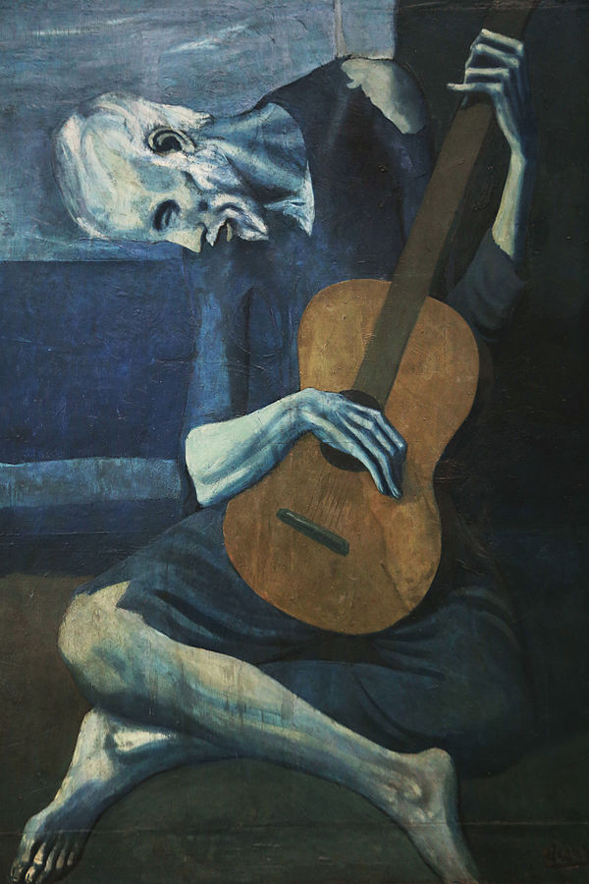  Picasso, P. (1904). The Old guitarist [Online image]. Retrieved June 18, 2020 from https://en.wikipedia.org/wiki/The_Old_Guitarist | O  Observations | What do you notice or observe in this piece of art?
 | P  Parts | What are the parts of this artwork? What are the details?
 | T  Title | What does the title tell you about the artwork? How does it relate to what you see?
 | I  Interrelationships | How do the parts of the painting work together to convey the artist’s message?
 | C  Conclusions | What does this artwork convey? What can you tell from the artwork (time period, artist, etc.)?

IT’S OPTIC-AL GRAPHIC ORGANIZER
Image | It’s OPTIC-al
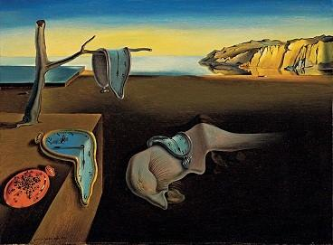  Dali, S. (1931). The Persistence of memory [Online image]. Retrieved June 18, 2020 from https://en.wikipedia.org/wiki/The_Persistence_of_Memory | O  Observations | What do you notice or observe in this piece of art?
 | P  Parts | What are the parts of this artwork? What are the details?
 | T  Title | What does the title tell you about the artwork? How does it relate to what you see?
 | I  Interrelationships | How do the parts of the painting work together to convey the artist’s message?
 | C  Conclusions | What does this artwork convey? What can you tell from the artwork (time period, artist, etc.)?

IT’S OPTIC-AL GRAPHIC ORGANIZER
Image | It’s OPTIC-al
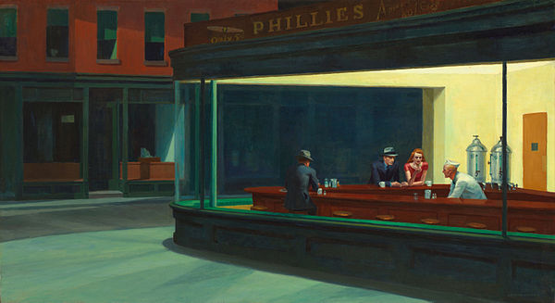  Hopper, E. (1942). Nighthawks [Online image]. Retrieved June 18, 2020 from https://en.wikipedia.org/wiki/Nighthawks_(painting) | O  Observations | What do you notice or observe in this piece of art?
 | P  Parts | What are the parts of this artwork? What are the details?
 | T  Title | What does the title tell you about the artwork? How does it relate to what you see?
 | I  Interrelationships | How do the parts of the painting work together to convey the artist’s message?
 | C  Conclusions | What does this artwork convey? What can you tell from the artwork (time period, artist, etc.)?

IT’S OPTIC-AL GRAPHIC ORGANIZER
Image | It’s OPTIC-al
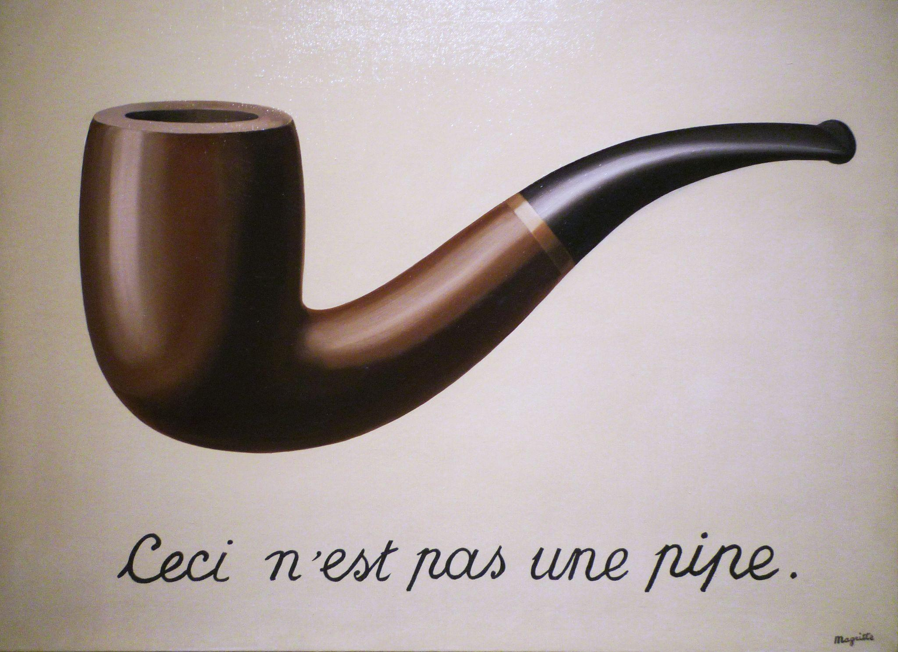  Magritte, R. (2009). Magritte, The Treachery of Images. flickr. Retrieved February 2, 2024, from https://www.flickr.com/photos/profzucker/3320751204. | O  Observations | What do you notice or observe in this piece of art?
 | P  Parts | What are the parts of this artwork? What are the details?
 | T  Title | What does the title tell you about the artwork? How does it relate to what you see?
 | I  Interrelationships | How do the parts of the painting work together to convey the artist’s message?
 | C  Conclusions | What does this artwork convey? What can you tell from the artwork (time period, artist, etc.)?

IT’S OPTIC-AL GRAPHIC ORGANIZER
Image | It’s OPTIC-al
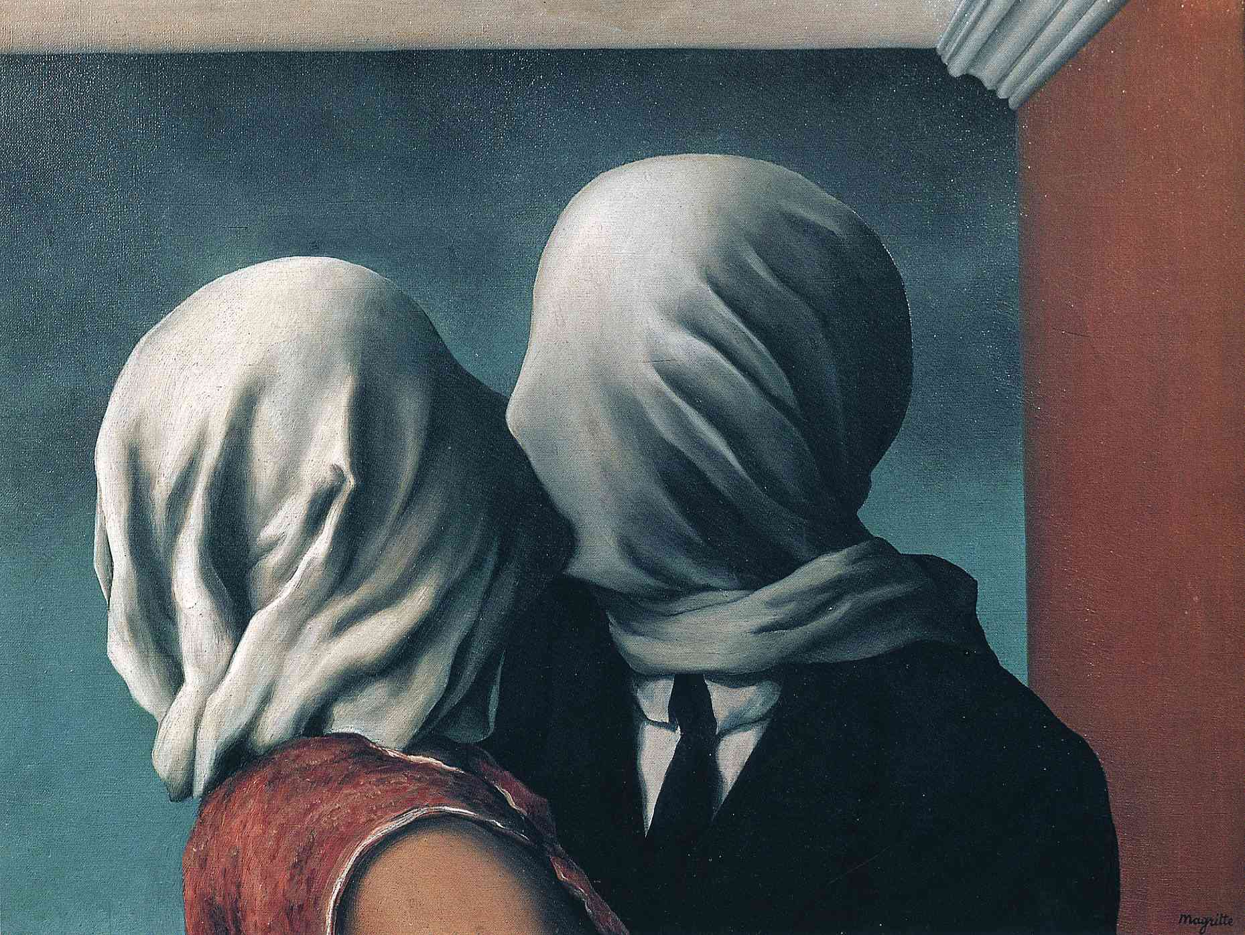  Magritte, R. (2012). René Magritte - The Lovers [1928]. flickr. Retrieved February 2, 2024, from https://www.flickr.com/photos/gandalfsgallery/7341046518. | O  Observations | What do you notice or observe in this piece of art?
 | P  Parts | What are the parts of this artwork? What are the details?
 | T  Title | What does the title tell you about the artwork? How does it relate to what you see?
 | I  Interrelationships | How do the parts of the painting work together to convey the artist’s message?
 | C  Conclusions | What does this artwork convey? What can you tell from the artwork (time period, artist, etc.)?

IT’S OPTIC-AL GRAPHIC ORGANIZER
Image | It’s OPTIC-al
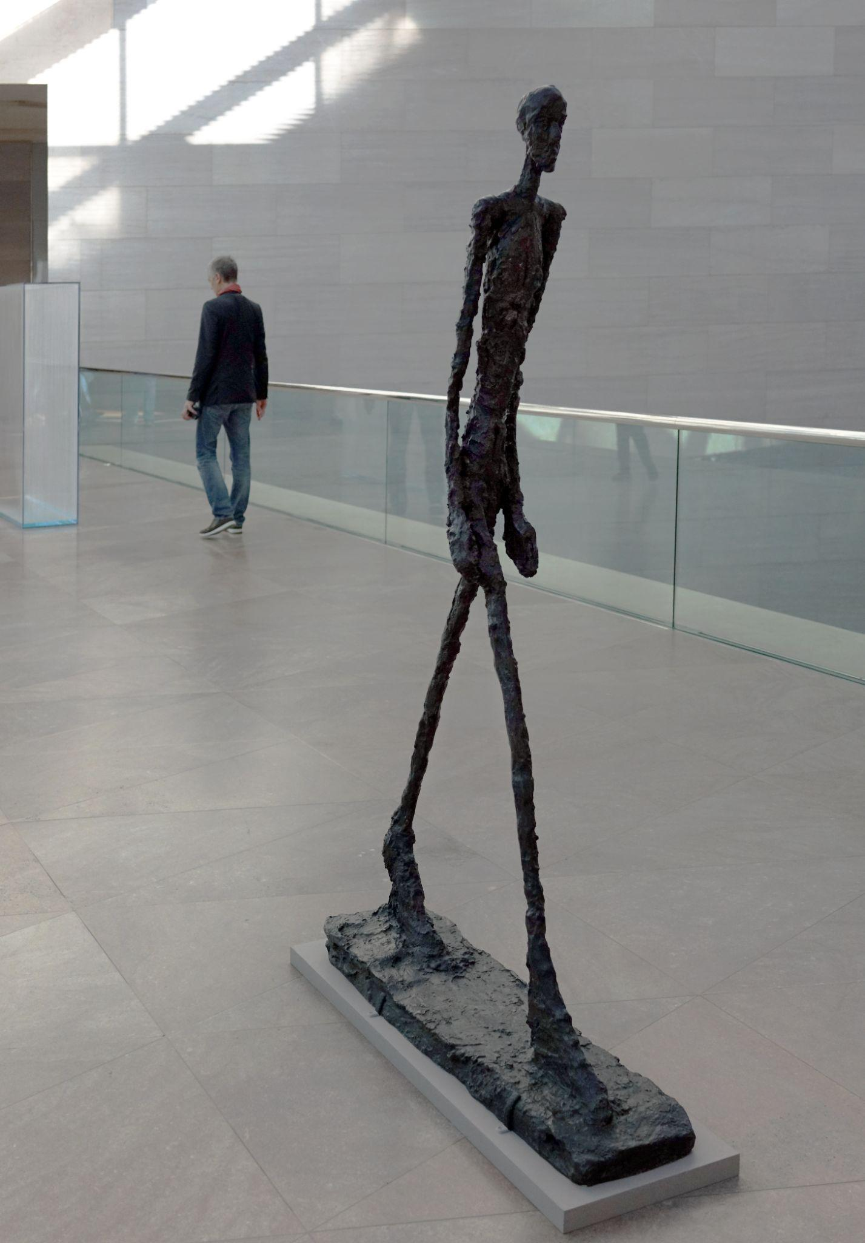  Giacometti, A. (2018). Giacometti, Walking Man II. flickr. Retrieved February 2, 2024, from https://www.flickr.com/photos/profzucker/39022546625. | O  Observations | What do you notice or observe in this piece of art?
 | P  Parts | What are the parts of this artwork? What are the details?
 | T  Title | What does the title tell you about the artwork? How does it relate to what you see?
 | I  Interrelationships | How do the parts of the painting work together to convey the artist’s message?
 | C  Conclusions | What does this artwork convey? What can you tell from the artwork (time period, artist, etc.)?

