PIGS AND SEMICOLONS

Excerpt from Lewis Carroll’s Alice in Wonderland
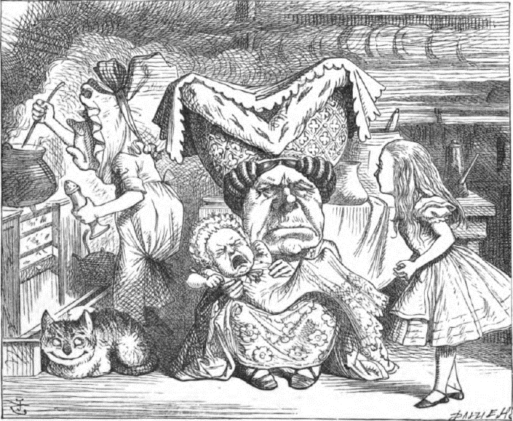
The door led right into a large kitchen, which was full of smoke from one end to the other: the Duchess was sitting on a three-legged stool in the middle, nursing a baby; the cook was leaning over the fire, stirring a large cauldron which seemed to be full of soup.
"There's certainly too much pepper in that soup!" Alice said to herself, as well as she could for sneezing.
There was certainly too much of it in the air. Even the Duchess sneezed occasionally; and as for the baby, it was sneezing and howling alternately without a moment's pause. The only two creatures in the kitchen that did not sneeze, were the cook, and a large cat which was sitting on the hearth and grinning from ear to ear.
"Please would you tell me," said Alice, a little timidly, for she was not quite sure whether it was good manners for her to speak first, "why your cat grins like that?"
"It's a Cheshire cat," said the Duchess, "and that's why. Pig!"
She said the last word with such sudden violence that Alice quite jumped; but she saw in another moment that it was addressed to the baby, and not to her, so she took courage, and went on again:—
"I didn't know that Cheshire cats always grinned; in fact, I didn't know that cats could grin."
"They all can," said the Duchess; "and most of 'em do."

"I don't know of any that do," Alice said very politely, feeling quite pleased to have got into a conversation.
"You don't know much," said the Duchess; "and that's a fact."
Alice did not at all like the tone of this remark, and thought it would be as well to introduce some other subject of conversation. While she was trying to fix on one, the cook took the cauldron of soup off the fire, and at once set to work throwing everything within her reach at the Duchess and the baby—the fireirons came first; then followed a shower of saucepans, plates, and dishes. The Duchess took no notice of them even when they hit her; and the baby was howling so much already, that it was quite impossible to say whether the blows hurt it or not.
"Oh, please mind what you're doing!" cried Alice, jumping up and down in an agony of terror. "Oh, there goes his precious nose!" as an unusually large saucepan flew close by it, and very nearly carried it off.
"If everybody minded their own business," the Duchess said in a hoarse growl, "the world would go round a deal faster than it does."
"Which would not be an advantage," said Alice, who felt very glad to get an opportunity of showing off a little of her knowledge. "Just think what work it would make with the day and night! You see the earth takes twenty-four hours to turn round on its axis—"
"Talking of axes," said the Duchess, "chop off her head!"
Alice glanced rather anxiously at the cook, to see if she meant to take the hint; but the cook was busily stirring the soup, and seemed not to be listening, so she went on again: "'Twenty-four hours, I think; or is it twelve? I—"
"Oh, don't bother me," said the Duchess; "I never could abide figures!" And with that she
began nursing her child again, singing a sort of lullaby to it as she did so, and giving it a violent shake at the end of every line:—
"Speak roughly to your little boy,
And beat him when he sneezes:
He only does it to annoy,
Because he knows it teases."
CHORUS.
(In which the cook and the baby joined):—
"Wow! wow! wow!"
While the Duchess sang the second verse of the song, she kept tossing the baby violently up and down, and the poor little thing howled so, that Alice could hardly hear the words:—
"I speak severely to my boy,
I beat him when he sneezes;
For he can thoroughly enjoy
The pepper when he pleases!"
CHORUS.
"Wow! wow! wow!"
"Here! you may nurse it a bit, if you like!" the Duchess said to Alice, flinging the baby at her as she spoke. "I must go and get ready to play croquet with the Queen," and she hurried out of the room. The cook threw a frying-pan after her as she went, but it just missed her.
Alice caught the baby with some difficulty, as it was a queer-shaped little creature, and held out its arms and legs in all directions, "just like a star-fish," thought Alice. The poor little thing was snorting like a steam-engine when she caught it, and kept doubling itself up and straightening itself out again, so that altogether, for the first minute or two, it was as much as she could do to hold it.
As soon as she had made out the proper way of nursing it, (which was to twist it up into a sort of knot, and then keep tight hold of its right ear and left foot, so as to prevent its undoing itself,) she carried it out into the open air. "If I don’t take this child away with me," thought Alice, "they’re sure to kill it in a day or two: wouldn’t it be murder to leave it behind?" She said the last words out loud, and the little thing grunted in reply (it had left off sneezing by this time). "Don’t grunt," said Alice; "that’s not at all a proper way of expressing yourself."
The baby grunted again, and Alice looked very anxiously into its face to see what was the matter with it. There could be no doubt that it had a very turn-up nose, much more like a snout than a real nose; also its eyes were getting extremely small for a baby: altogether Alice did not like the look of the thing at all. "But perhaps it was only sobbing," she thought, and looked into its eyes again, to see if there were any tears.
No, there were no tears. "If you’re going to turn into a pig, my dear," said Alice, seriously, "I’ll have nothing more to do with you. Mind now!" The poor little thing sobbed again (or grunted, it was impossible to say which), and they went on for some while in silence.
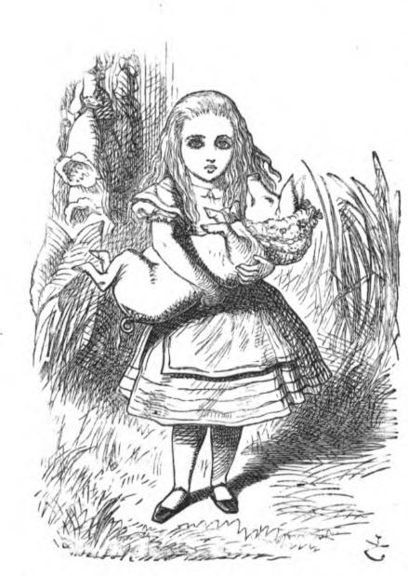
Alice was just beginning to think to herself, "Now, what am I to do with this creature when I get it home?" when it grunted again, so violently, that she looked down into its face in some alarm. This time there could be no mistake about it: it was neither more nor less than a pig, and she felt that it would be quite absurd for her to carry it any further.
So she set the little creature down, and felt quite relieved to see it trot away quietly into the wood. "If it had grown up," she said to herself, "it would have made a dreadfully ugly child: but it makes rather a handsome pig, I think."

Source

Carroll, L. (1869). Alice’s Adventures in Wonderland. [Excerpt]. MacMillan and Co. http://dbooks.bodleian.ox.ac.uk/books/PDFs/590306858.pdf

