Understanding ADSR in Music Production
ADSR is a term used in the world of music production as well as in the area of music synthesis. While it is possible to use ADSR tools without knowing the context behind them and arrive at one’s desired sound, if you have an understanding of what is happening behind the scenes, it can help you achieve the desired results more quickly.

What is ADSR?
ADSR refers to a type of “envelope.” Envelopes are a way to modulate or change any part of the signal path (Mantione, 2017), but for our purposes we will be focusing on “amplitude envelopes,” which have an effect on the perceived loudness of a signal. ADSR is an acronym for Attack, Decay, Sustain, and Release.

But what do those terms mean?

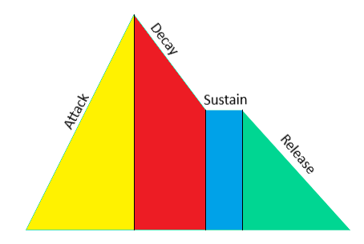
- “Attack: Sets the time it takes for the signal to rise from an amplitude of 0 to 100% (full amplitude).
- Decay: Sets the time it takes for the signal to fall from 100% amplitude to the designated sustain level.
- Sustain: Sets the steady amplitude level produced when a [note] is held down.
- Release: Sets the time it takes for the sound to decay from the sustain level to an amplitude of 0 when the [note] is released” (Apple, 2020).

References:
Apple Support. (2020). Attack, decay, sustain, and release. https://support.apple.com/guide/logicpro/attack-decay-sustain-and-release-lgsife419620/mac
Mantione, P. (2017, July 16). Synth envelopes 101: Attack, decay, sustain, release (ADSR). Pro Audio Files. https://theproaudiofiles.com/synthesis-101-envelope-parameters-uses/

