H CHART

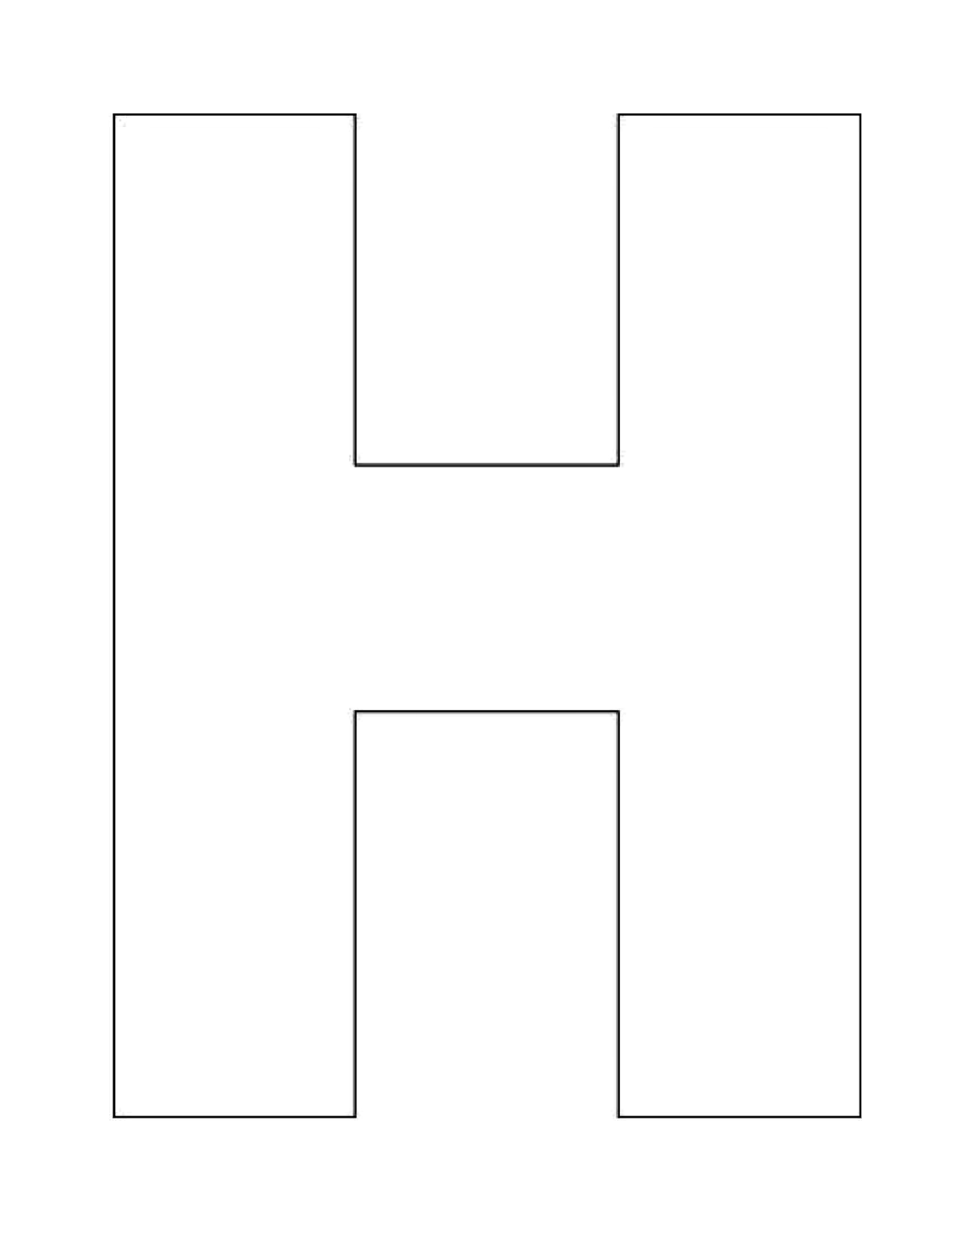



Texts Together

Separate Text
Separate Text

