# H CHART

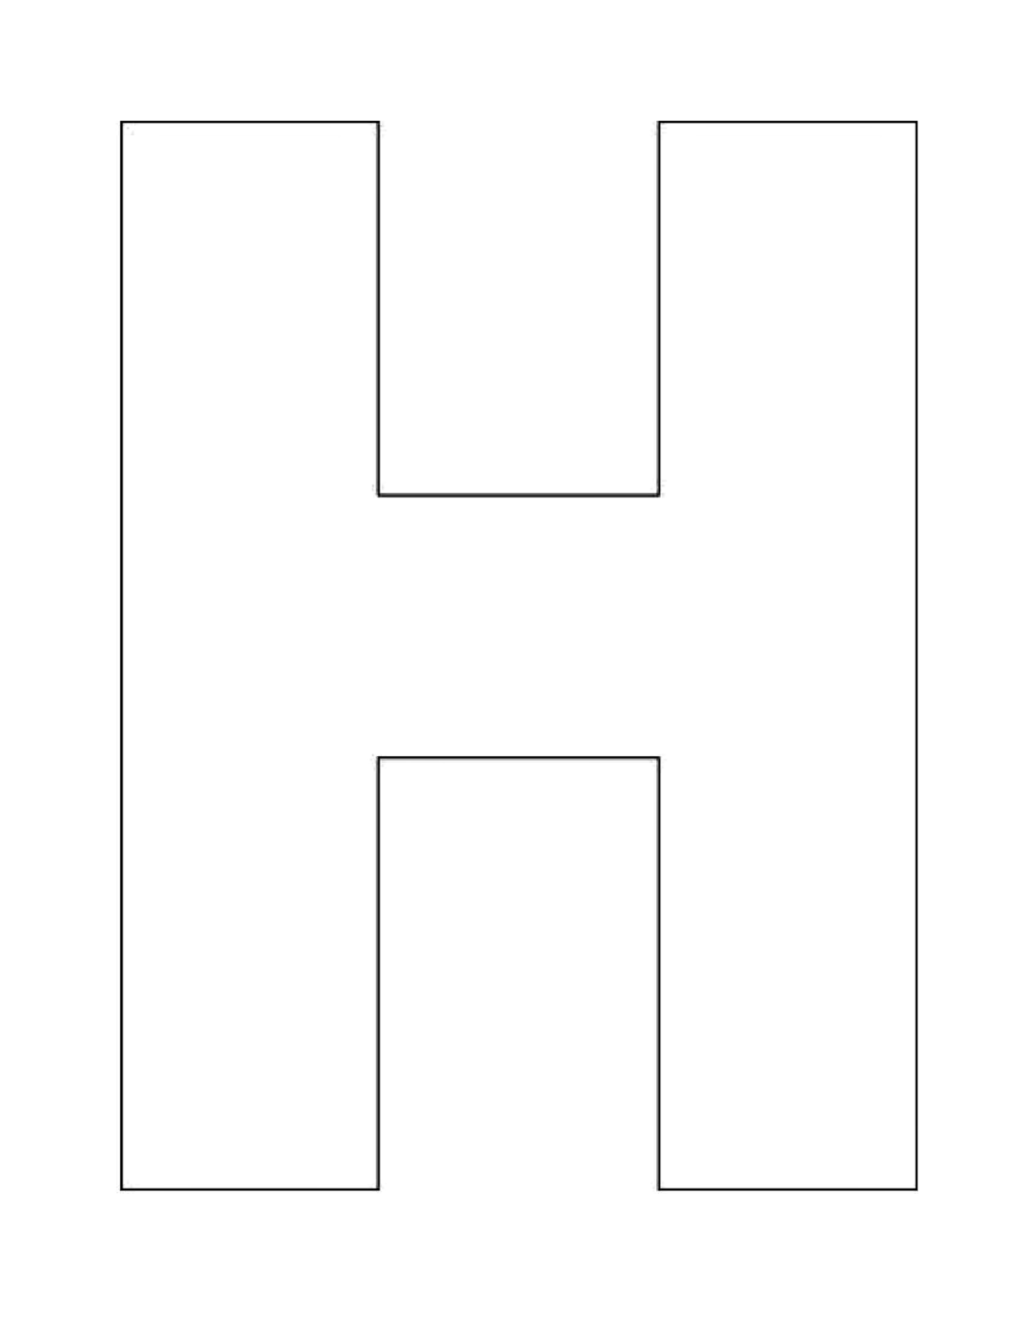

Texts Together

Separate Text

Separate Text