PINTANDO UNA IMAGEN PAQUETE DE documentOS
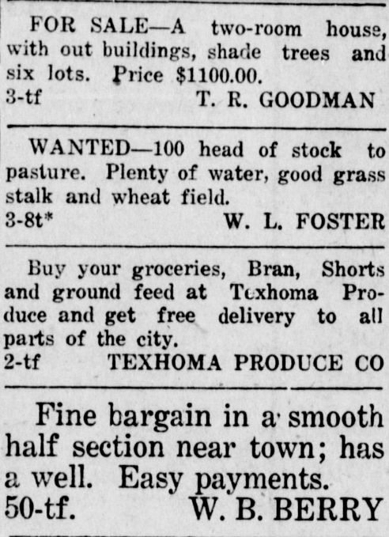
Anuncios de 1920
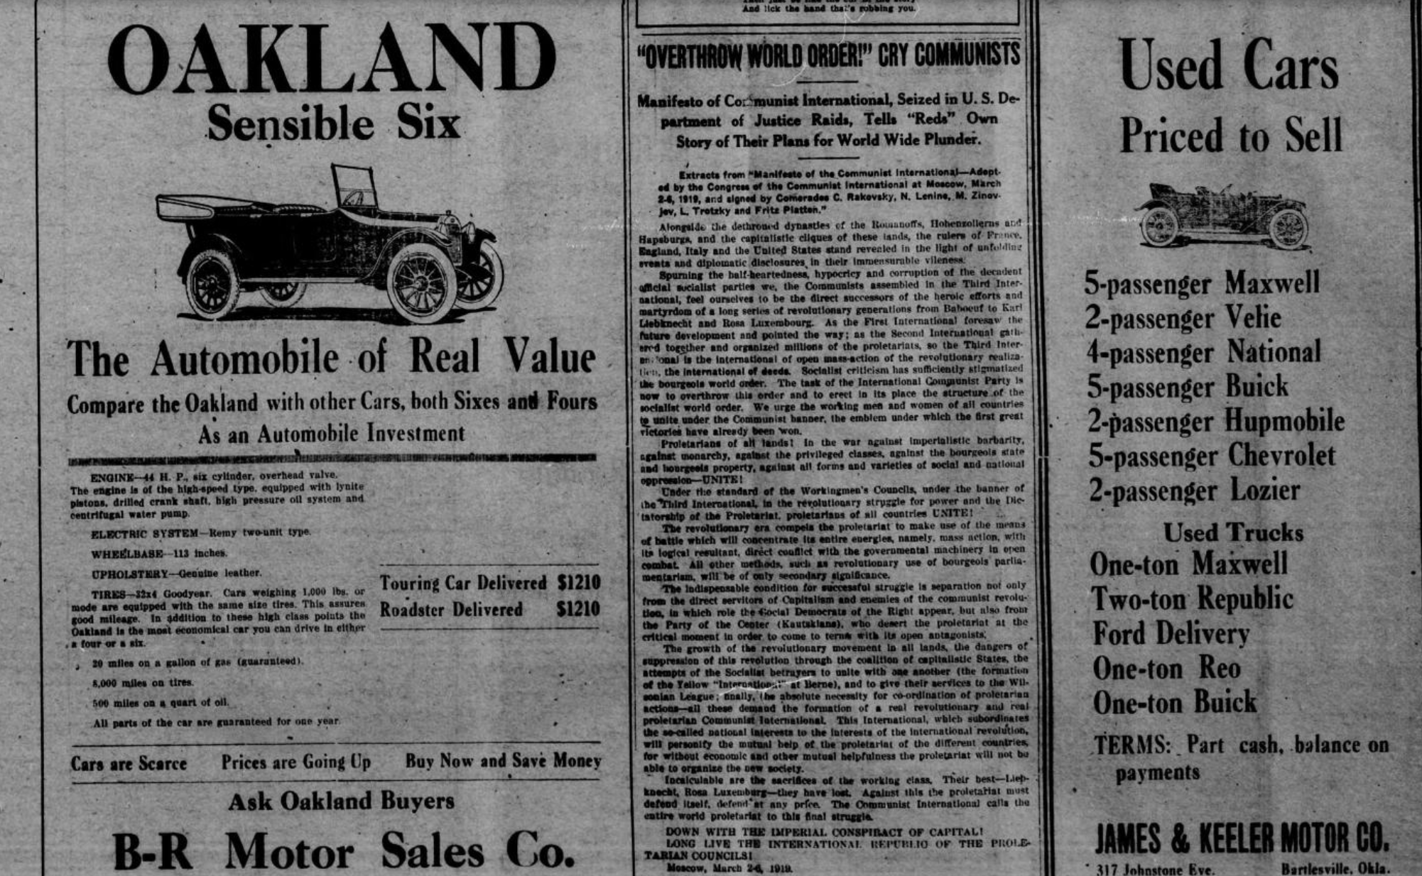

Fuentes:
Oklahoma Historical Society. (s.f.). The Gateway to Oklahoma History. Dewey Globe (Dewey, Okla.), Vol. 10, No. 8, Ed. 1. Viernes, 27 de febrero de 1920. Página: 5 de 8. https://gateway.okhistory.org/ark:/67531/metadc950518/m1/5/?q=dewey%20globe%20february%2027%201920
Oklahoma Historical Society. (s.f.). The Gateway to Oklahoma History. The Texhoma Times (Texhoma, Okla.), Ed. 1. Viernes, 15 de octubre de 1920. Página: 4 de 8. https://gateway.okhistory.org/ark:/67531/metapth350892/m1/4/?q=texhoma%20times%20october%2015,%201920

Anuncios de 1930
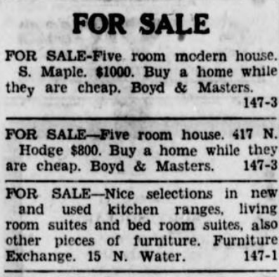
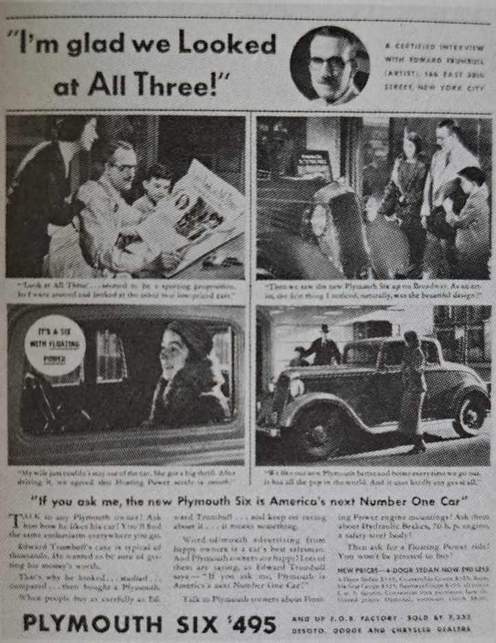
Fuentes:
Marchand, R. (1985). Advertising the American dream. University of California Press.
Oklahoma Historical Society. (s.f.). The Gateway to Oklahoma History. Sapulpa Herald (Sapulpa, Okla.), Vol. 16, No. 147, Ed. 1. Lunes, 24 de febrero de 1930. Página: 5 de 6. https://gateway.okhistory.org/ark:/67531/metadc1524013/m1/5/?q=sapulpa%20herald%20february%2024%201930

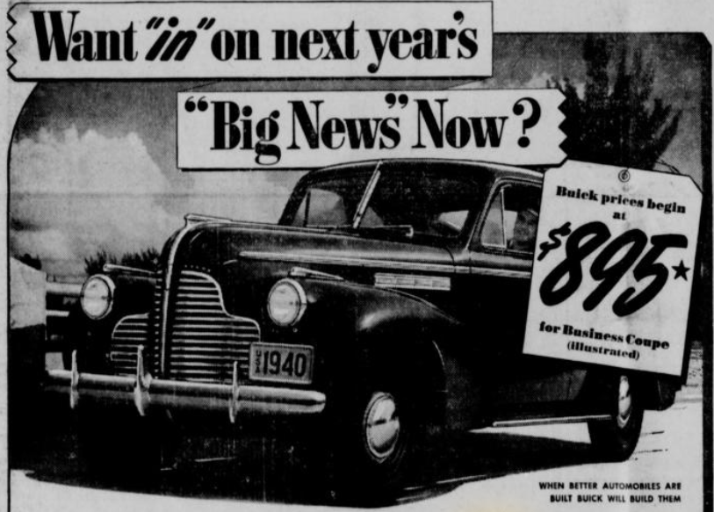
Anuncios de 1940

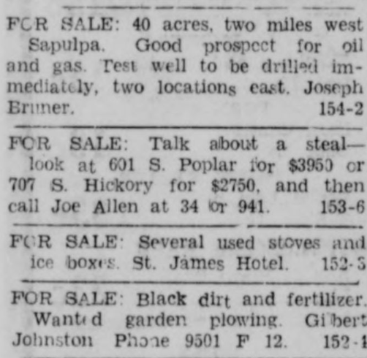

Fuentes:
Oklahoma Historical Society. (s.f.). The Gateway to Oklahoma History. Sapulpa Herald (Sapulpa, Okla.), Vol. 25, No. 189, Ed. 1. Viernes, 12 de abril de 1940. Página: 8 de 8. https://gateway.okhistory.org/ark:/67531/metadc1524318/m1/8/?q=sapulpa%20herald%20april%2012%201940
Oklahoma Historical Society. (s.f.). The Gateway to Oklahoma History. Sapulpa Herald (Sapulpa, Okla.), Vol. 25, No. 153, Ed. 1. Viernes, 1 de marzo de 1940. Página: 7 de 8. https://gateway.okhistory.org/ark:/67531/metadc1528642/m1/7/?q=sapulpa%20herald%20march%201%201940

