Painting a picture document packet – It’s a Wonderful Life
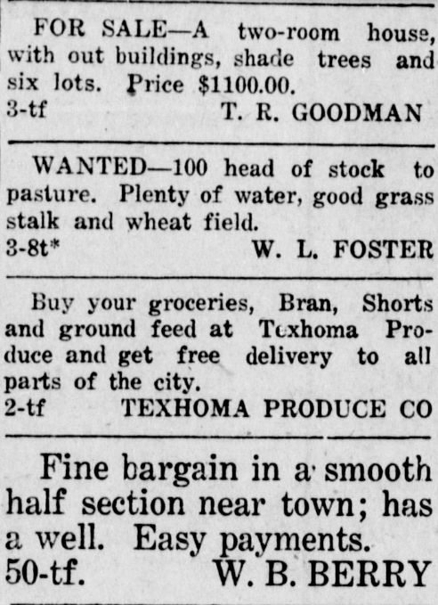
1920s Ads
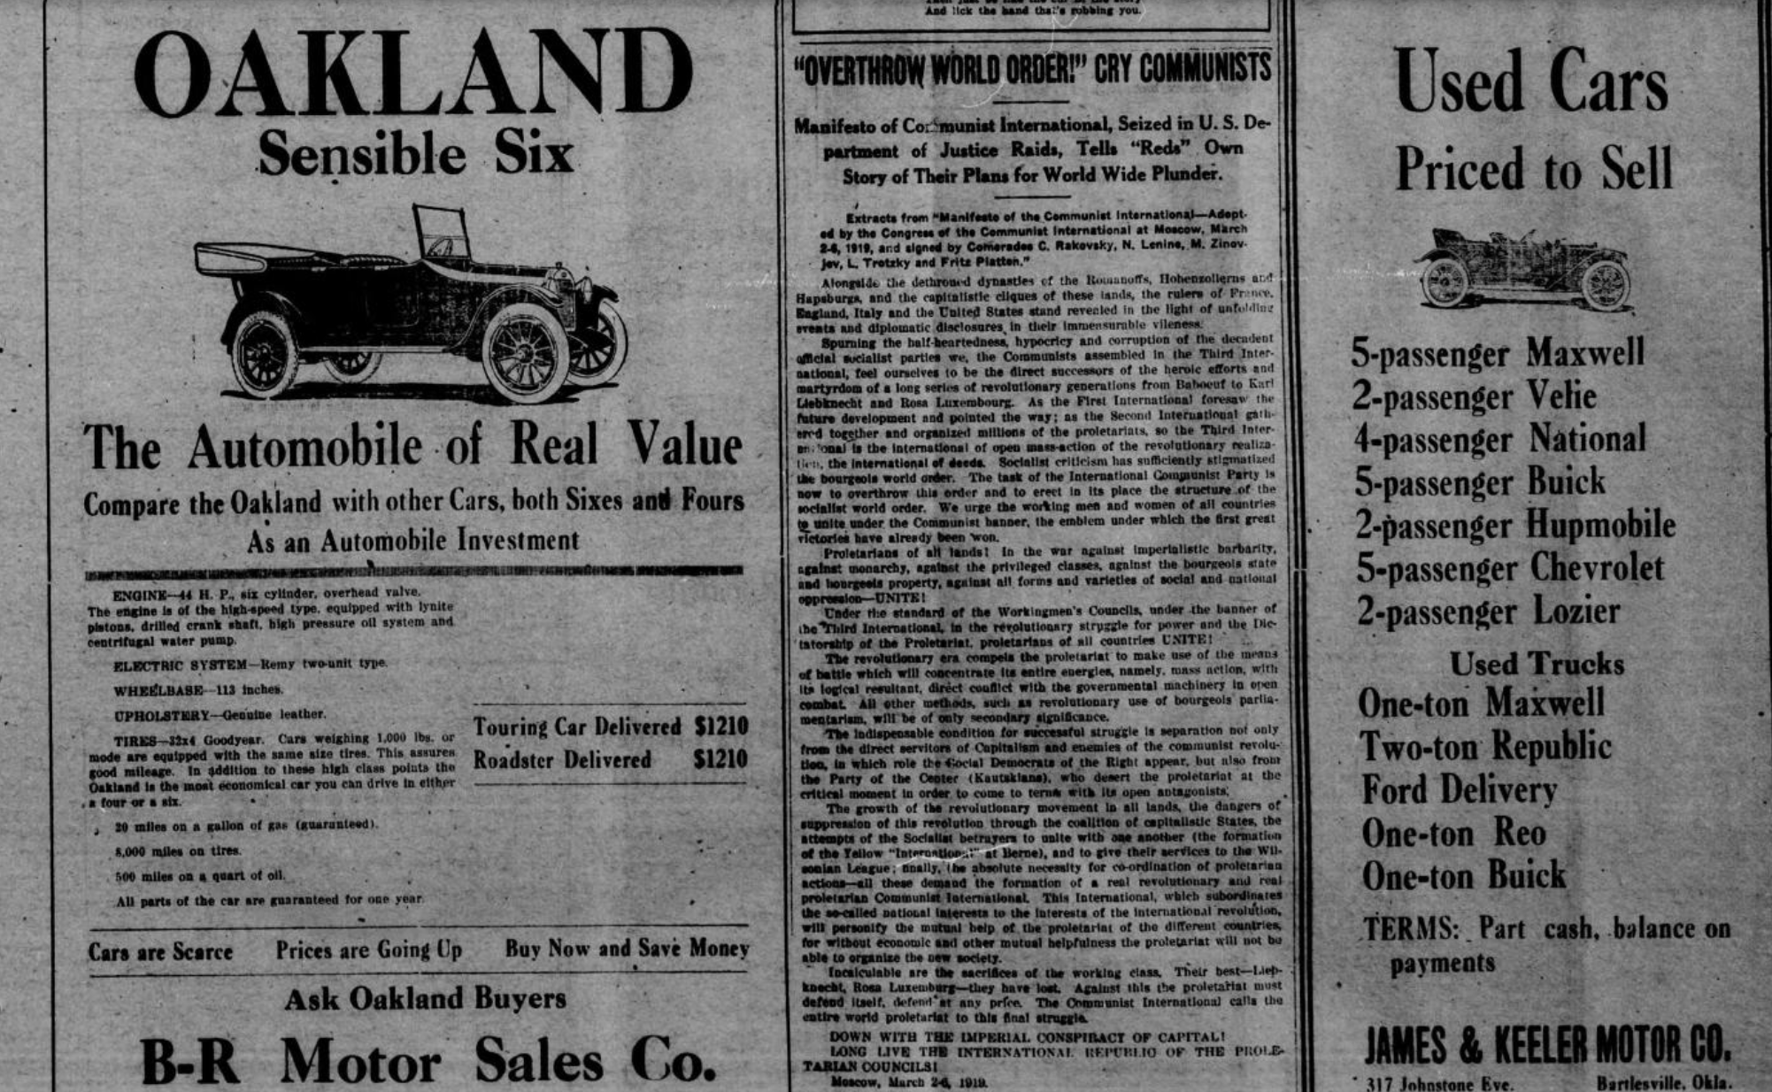

Sources:
Oklahoma Historical Society. (n.d.). The Gateway to Oklahoma History. Dewey Globe (Dewey, Okla.), Vol. 10, No. 8, Ed. 1. Friday, February 27, 1920. Page: 5 of 8. https://gateway.okhistory.org/ark:/67531/metadc950518/m1/5/?q=dewey%20globe%20february%2027%201920
Oklahoma Historical Society. (n.d.). The Gateway to Oklahoma History. The Texhoma Times (Texhoma, Okla.), Ed. 1. Friday, October 15, 1920. Page: 4 of 8. https://gateway.okhistory.org/ark:/67531/metapth350892/m1/4/?q=texhoma%20times%20october%2015,%201920

1930s Ads
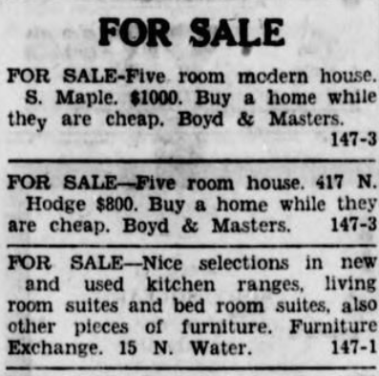
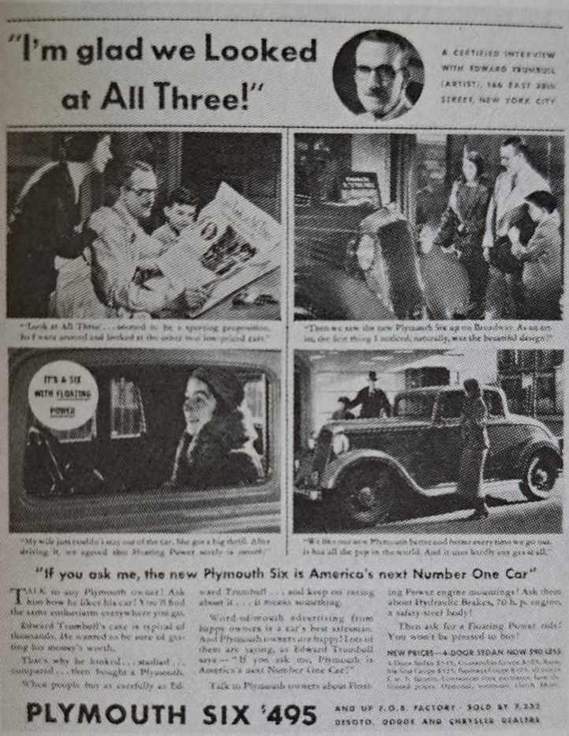
Sources:
Marchand, R. (1985). Advertising the American dream. University of California Press.
Oklahoma Historical Society. (n.d.). The Gateway to Oklahoma History. Sapulpa Herald (Sapulpa, Okla.), Vol. 16, No. 147, Ed. 1. Monday, February 24, 1930. Page: 5 of 6. https://gateway.okhistory.org/ark:/67531/metadc1524013/m1/5/?q=sapulpa%20herald%20february%2024%201930

1940s Ads

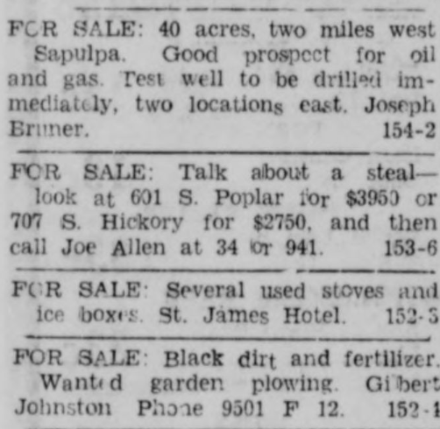

Sources:
Oklahoma Historical Society. (n.d.). The Gateway to Oklahoma History. Sapulpa Herald (Sapulpa, Okla.), Vol. 25, No. 189, Ed. 1 Friday, April 12, 1940. Page: 8 of 8. https://gateway.okhistory.org/ark:/67531/metadc1524318/m1/8/?q=sapulpa%20herald%20april%2012%201940
Oklahoma Historical Society. (n.d.). The Gateway to Oklahoma History. Sapulpa Herald (Sapulpa, Okla.), Vol. 25, No. 153, Ed. 1. Friday, March 1, 1940. Page: 7 of 8. https://gateway.okhistory.org/ark:/67531/metadc1528642/m1/7/?q=sapulpa%20herald%20march%201%201940

