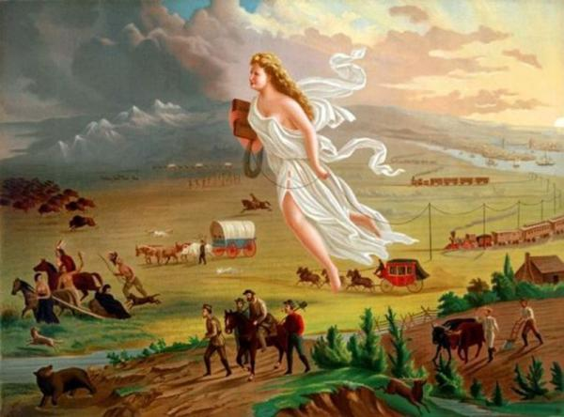
“American Progress”
By John Gast, 1872
In your mind, divide the painting into four equal sections.

- Describe what is happening in your section of the painting.
- What does each of the figures represent?
- Some parts of the painting are dark and some are light. What does this "light" and "dark" imply?
- What does the artist want you to notice, think, and feel?
- What do you know about this time period?

