BOB DYLAN | THE TIMES THEY ARE A-CHANGIN
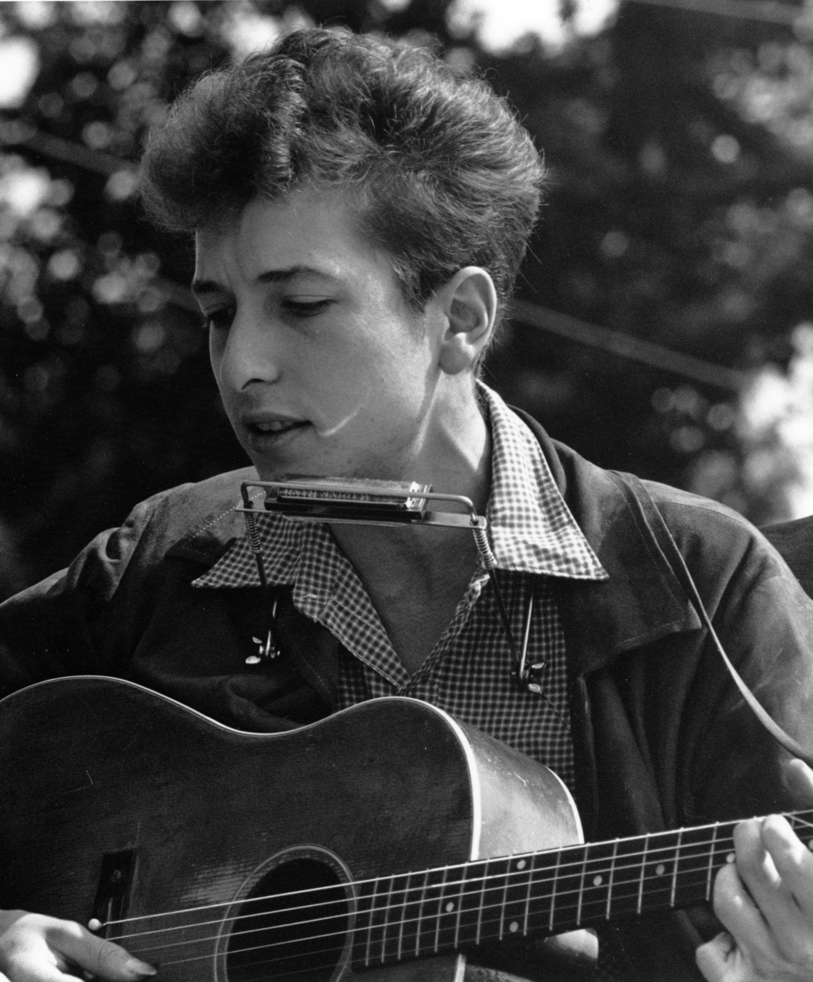
- Born in Duluth, Minnesota in 1941 as Robert Allen Zimmerman  - Began performing in Greenwich Village coffeehouses in 1962  - Inducted into the Rock and Roll Hall of Fame in 1988 by Bruce Springsteen  - During his induction into the Rock and Roll Hall of Fame, he was introduced as, “one of the greatest songwriters of all time, a gifted wordsmith with a political conscience, incisive storytelling abilities and a poet-like acumen for meter and language.” | http://k20.ou.edu/Dylan1  - Highly thought of as his most popular and best crafted song  - Shortly after the song was released, President Kennedy was assassinated. After this, Dylan avoided performing the song.  - In 1965 the song became a favorite of students and pop audiences who heard the lyrics as a statement of the ever-widening generation gap.  - The song was adopted by the civil rights movement, as well.
BOB DYLAN | ALL ALONG THE WATCHTOWER
- Born in Duluth, Minnesota in 1941 as Robert Allen Zimmerman  - Began performing in Greenwich Village coffeehouses in 1962  - Inducted into the Rock and Roll Hall of Fame in 1988 by Bruce Springsteen  - During his induction into the Rock and Roll Hall of Fame, he was introduced as, “one of the greatest songwriters of all time, a gifted wordsmith with a political conscience, incisive storytelling abilities and a poet-like acumen for meter and language.” | http://k20.ou.edu/Dylan2  - The original version showcases the song’s inherent drama and dread.  - Tells a story of the joker and the thief sharing perspectives about the dire world and its perils  - The song seems to tell us that there is no room for callous consumerism.  - The thief is symbolic of the virtue of forgiveness.  - Provides a message of forgiveness through hope

BOB DYLAN | MASTERS OF WAR
- Born in Duluth, Minnesota in 1941 as Robert Allen Zimmerman  - Began performing in Greenwich Village coffeehouses in 1962  - Inducted into the Rock and Roll Hall of Fame in 1988 by Bruce Springsteen  - During his induction into the Rock and Roll Hall of Fame, he was introduced as, “one of the greatest songwriters of all time, a gifted wordsmith with a political conscience, incisive storytelling abilities and a poet-like acumen for meter and language.” | http://k20.ou.edu/Dylan3  - “Masters of War” (1963) was a more direct protest than his other songs.  - The lyrics implied that people with power in the government are at fault for the atrocities of war and all the unnecessary spilling of blood.

CREEDENCE CLEARWATER REVIVAL | FORTUNATE SON
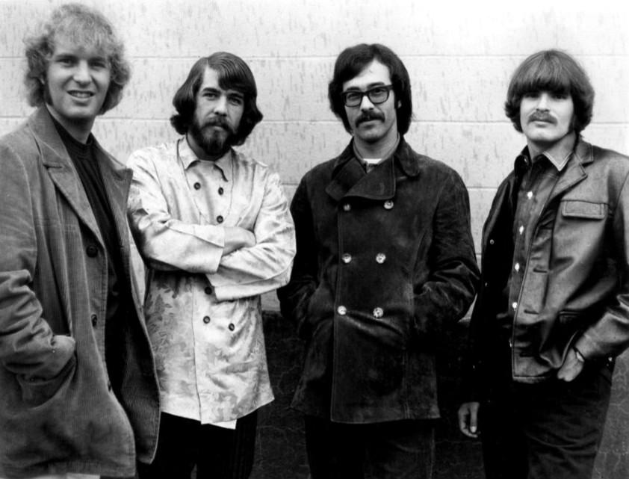 | http://k20.ou.edu/CCR
- An American Rock Band formed in El Cerrito California, made up of brothers John and Tom Fogerty, Doug Clifford, and Stu Cook  - Inducted into the Rock and Roll Hall of Fame in 1993 by Bruce Springsteen  - During their induction into the Rock and Roll Hall of Fame, they were introduced as a band that “cranked out hit after hit, proving themselves to be a timeless talent with enduring popularity. At a time when prog rock dominated the San Francisco music scene, Creedence Clearwater Revival’s roots rock was an offbeat standout. Their country sensibility made them possibly the most popular band in America, with nine Top Ten singles in three years.” | - "Fortunate Son" (1969) was the only popular antiwar song of the 1960s to observe that the sons of the working class were more likely to be drafted than the sons of the privileged.  - During Vietnam, college students were able to defer their service because their education was deemed to be in the national interest by the federal government. Much of the anger around the draft centered around the number of deferments that were allowed.  - The marriage between President Nixon’s daughter and President Eisenhower’s grandson inspired John Fogerty of Creedence Clearwater Revival to write the song as a commentary on the increasing gap between the “haves and have-nots.”

CROSBY, STILLS, NASH AND YOUNG | OHIO
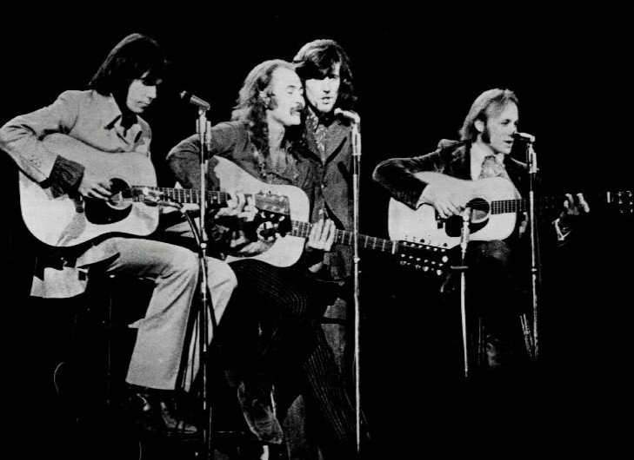
- A “supergroup” formed in 1968 by already revered performers  - David Crosby (the Byrds)  - Stephen Stills and Neil Young (Buffalo Springfield)  - Graham Nash (The Hollies)  - Neil Young was inducted into the Rock and Roll Hall of Fame in 1995 and again in 1997 with bandmate, Stephen Stills for their work in the band Buffalo Springfield.  - Crosby, Stills, and Nash were inducted into the Rock and Roll Hall of Fame in 1997 by James Taylor.  - During their induction into the Rock and Roll Hall of Fame, they were introduced as “the voice of a generation [that] sang in impeccable three-part harmony. Crosby, Stills and Nash took a thoughtful, song-centric approach to music, penning folk hits with messages of change, hope and forward motion.” | http://k20.ou.edu/CSNY  - “Ohio” (1970) was written and recorded in the wake of the Kent State University shooting, in which four people were killed and nine were seriously injured at an anti-Vietnam protest.  - At the time, many Americans believed the protesters were at fault, but Neil Young asked those who faulted the protesters, “what if you knew her?/And found her dead on the ground?”  - "I remember getting nuts at the end of the song, I was so moved," Crosby told Young's biographer Jimmy McDonough. "I was freaked out because I felt it so strongly, screaming, 'Why? Why?'"

JOHN LENNON | IMAGINE
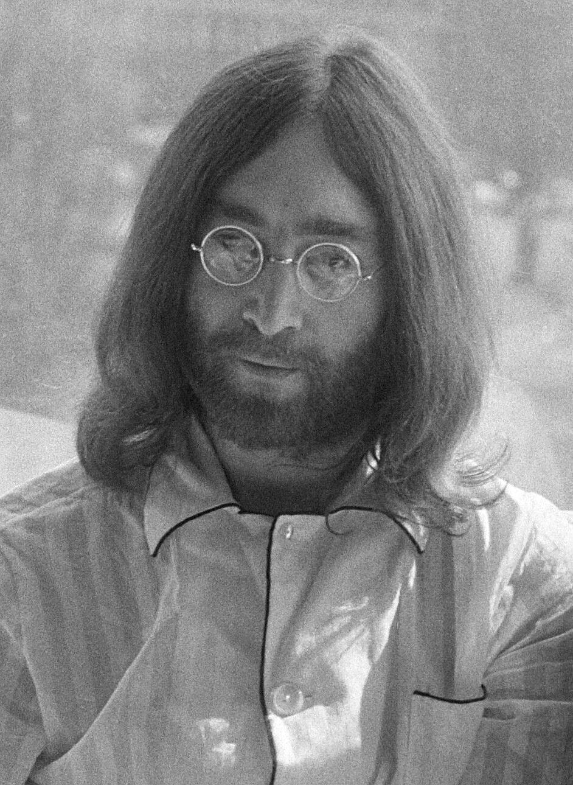
- Born in 1940 in Liverpool, England  - Founder of the English rock band, The Beatles  - Inducted into the Rock and Roll Hall of Fame in 1988 with The Beatles by Mick Jagger then again in 1994 by Paul McCartney  - During their induction into the Rock and Roll Hall of Fame, they were introduced as a band that “spoke to a younger generation and ushered in a modern era of rock & roll where experimentation, transformation and taboo topics became de rigueur.”  - McCartney later said that Lennon was “never content with the status quo, Lennon then launched a solo career marked by experimentation, political activism, embrace of the counterculture and more enduring songs.” | http://k20.ou.edu/Lennon1  - Written in March 1971, “Imagine” has become a permanent protest song and a lasting emblem of hope.  - Lennon described the song as an ad campaign for peace.  - In December 1980, Lennon shared that a prayer book inspired him. “The concept of positive prayer…If you can imagine a world at peace, with no denominations of religion – not without religion but without this my God-is-bigger-than-your-God thing – then it can be true.”

JOHN LENNON | GIVE PEACE A CHANCE
- Born in 1940 in Liverpool, England  - Founder of the English rock band, The Beatles  - Inducted into the Rock and Roll Hall of Fame in 1988 with The Beatles by Mick Jagger then again in 1994 by Paul McCartney  - During their induction into the Rock and Roll Hall of Fame, they were introduced as a band that “spoke to a younger generation and ushered in a modern era of rock & roll where experimentation, transformation and taboo topics became de rigueur.”  - McCartney later said that Lennon was “never content with the status quo; Lennon then launched a solo career marked by experimentation, political activism, embrace of the counterculture and more enduring songs.” | http://k20.ou.edu/Lennon2  - Written and recorded in June 1969 during a “bed-in” with his wife Yoko Ono  - A “bed-in” was a way to protest war and promote peace by staying in bed all day.  - Week-long protest  - The phrase “give peace a chance” came to Lennon during an interview.  - Became an anthem of the anti-Vietnam war and counterculture movements

BARRY MCGUIRE | EVE OF DESTRUCTION
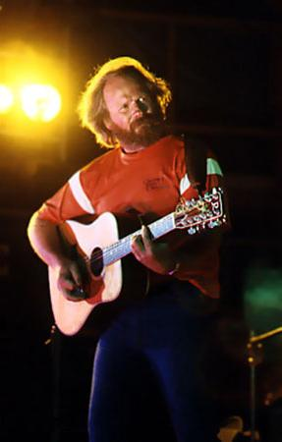
- Born in 1935 in Oklahoma City  - Folk music singer-songwriter  - Sang with different groups throughout his career  - The New Christy Minstrels  - Barry & Barry  - The Mamas and The Papas  - Broadway musical “Hair” | http://k20.ou.edu/McGuire  - Although “Eve of Destruction” (1965) was performed by Barry McGuire, it was written by P.F. Sloan.  - “Sloan name-checked the conflicts festering around the Jordan River and Red China, and the civil rights marches at Selma, Alabama, as well as the John F Kennedy assassination and funeral in 1963, and his directness and wide scope of reference turned “Eve of Destruction” into the anti-Vietnam war anthem par excellence.”

Resources
995577823Xyn. (2012). Crosby Stills Nash and Young 1970. Wikimedia Commons. Retrieved February 28, 2024, from https://commons.wikimedia.org/wiki/File:Crosby_Stills_Nash_and_Young_1970.jpg.
BappleBusiness. (2022). John Lennon 25 March 1969 (cropped). Wikimedia Commons. Retrieved February 28, 2024, from https://commons.wikimedia.org/wiki/File:John_Lennon_25_March_1969_(cropped).jpg.
Bob Dylan. Bob Dylan | Rock & Roll Hall of Fame. (n.d.). https://www.rockhall.com/inductees/bob-dylan
Boilen, B. (2009, June 30). Old music Tuesday: 40 years of giving peace a chance. NPR. https://www.npr.org/sections/allsongs/2009/06/old_music_tuesday_40_years_of_2.html#:~:text=The%20phrase%20%22give%20peace%20a,staying%20in%20bed%20all%20day.
Bubba73. (2010). Barry McGuire at the 3 day Music & Alternatives festival, New Zealand 1979. Wikimedia Commons. Retrieved March 5, 2024, from https://commons.wikimedia.org/wiki/File:Barry_McGuire_at_the_3_day_Music_%26_Alternatives_festival,_New_Zealand_1979..jpg.
Buffalo Springfield. Buffalo Springfield | Rock & Roll Hall of Fame. (n.d.). https://www.rockhall.com/inductees/buffalo-springfield
Callesen, E. (2015, November 30). “Masters of War” by Bob Dylan. Music politics. https://musicpolitics.as.ua.edu/timeline-articles/masters-of-war-by-bob-dylan/#:~:text=Bob%20Dylan%20has%20written%20some,to%20protest%20present%2Dday%20wars
Chilton, M. (2023, October 11). “imagine”: How john and Yoko’s provocative anthem became a hymn for peace. uDiscover Music. https://www.udiscovermusic.com/stories/imagine-john-lennons-provocative-anthem-became-hymn-peace/
Creedence Clearwater Revival. Creedence Clearwater Revival | Rock & Roll Hall of Fame. (n.d.). https://www.rockhall.com/inductees/creedence-clearwater-revival
Crosby, Stills and Nash. Crosby, Stills and Nash | Rock & Roll Hall of Fame. (n.d.). https://www.rockhall.com/inductees/crosby-stills-and-nash
Government, politics, and protest: Essential Primary sources. (n.d.). Encyclopedia.com. Retrieved February 7, 2024, from https://www.encyclopedia.com/politics/legal-and-political-magazines/fortunate-son
John Lennon. John Lennon | Rock & Roll Hall of Fame. (n.d.). https://www.rockhall.com/inductees/john-lennon
Levy, D. (2011). Joan Baez Bob Dylan crop. Wikimedia Commons. Retrieved February 26, 2024, from https://commons.wikimedia.org/wiki/File:Joan_Baez_Bob_Dylan_crop.jpg.
Neil Young. Neil Young | Rock & Roll Hall of Fame. (n.d.). https://www.rockhall.com/inductees/neil-young
Perrone, P. (2015, November 23). P.F. Sloan: Songwriter best known for protest song “eve of destruction.” The Independent. https://www.independent.co.uk/news/obituaries/pf-sloan-songwriter-whose-protest-song-eve-of-destruction-became-the-antivietnam-war-song-par-excellence-a6745901.html
Taylor@tomtaylorfo, T. (2022, September 21). What is Bob Dylan’s all along the watchtower actually about? Far Out Magazine. https://faroutmagazine.co.uk/what-is-bob-dylans-all-along-the-watchtower-about/
Taysom@josephtaysom, J. (2020, June 3). Remembering John Lennon and The Plastic Ono Band Recording “Give Peace a Chance” in a Montreal Hotel. Far Out Magazine. https://faroutmagazine.co.uk/john-lennon-yoko-ono-bed-record-give-peace-chance/
Taysom@josephtaysom, J. (2021, November 12). The misunderstood meaning of John Lennon song “imagine.” Far Out Magazine. https://faroutmagazine.co.uk/john-lennon-imagine-real-meaning-communism/
Taylor@tomtaylorfo, T. (2021, September 29). The story behind the song: The tragedy of Neil Young track “Ohio.” Far Out Magazine. https://faroutmagazine.co.uk/neil-young-ohio-story-behind-crosby-stills-nash/
The Beatles. The Beatles | Rock & Roll Hall of Fame. (n.d.). https://www.rockhall.com/inductees/beatles
Tredinnick, A. (n.d.). Analyzing protest songs of the 1960s. Analyzing Protest Songs of the 1960s | Gilder Lehrman Institute of American History. https://www.gilderlehrman.org/history-resources/lesson-plan/analyzing-protest-songs-1960s
Uitti, J. (2024, January 18). The meaning of “All along the watchtower” lyrics by Bob Dylan. American Songwriter. https://americansongwriter.com/all-along-the-watchtower-lyrics-meaning-bob-dylan/
University of Pittsburgh | Library System. (n.d.). A folk song about the inevitability of change. Voices Across Time: American Culture Through Music. https://voices.pitt.edu/TeachersGuide/Unit8/TheTimesTheyAre%20AChangin.htm
We hope. (2012). Creedence Clearwater Revival (1968). Wikimedia Commons. Retrieved February 28, 2024, from https://commons.wikimedia.org/wiki/File:Creedence_Clearwater_Revival_1968.jpg

