“THE ULTIMATE CONFRONTATION” QUARTER PEEKS

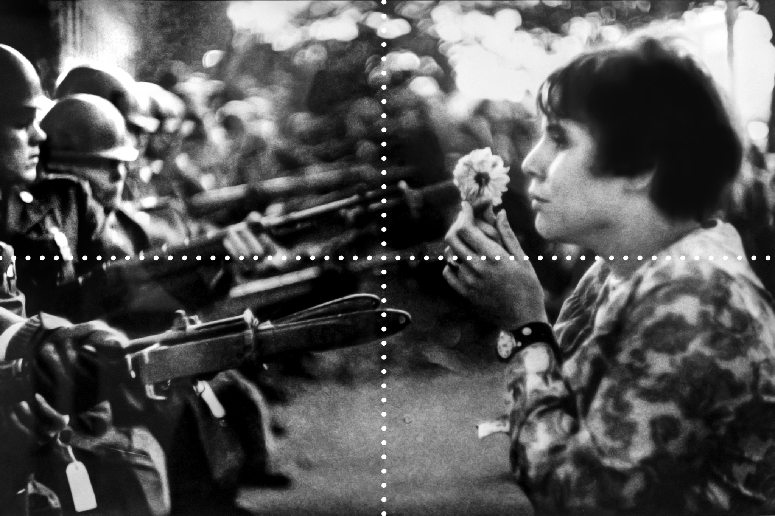
Source: Riboud, M. (1967, October 21). Jan Rose Kasmir. Wikipedia. https://en.wikipedia.org/w/index.php?title=File:Jan_Rose_Kasmir.jpg&oldid=781436404

