Guided Notes: Piecewise Functions and TAxes
Social Security Tax
Description (Verbal)
In 2024, 6.2% of your salary is set aside for Social Security tax for the first $168,600 you earn in a year.
Table (Numeric)  Salary ($) Social Security Tax ($) | Equation (Algebraic)
Graph (Visual)

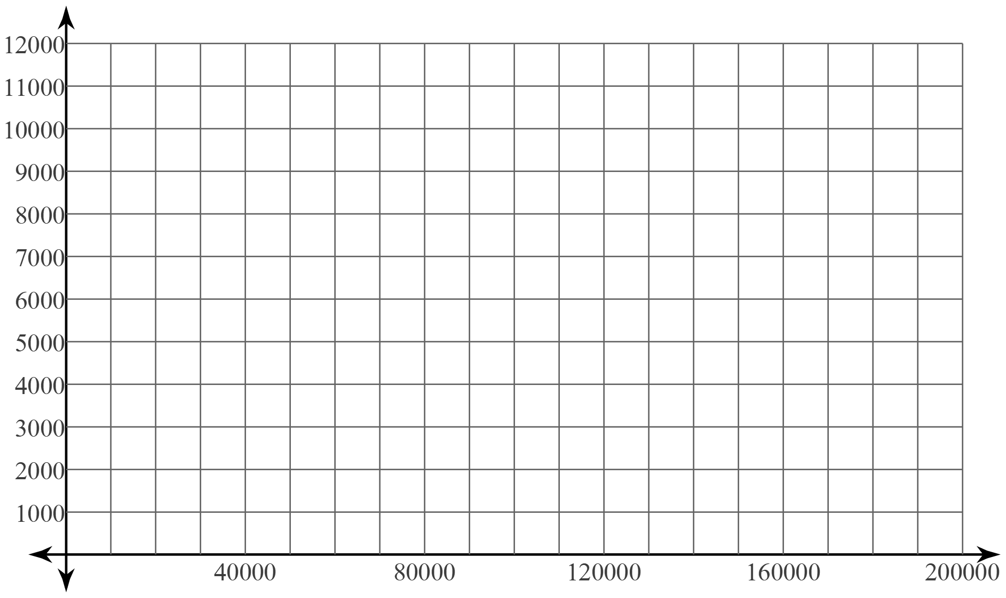

Medicare Tax
Description (Verbal)
In 2024, 1.45% of your salary is set aside for Medicare tax. For single people, any money earned over $200,000 in a year is taxed an additional 0.9%.
Table (Numeric)  Salary ($) Medicare Tax ($) | Equation (Algebraic)
Graph (Visual)

