Depictions of the Event

Image 1
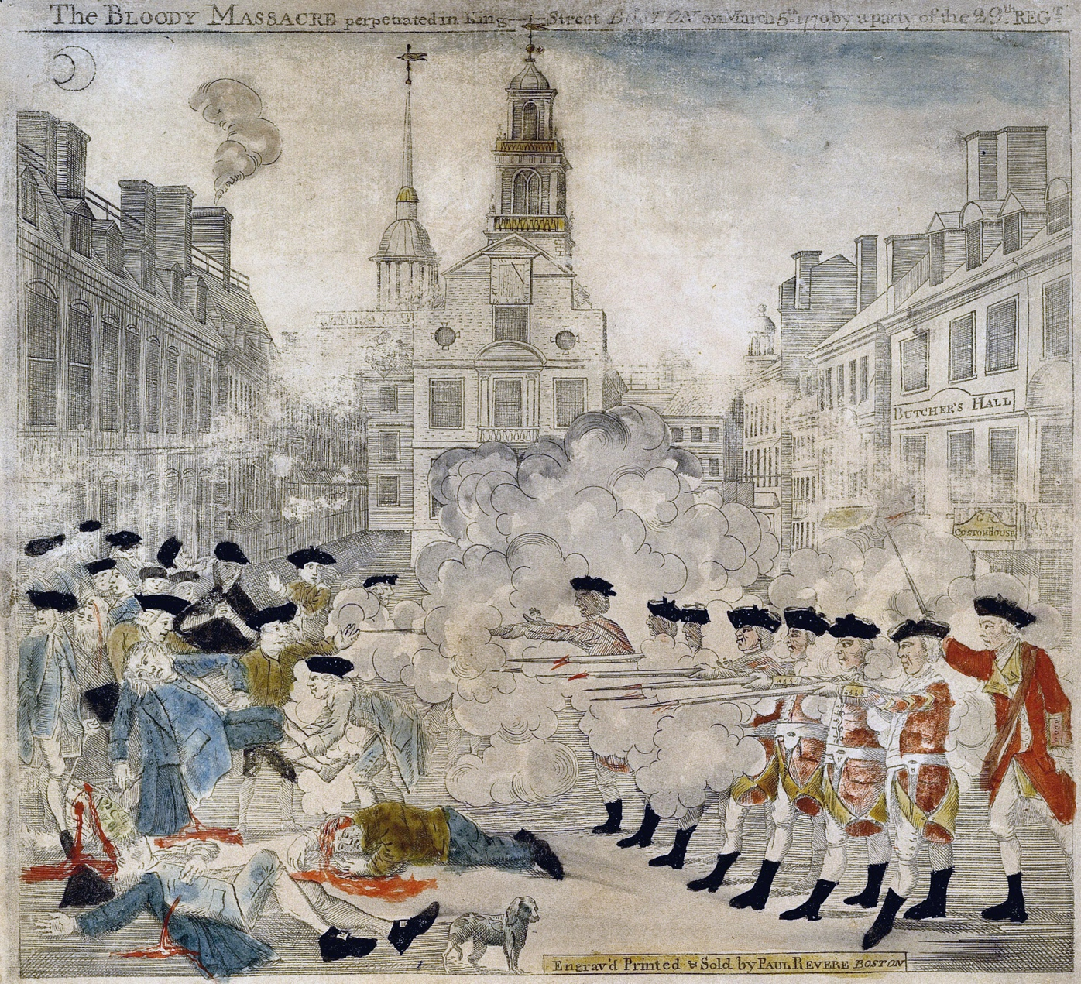

Depictions of the Event

Image 2
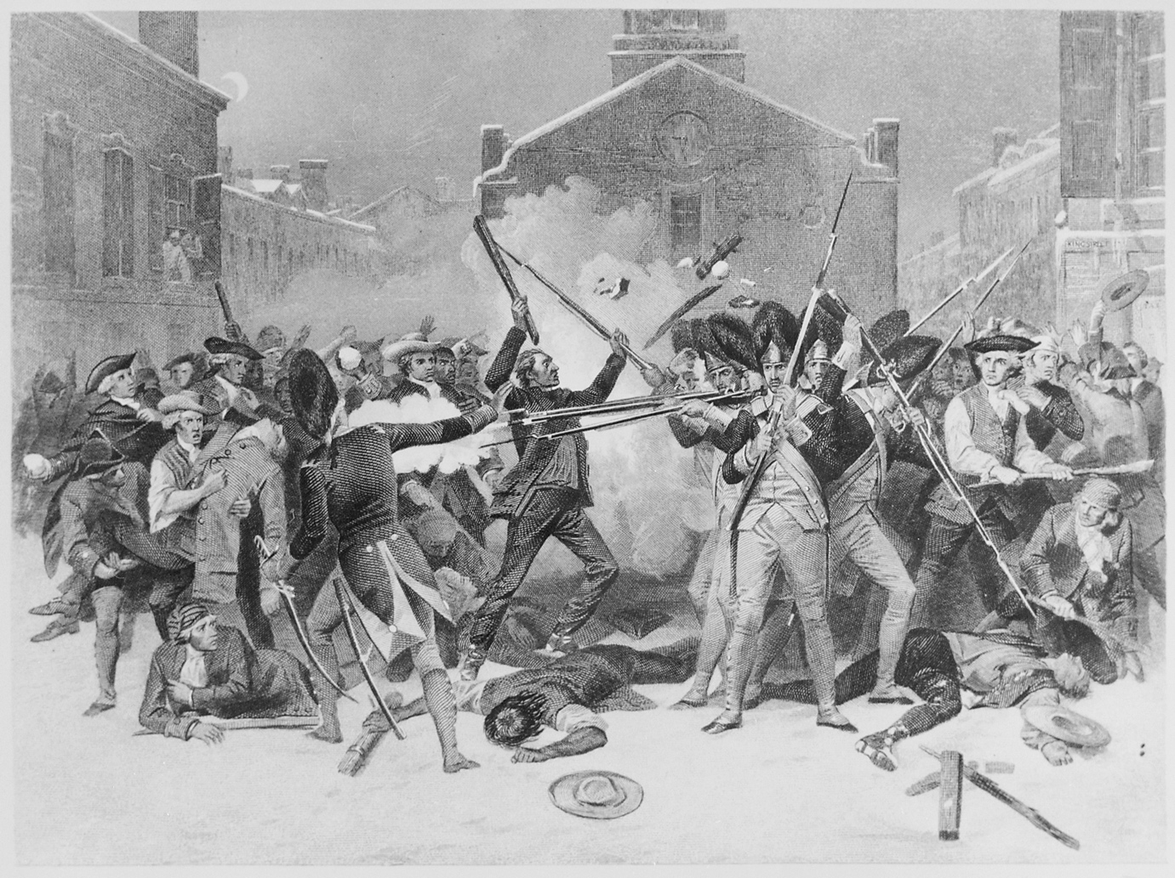

Image Sources
Library of Congress. (1770). Boston Massacre as portrayed by Paul Revere [Image]. Wikimedia Commons. https://commons.wikimedia.org/w/index.php?title=File:Boston_Massacre_high-res.jpg&oldid=401629174.
National Archives at College Park. (1770). The Boston Massacre [Image]. Wikimedia Commons. https://commons.wikimedia.org/w/index.php?title=File:%22The_Boston_Massacre%22,_03-05-1770_-_NARA_-_513326.jpg&oldid=342540992

