Card Sort
Right Angle | Acute Angle | Obtuse Angle
Straight Angle | An angle of 90 degrees, as in a corner of a square | An angle less than 90 degrees
An angle greater than 90 degrees but less than 180 degrees | An angle that is exactly 180 degrees, as in a straight line | 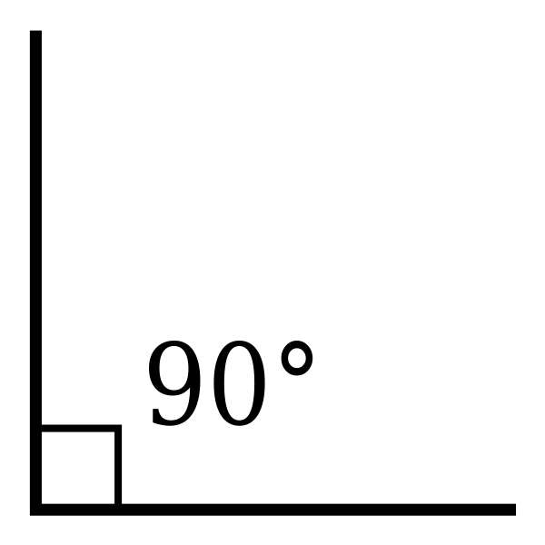
 | 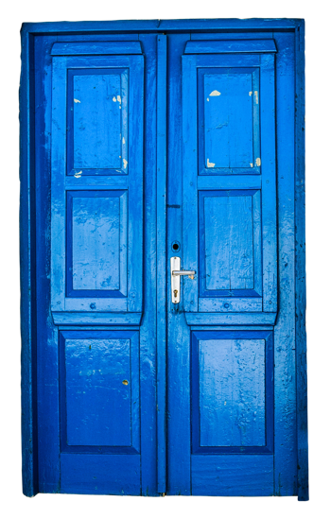 | 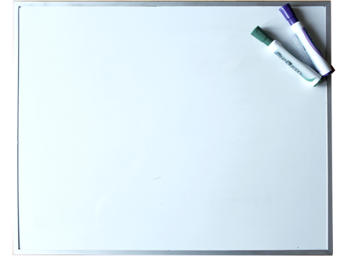
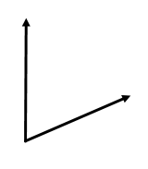 | 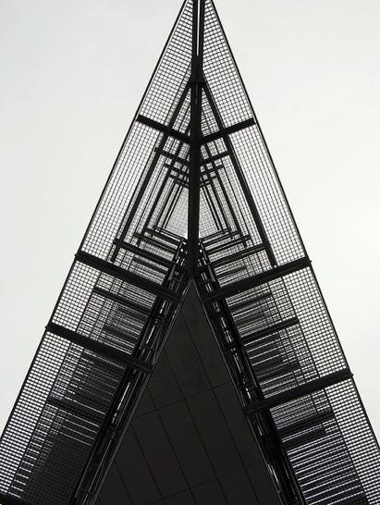 | 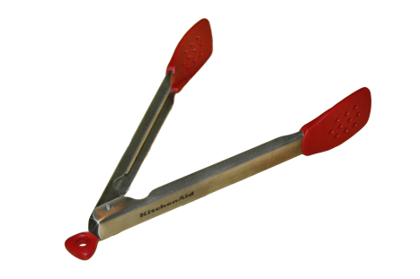
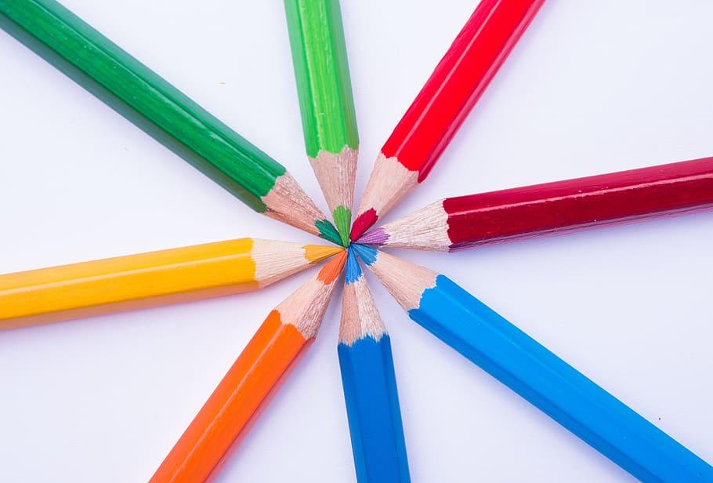 | 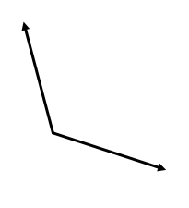 | 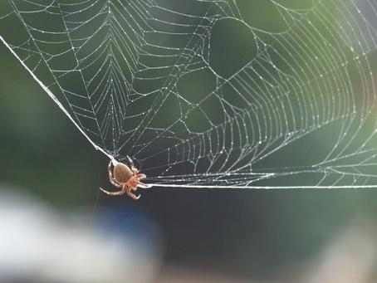
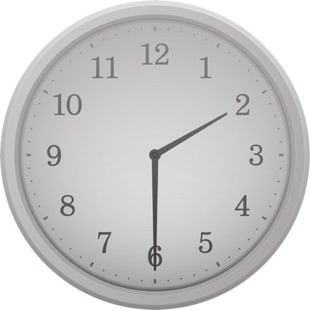 | 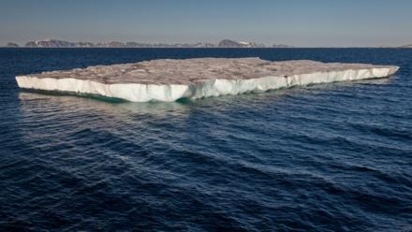
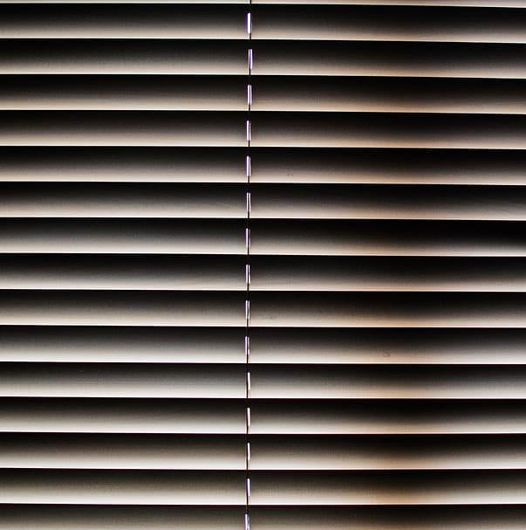 | 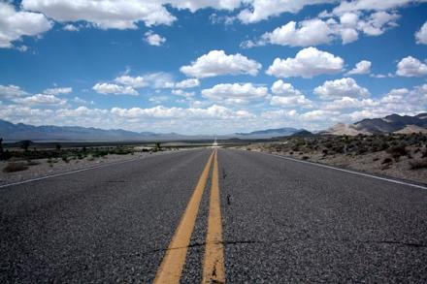 | 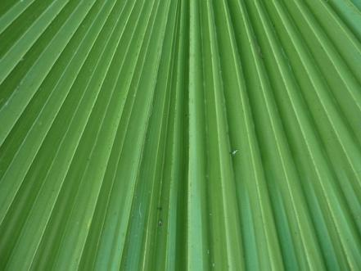

Image Sources
Camera Eye Photography. (2013, July 6). Right angle… Week #27 [27of52] [This weeks shot was taken in cottage country in Ontario Canada. Many right angles here!] [Digital image]. Retrieved May 27, 2020, from https://www.flickr.com/photos/camera_is_a_mirror_with_memory/9235225328
Eddideigel. (2005, September 2). Angle straight [Digital image]. Retrieved May 27, 2020, from https://commons.wikimedia.org/wiki/File:Angle_straight.png
Eva the Weaver. (2008, August 23). Looking up the acute angle [Which doesn't reach the ground] [Digital image]. Retrieved May 27, 2020, from https://www.flickr.com/photos/evaekeblad/2791135675
Jjuni. (n.d.). Clock wall clocks [Digital image]. Retrieved May 27, 2020, from https://www.needpix.com/photo/533721/clock-wall-clocks-alarm-time-on-time-wall-clock
Lasunncty. (2019, August 10). Right angle [Digital image]. Retrieved May 27, 2020, from https://commons.wikimedia.org/wiki/File:Right_angle.svg#file
Mliu92. (2008, September 6). Obtuse angle 6506 [I still think it's fascinating that these orb spiders will eat their web every morning.]. Retrieved May 27, 2020, from https://www.flickr.com/photos/mliu92/2835308212
Mnplatypus. (n.d.). Whiteboard dry erase marker [Digital image]. Retrieved May 27, 2020, from https://www.needpix.com/photo/1187398/whiteboard-dry-erase-marker-blank-white-board-school-office-white-clean
Momentmal. (n.d.). Door old blue [Digital image]. Retrieved May 27, 2020, from https://www.needpix.com/photo/1212381/door-old-blue-blue-door-old-door-house-entrance-input-wood-break-up
Openclipart. (2016, July 3). Ocean-view window [Digital image]. Retrieved May 27, 2020, from https://publicdomainvectors.org/en/free-clipart/Ocean-view-window/45480.html
Paco. (2015, February 1). Leaf [Nature/Landscapes]. Retrieved May 27, 2020, from https://pixabay.com/photos/leaf-leaflets-palm-tree-palma-619102/
Pearson Scott Foresman. (2008, April 26). Protractor [Line art drawing of protractor]. Retrieved May 27, 2020, from https://commons.wikimedia.org/wiki/File:Protractor_(PSF).png
Pexels. (2016, November 19). Desert horizon landscape lines [Digital image]. Retrieved May 27, 2020, from https://pixabay.com/photos/desert-horizon-landscape-lines-1839281/
Sac86738. (2007, August 5). Silicon-coated tongs used for cooking or serving food [Digital image]. Retrieved May 27, 2020, from https://commons.wikimedia.org/wiki/File:Kitchen-tongs.png
Tladie. (2020, March 22). Basic obtuse angle [Digital image]. Retrieved May 27, 2020, from https://commons.wikimedia.org/wiki/File:Obtuse_Angle.png
Tladie. (2020, March 22). Basic acute angle [Digital image]. Retrieved May 27, 2020, from https://commons.wikimedia.org/wiki/File:Acute_Angle.png
Unknown artist. (n.d.). Green, red, blue, and orange color pencils, spectrum, chevreul, HD wallpaper [Digital image]. Retrieved May 27, 2020, from https://www.wallpaperflare.com/green-red-blue-and-orange-color-pencils-spectrum-chevreul-wallpaper-wszwr
Unknown artist. (n.d.). White window blinds [Digital image]. Retrieved May 27, 2020, from https://www.piqsels.com/en/public-domain-photo-ffkmu
Weith, A. (2015, August 1). Table iceberg west of Sjuøyane, Arctic Ocean [Digital image]. Retrieved May 27, 2020, from https://commons.wikimedia.org/wiki/File:Table_iceberg_west_of_Sju%C3%B8yane,_Arctic_ocean.jpg

