Choice Board

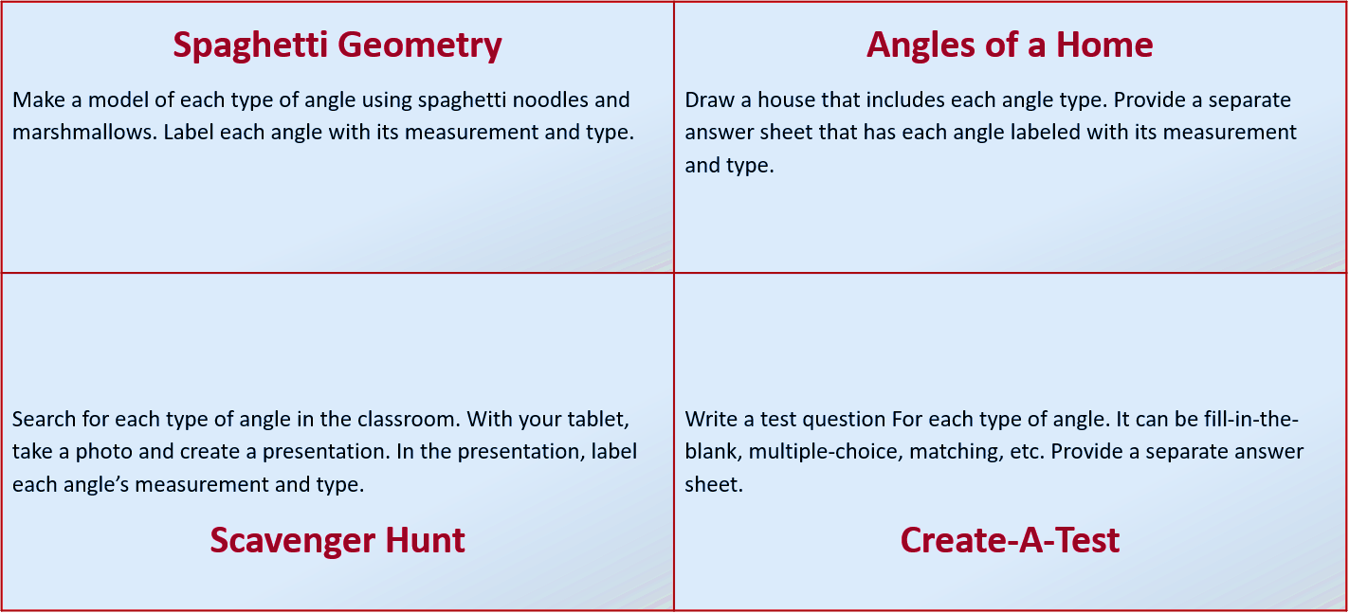

**Chant It, Sing It, Rap It**

Write a song that you will perform for the class that describes each of the different angles and their measurements.