STAR Notes–Teacher’s Guide
Term | Definition | Image
Right Angle | When an angle measures 90 degrees  Looks like an “L” or the corner of a square  Looks like the corner of a pizza box | 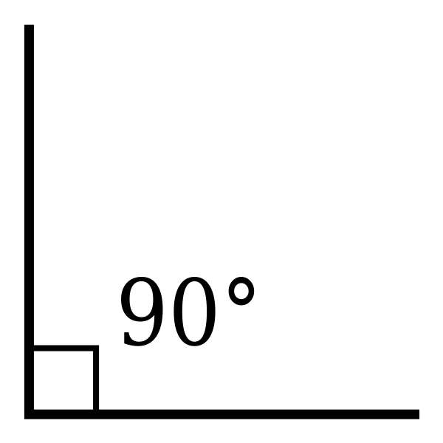
Acute Angle | Measures between 0 and 90 degrees  Looks like a “V” or the top of a “Y”  Looks like slices of pizza or pie | 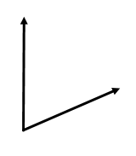
Obtuse Angle | Measures between 90 and 180 degrees  Looks like the hands on a clock when it is a quarter to 2 | 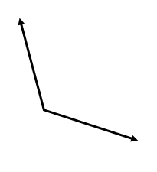
Straight Angle | An angle that is exactly 180 degrees, as in a straight line.
Protractor | Measures the number of degrees in an angle  Place the vertex at the hole in the center, line up one ray at the zero, and count up to where the other ray is located. | 