COMBO MEAL GALLERY WALK JOURNAL
Solve your peers’ combo meal equations. Use this table to keep track of your work.
Picture of Combo Meal | Expression | Simplified
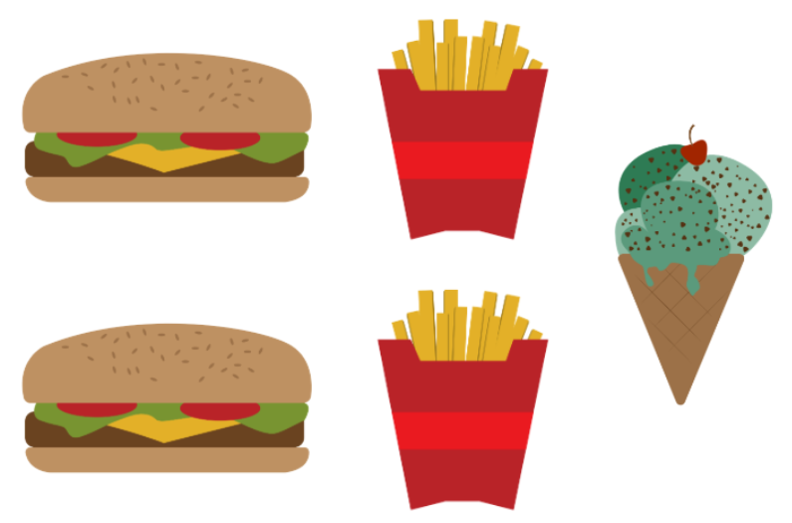 | $$3(2B+2F+1C)$$ | $$6B+6F+3C$$

