Card Sort

$$f(x)=-3x+12$$ | You drink a 12oz cup of coffee, swallowing three ounces per gulp.
$$x$$ $$f(x)$$  0 12  1 9  2 6  3 3  4 0 | 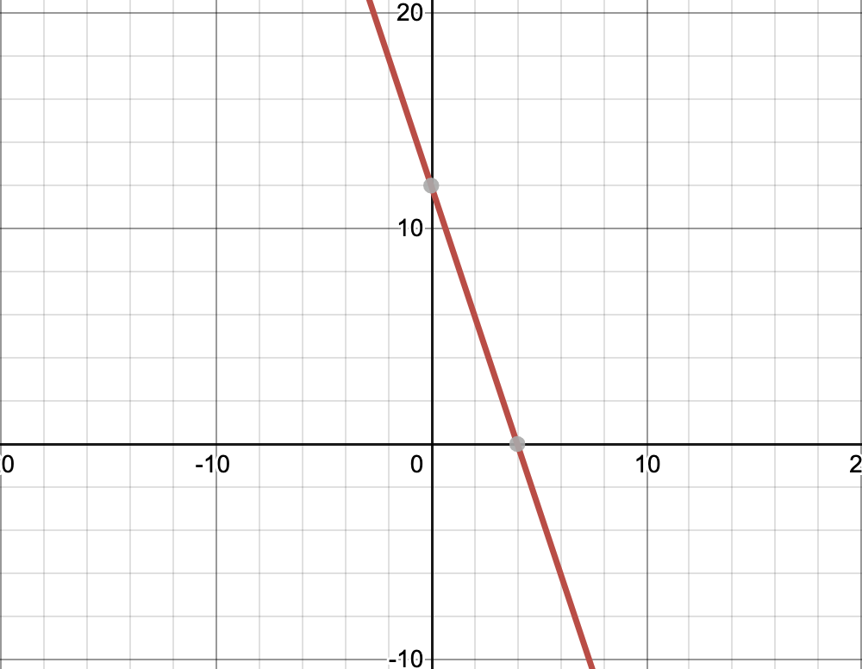

$$f\left(x\right)=.70x+1.80$$ | You call for an Uber. Your Uber driver charges you an automatic base fee of $1.80, plus $0.70 per mile.
$$x$$ $$f(x)$$  0 1.80  1 2.50  2 3.20  3 3.90  4 4.60 | 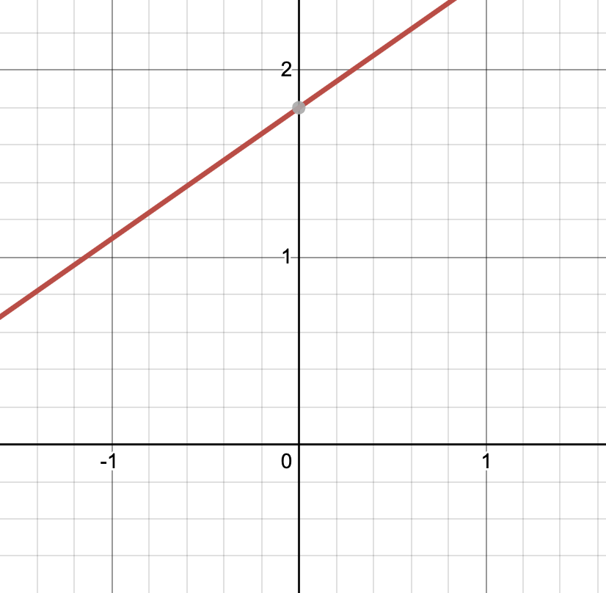

$$f(x)=9x+15$$ | You and your friends decide to start a lawn mowing business for extra money. You charge a $15 flat fee and $9 for each hour it takes to mow.
$$x$$ $$f(x)$$  0 15  1 24  2 33  3 42  4 51 | 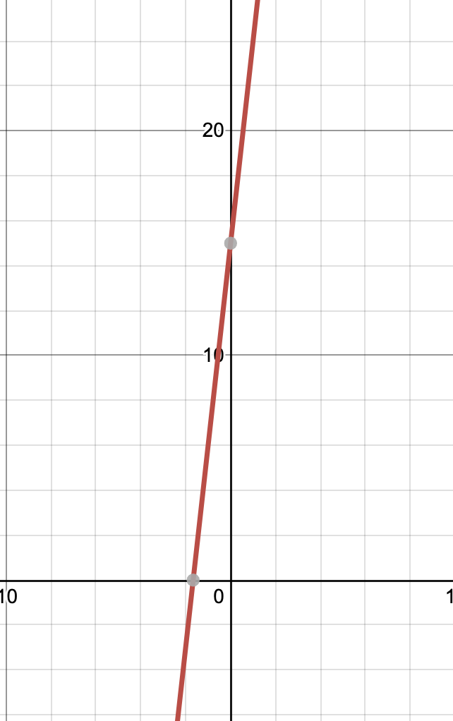

$$f\left(x\right)=-5x+100$$ | You lose 5% of battery life on your phone for every hour you use it.
$$x$$ $$f(x)$$  0 100  1 95  2 90  3 85  4 80 | 