Make Your Own Scenario
Your scenario’s story: | Equation:  Work:  Answer (with units):
Unit 1 Unit 2  Data table: | 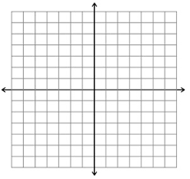  Graph:

