# **L🤑AN**

# **C↻NNECTI♥️N**

# **CONTENTS**

* Game Instructions (one per facilitator)
* Questions for Reflection and Discussion (one per facilitator)
* Lender Character Sheets (one per lender)
* Borrower Character Sheets (one per borrower)
* Lender Note Organizer (one per lender)
* Borrower Note Organizer (one per borrower)

# **GAME INSTRUCTIONS**

1. **Set-Up:** Place different stations around the room, each representing a lender type (Local Bank, Big Bank, Credit Union, Payday Lender). If you have a large group, you may wish to allow two students to pair up and play the same lender or borrower roles. Make sure that student borrowers visit at least one of each type of lender and that lenders get to meet at least one of each of the borrower characters.
2. **Speed Dating**: With lenders stationed around the room, allow the borrowers to spend two or three minutes speaking to a lender. Then, on your cue, borrowers rotate to the next lender station.
   * Students playing their respective roles as lenders and borrowers will each have a Note Organizer to record their notes, including whether they were approved or denied for each type of loan and the reason for approval or denial.
   * Borrower characters present their financial situation, loan request, and why they believe the lender should approve their loan. After the pitch, the lender quickly decides whether to approve or deny the loan. Lenders and borrowers should closely follow the information on their character cards.

*It’s possible to play a simplified version of this game with students playing lender roles alone. As lenders, students read borrower character cards and note their decisions on the Note Organizer.*

# **QUESTIONS FOR GUIDING REFLECTION AND DISCUSSION**

After all the lenders and borrowers have had a chance to exchange information, group them into 4-5 of the same roles, either lender or borrower, for reflection on the questions below.

**Lenders**

* If you were a character in this scenario, which lender would you prefer to approach for a loan, and why?
* Were there any moments where you felt conflicted about denying or approving a loan? What does this tell you about the ethical responsibilities of lenders?
* How might predatory lending practices impact someone like one of the characters in the game? What long-term effects could these practices have on borrowers?

**Borrowers**

* How might the characters' lives change depending on the loan terms they were offered? Consider both positive and negative outcomes.
* What are some risks that borrowers face when dealing with different types of lenders, and how can they protect themselves?
* How do you think the decisions made in this game compare to what happens in real life? Are there any similarities or differences that stood out to you?

**Summary, Both Groups:**

After discussing, have each group share with the whole class a summary of what they discussed using the [S-I-T strategy](https://learn.k20center.ou.edu/strategy/926):

* What surprising things have you learned about loans and making financial decisions through playing this game?
* Were there interesting things you learned about loans and making financial decisions through playing this game?
* What troubling things have you learned about loans and making financial decisions through playing this game?

Lender Character Sheet



# **HILLVIEW COMMUNITY BANK**

### A local community-focused bank that prioritizes serving the local population. They have a deep understanding of the community's needs and often provide personalized services.

***Lending Style***

They have strict lending criteria, preferring borrowers with good credit and stable income. In return, they offer lower interest rates and more personalized service. They may also offer financial advice and support to help borrowers succeed.

**Loan Offer Information**

|  |  |
| --- | --- |
| Amounts | $5,000-$50-000 |
| Interest  rates | 4-8% (fixed rate) |
| Fees | Origination fees are 1-2% of loan amount with no hidden fees |
| Qualifications | Requires a credit score of 680+. Borrows must show steady employment and reliable income. Very interested in supporting local businesses that offer the best rates. Most flexibility to these borrowers |
| Repayment Terms | Flexibility in plans is available. Pay off in 2-10 years |

Lender Character Sheet



# **COLOSSUS BANKING CORP**

### A large, nationwide bank with extensive resources and a wide range of financial products. They serve a diverse customer base and often use advanced technology for credit assessments.

***Lending Style***

More flexible in their lending criteria, willing to take on riskier borrowers, but typically at higher interest rates. They may prioritize profit over personal relationships and have less flexibility in tailoring loans to individual needs.

**Loan Offer Information**

|  |  |
| --- | --- |
| Amounts | $10,000-100,000+ |
| Interest  rates | 6-12% ( variable or fixed rate) |
| Fees | Origination fees are 2-4%. Prepayment penalties $50/year. |
| Qualifications | Requires credit score of 640+. Some leniency on income stability but will give the highest interest rates to the riskiest borrowers |
| Repayment Terms | Not flexible on repayment terms. Loans should be paid off in 3-15 years. Riskier loans should be given stricter repayment schedules |

Lender Character Sheet

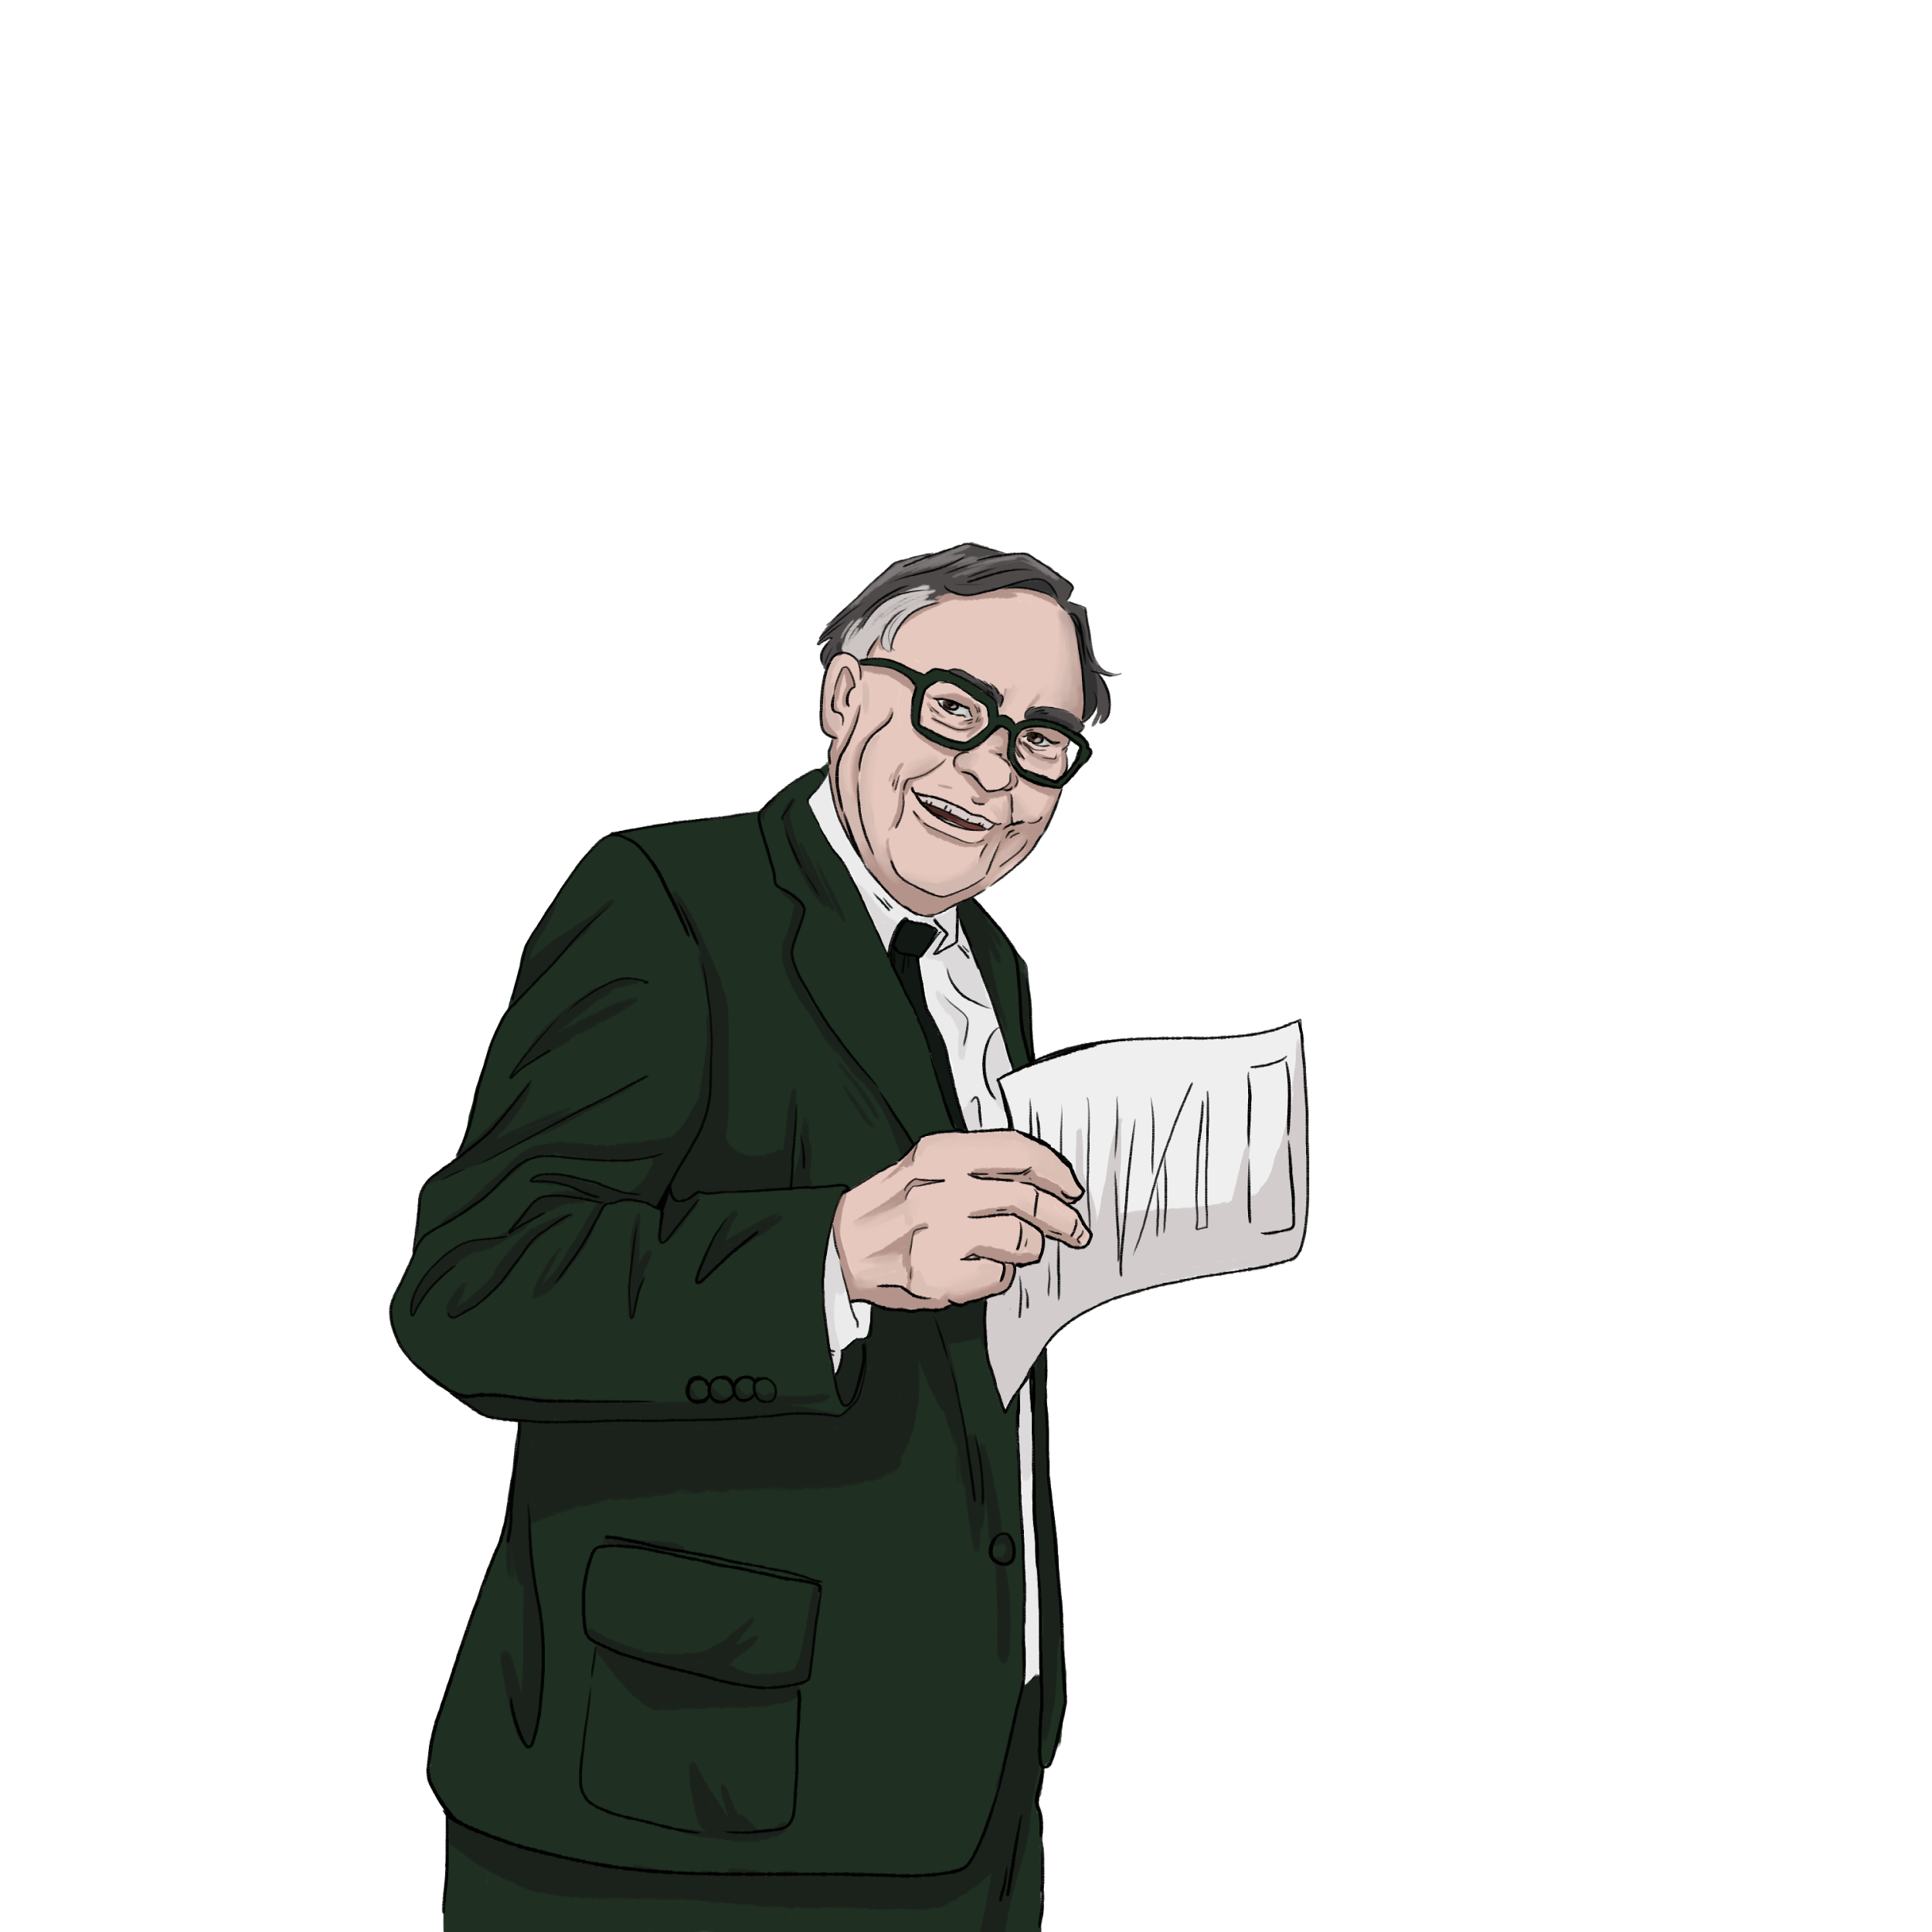

# **BEACON HILL CREDIT UNION**

### A member-owned financial institution that operates on a not-for-profit basis. They focus on providing fair financial services to their members and often reinvest profits into community services.

***Lending Style***

They offer fair interest rates and emphasize responsible lending. Credit unions prioritize the financial well-being of their members and often provide financial education and counseling alongside loans.

**Loan Offer Information**

|  |  |
| --- | --- |
| Amounts | $1,000-$30,000 |
| Interest  rates | 3-7% (fixed rate) |
| Fees | Waive origination fees, no prepayment penalty, no hidden fees |
| Qualifications | Requires a credit score of 650+, but may still be willing to work with some members who have lower scores. These exceptions would be for borrowers who have a personal financial history that shows commitment to improving credit |
| Repayment Terms | Loans should be paid off in 1-7 years, with flexibility given, including options for income-based repayment and deferment in cases of hardship |

Lender Character Sheet

# 



# **LIGHTNINGPAY LOANS**

### A high-risk lender that provides short-term, high-interest loans, often to individuals with urgent cash needs. These lenders are usually easy to access, with minimal requirements.

***Lending Style***

Payday lenders focus more on immediate repayment ability rather than long-term financial health. Loans have high interest rates and fees, often leading to a cycle of debt for borrowers.

**Loan Offer Information**

|  |  |
| --- | --- |
| Amounts | $100-$1,500. Offer to lend more than your borrower is asking for up to $1,500 |
| Interest  rates | One month with zero interest. Focus on this unless asked for more information.  If asked, the interest increases to 35% after the first two weeks and increases by 10% every month if it’s not repaid up to 400% APR |
| Fees | Don’t talk about these unless asked. If asked about fees, you can say that you charge $15 for every $100 borrowed and a fee of 5% of the loan for paying off early |
| Qualifications | Credit score is not a factor. Accept everyone without any questions about income or credit history |
| Repayment Terms | Must be repaid within two weeks, or fees are reapplied, and interest rates continue to increase |

Borrower Character Sheet

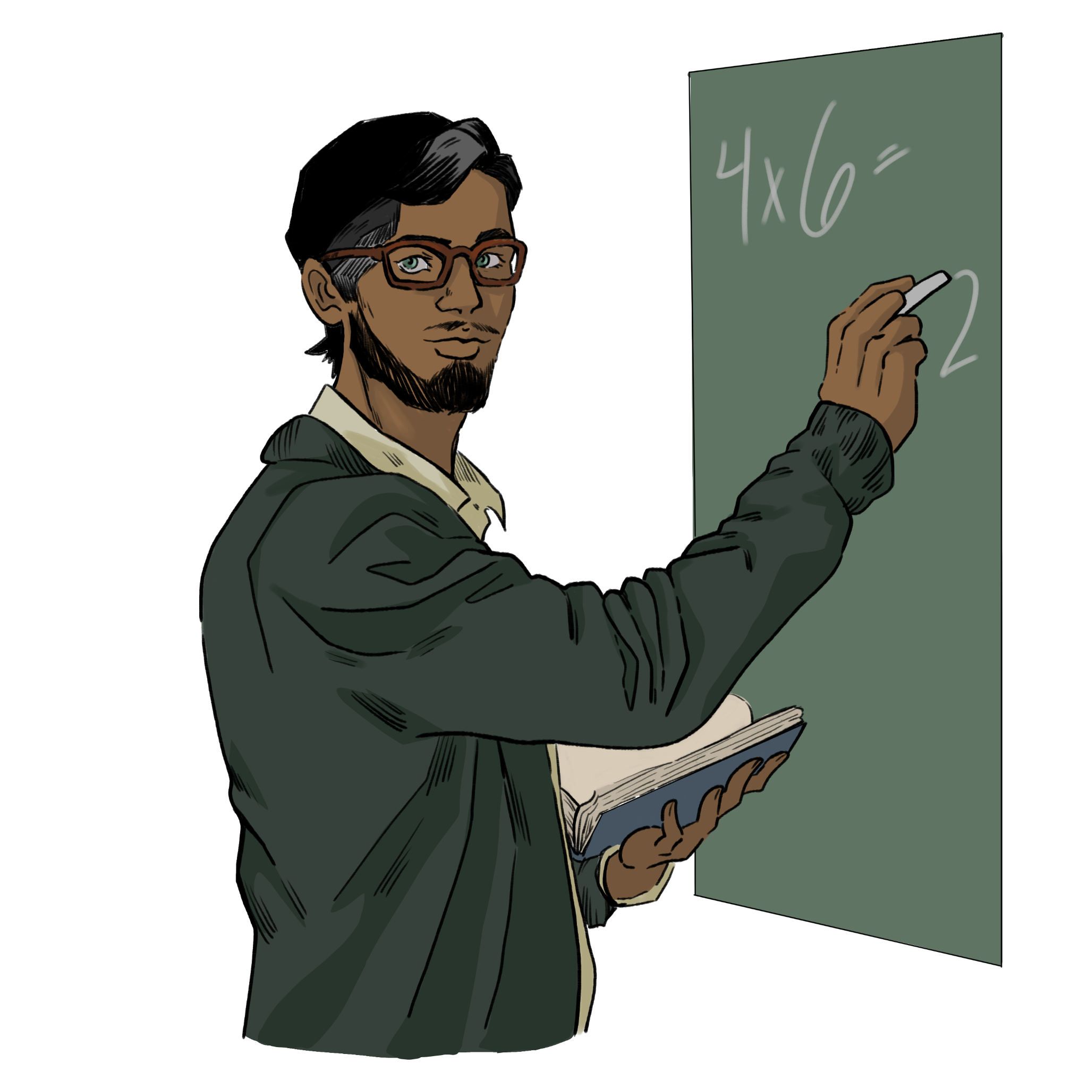

# **JAVIER MORALES**

### A teacher with a stable job and excellent credit. They have been employed for over a decade and are well-regarded in their community.

***Loan Request***

Seeking a $25,000 loan to buy a new car to replace an aging vehicle. They are looking for a lender that offers competitive interest rates and straightforward terms.

**Risk Assessment Information**

|  |  |
| --- | --- |
| Income | $55,000 per year |
| Employment History | Has been teaching in the same position for 10 years |
| Credit Score | 780 |

Borrower Character Sheet



# **ALISHA PATEL**

### A recent college graduate with student loan debt and a part-time job. They have a degree in business but are currently underemployed.

***Loan Request***

Looking for $15,000 to start a small business in their field of study. They need a lender that is willing to take a chance on a new entrepreneur with a limited credit history.

**Risk Assessment Information**

|  |  |
| --- | --- |
| Income | $30,000 per year |
| Employment History | Recently graduated, has 1 year of part-time work in their field from internships to freelance roles |
| Credit Score | 630 |

Borrower Character Sheet

# **LILY ROBERTS**



### A single parent with a low credit score due to past financial difficulties, including unexpected medical bills. They are working full-time but struggling to make ends meet.

***Loan Request***

Seeking $10,000 to cover immediate medical expenses and consolidate existing debt. They are looking for a lender that offers flexible repayment options and understands their financial challenges.

**Risk Assessment Information**

|  |  |
| --- | --- |
| Income | $40,000 per year |
| Employment History | 8 years with gaps due to medical issues, currently employed full-time in retail |
| Credit Score | 540 |

Borrower Character Sheet



# **DEREK JOHNSON**

### An individual with no credit history who works in a gig economy job. They’ve been managing their finances primarily through cash and have no significant debts or assets.

***Loan Request***

Looking for a payday loan of $500 to cover rent until their next paycheck arrives. They need fast approval and are willing to pay higher fees for immediate access to cash.

**Risk Assessment Information**

|  |  |
| --- | --- |
| Income | $25,000 per year |
| Employment History | 3 years of steady gigs in the freelance economy, no formal employment history |
| Credit Score | No credit history/thin file |

**NOTE ORGANIZER**

|  |  |  |
| --- | --- | --- |
| **Name**  (Lender/Borrower) | **Notes**  What were the terms of acceptance? or  What was the reason for declining? | |
|  | **ACCEPT** |  |
| **DECLINE** |
|  | **ACCEPT** |  |
| **DECLINE** |
|  | **ACCEPT** |  |
| **DECLINE** |
|  | **ACCEPT** |  |
| **DECLINE** |