Pass the Problem: Food

Round 1
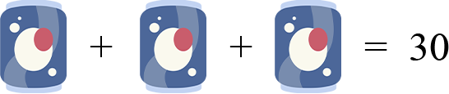

Round 2
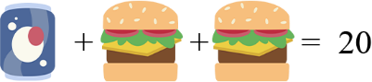

Round 3
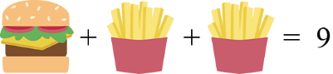

Round 4
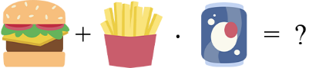

Pass the Problem: Animals

Round 1
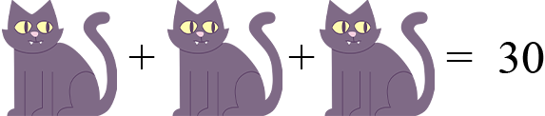

Round 2
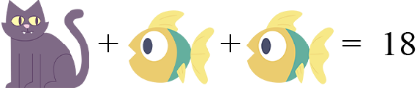

Round 3
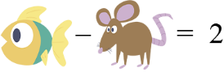

Round 4
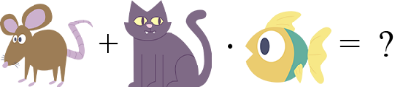

Pass the Problem: Space

Round 1
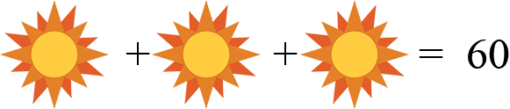

Round 2
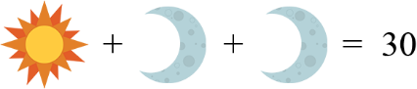

Round 3


Round 4


