PET ROCKS
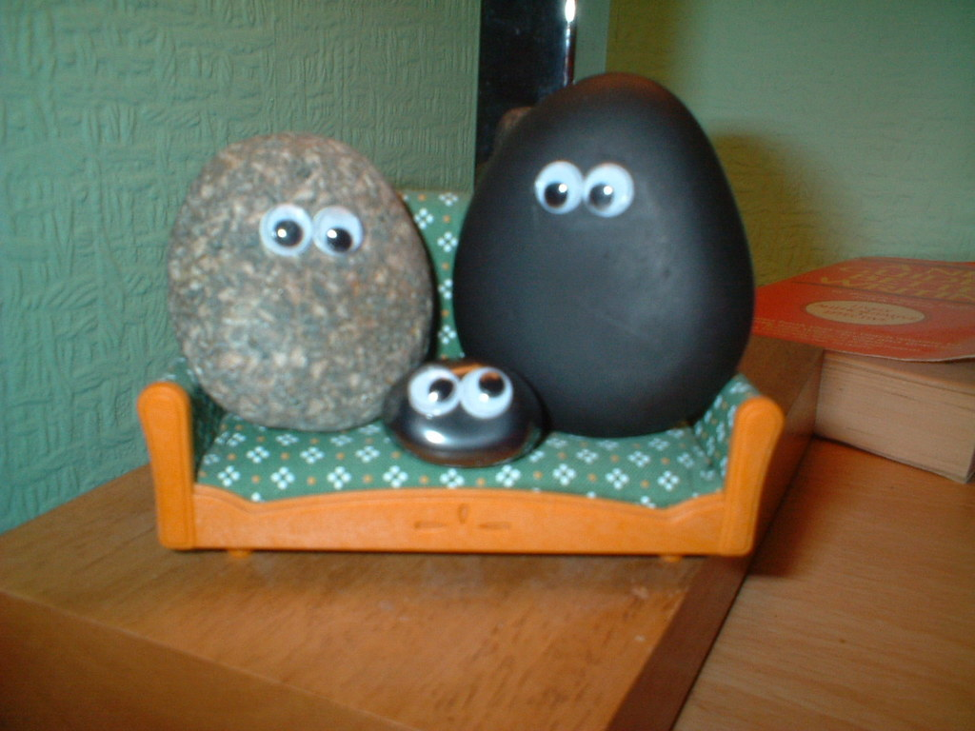
Pet Rock Net. (2003, January 1). Pet rock [Online Image]. Wikimedia Commons. Retrieved from https://commons.wikimedia.org/wiki/File:Pet_rock.jpg

sIDEBURNS
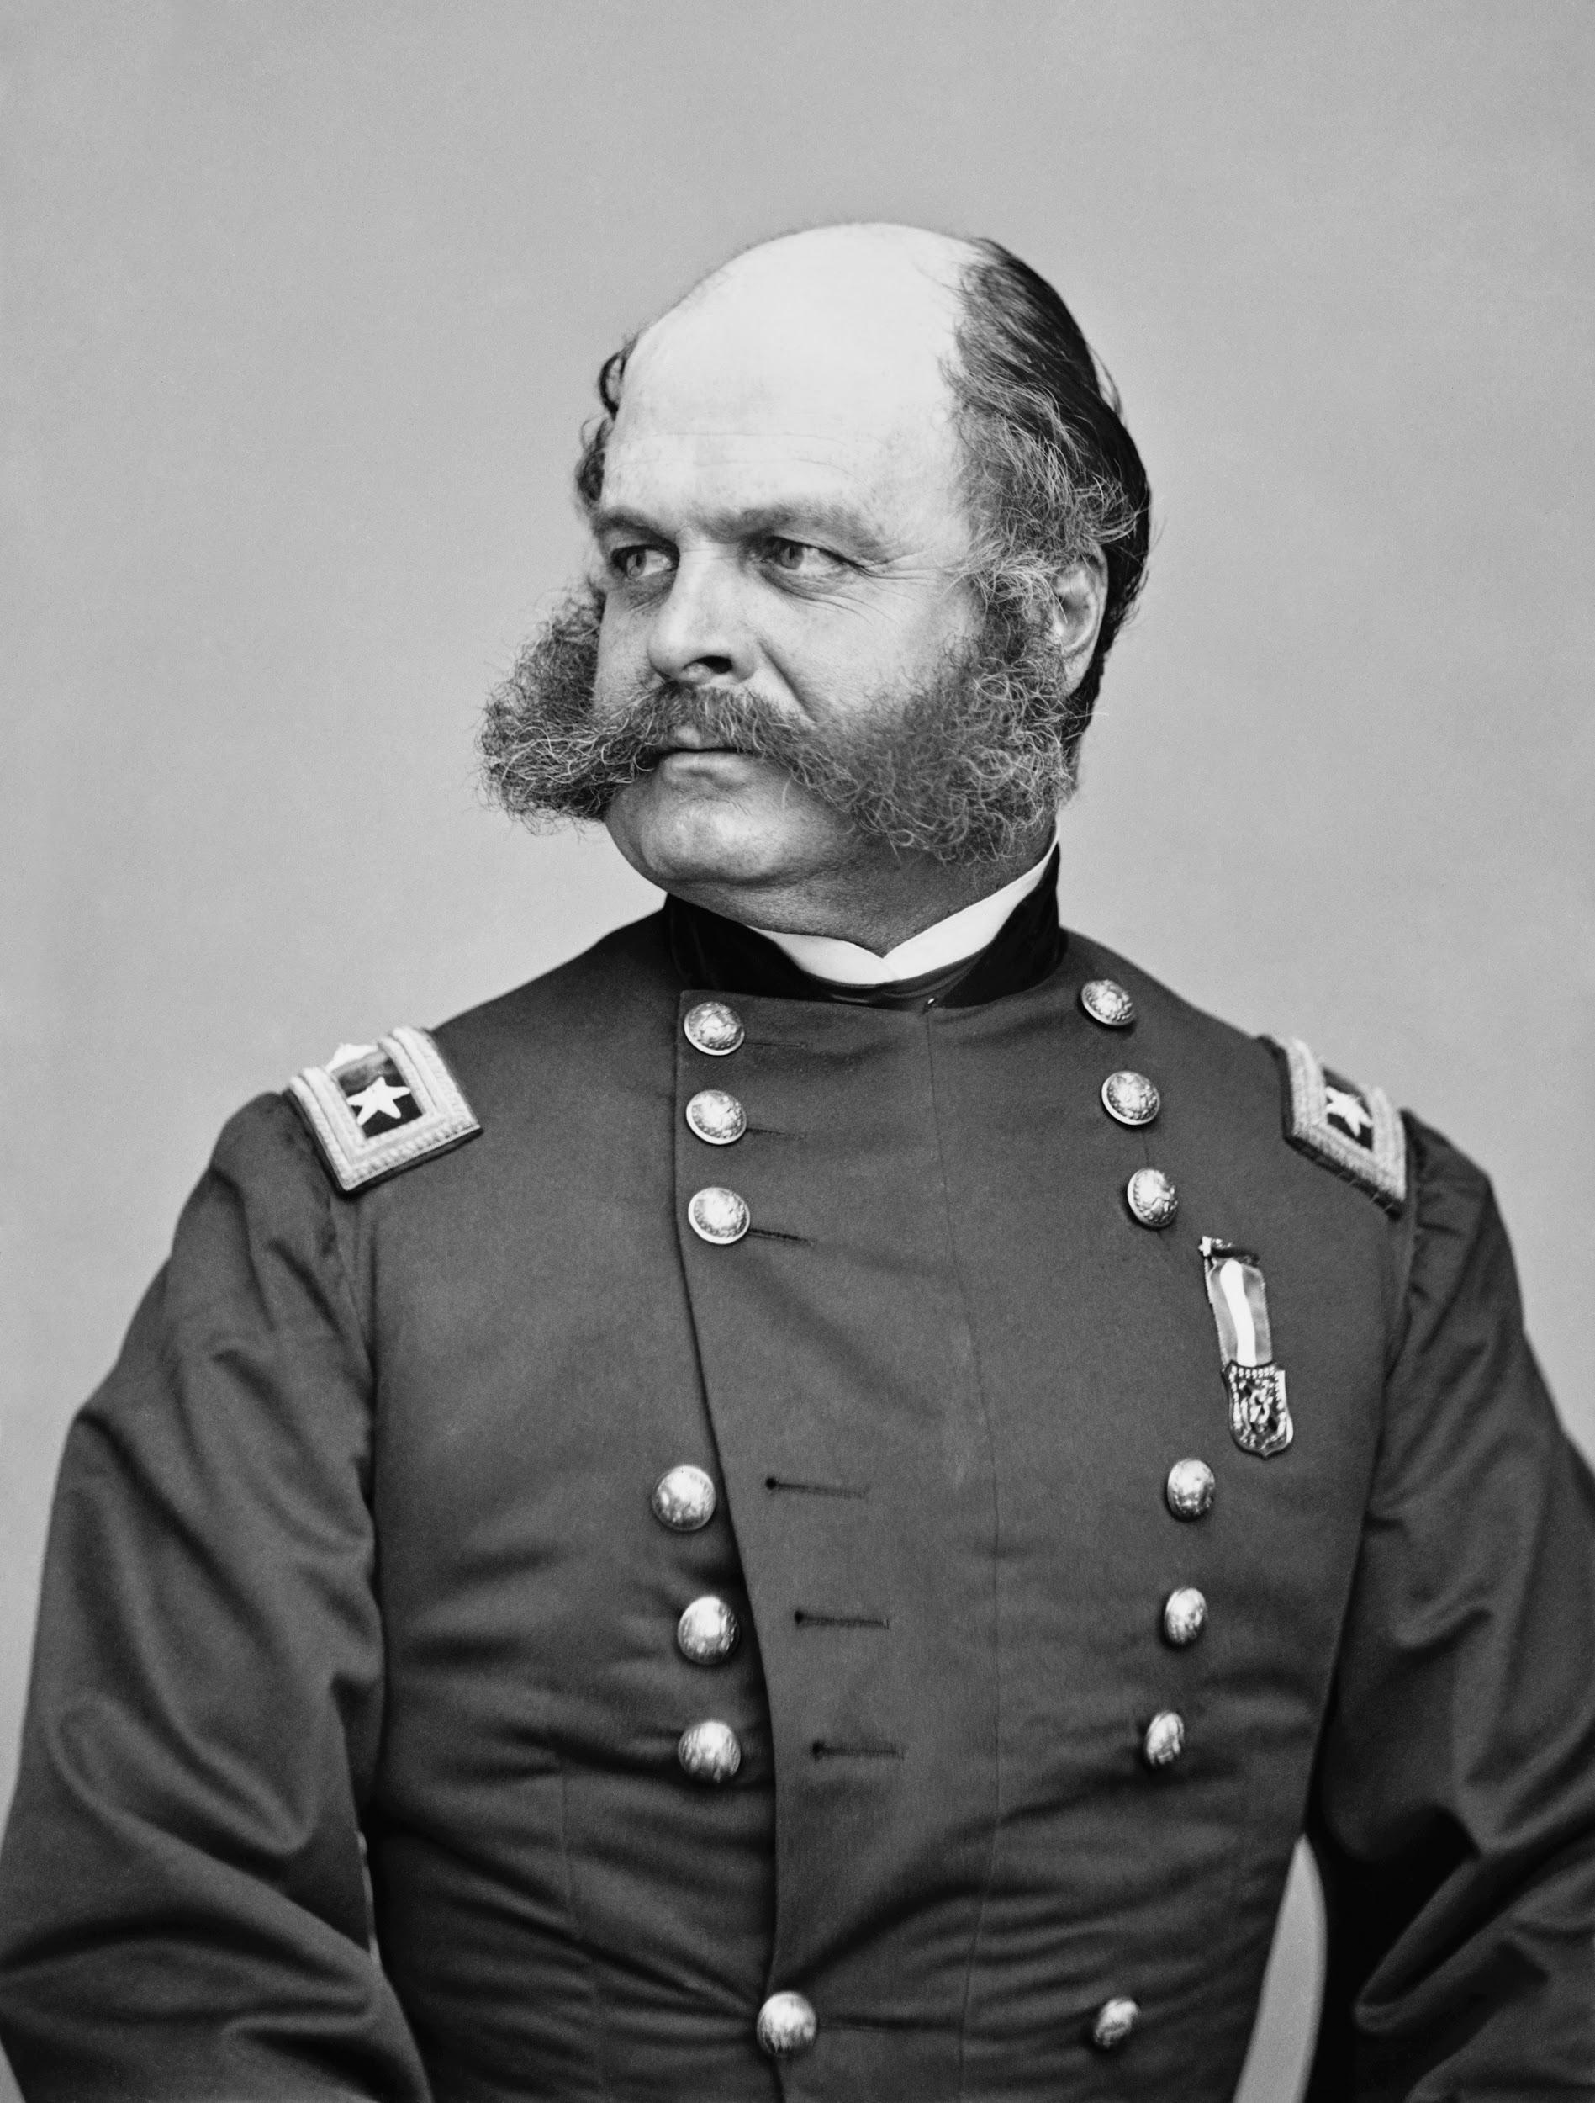
Mathew Brady. (1860-1865). Portrait of Maj. Gen. Ambrose E. Burnside [Online Image]. Wikimedia Commons. Retrieved from https://en.wikipedia.org/wiki/File:Ambrose_Everett_Burnside.jpg

gOLDFISH sWALLOWING
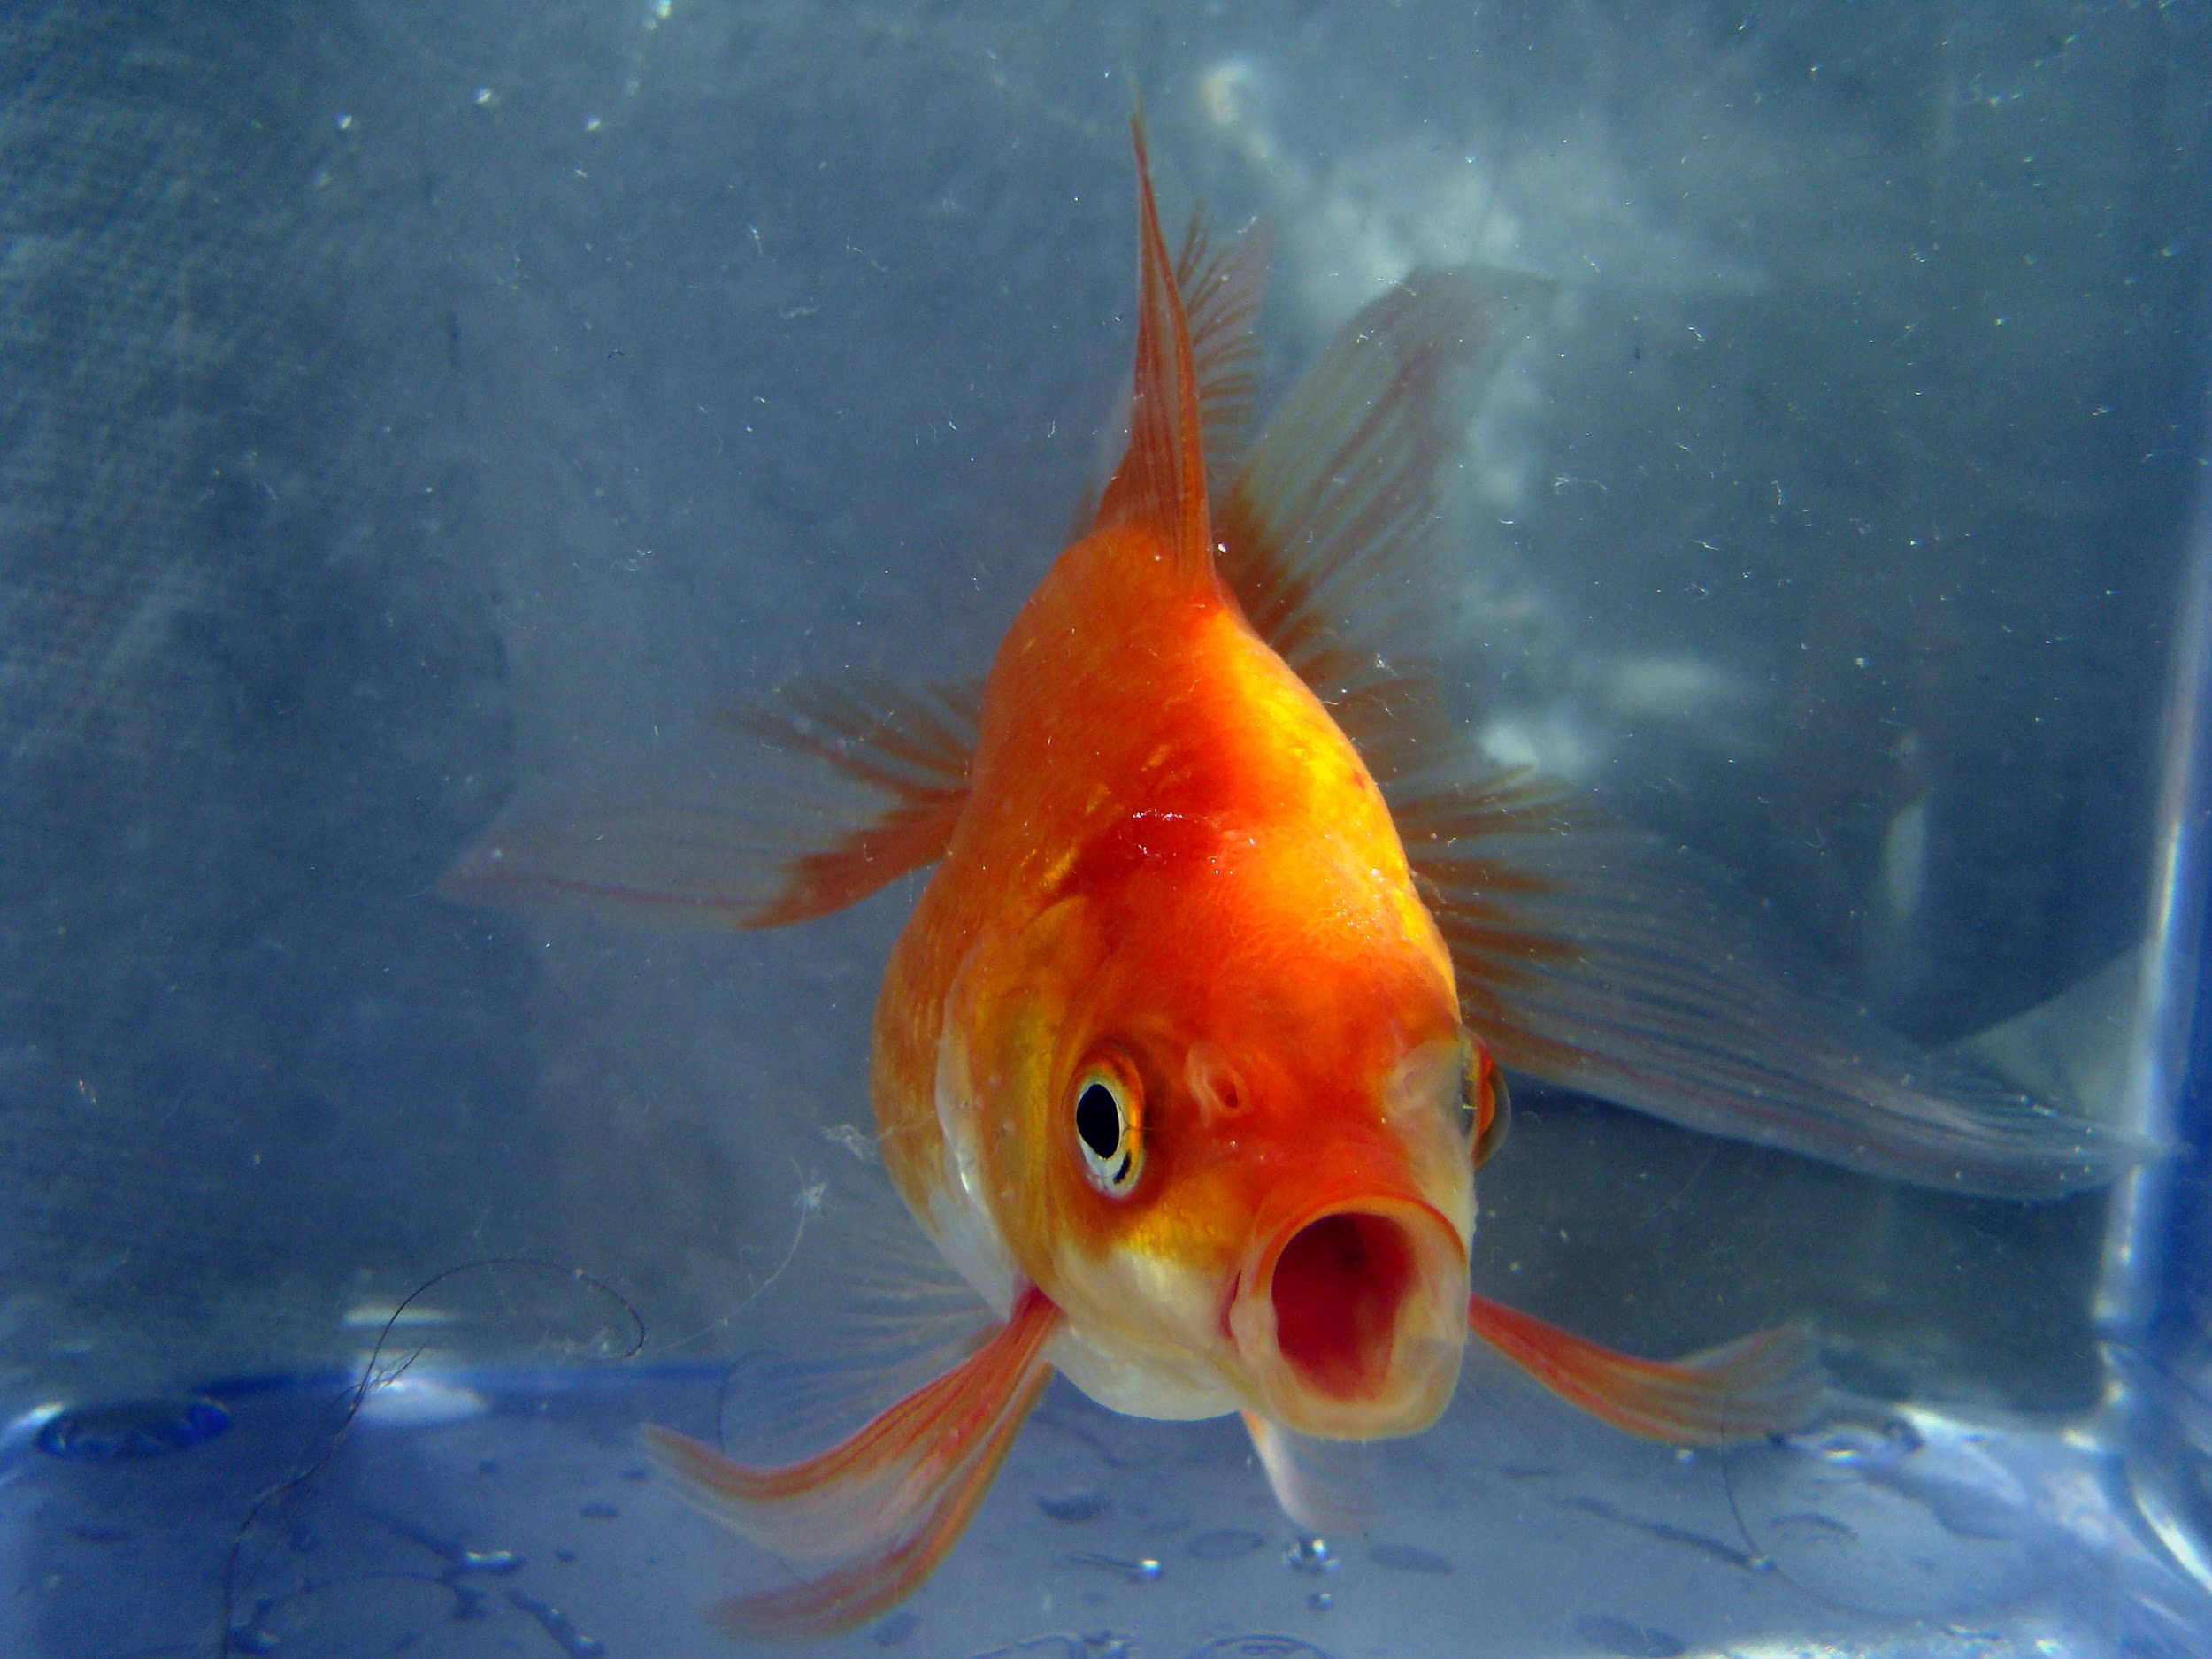
Pogrebnoj Aledandroff. (2013, April 28). Butterfly Goldfish [Online Image]. Wikimedia Commons. Retrieved from https://commons.wikimedia.org/wiki/File:Butterfly_Goldfish_02.JPG

bEANIE bABIES
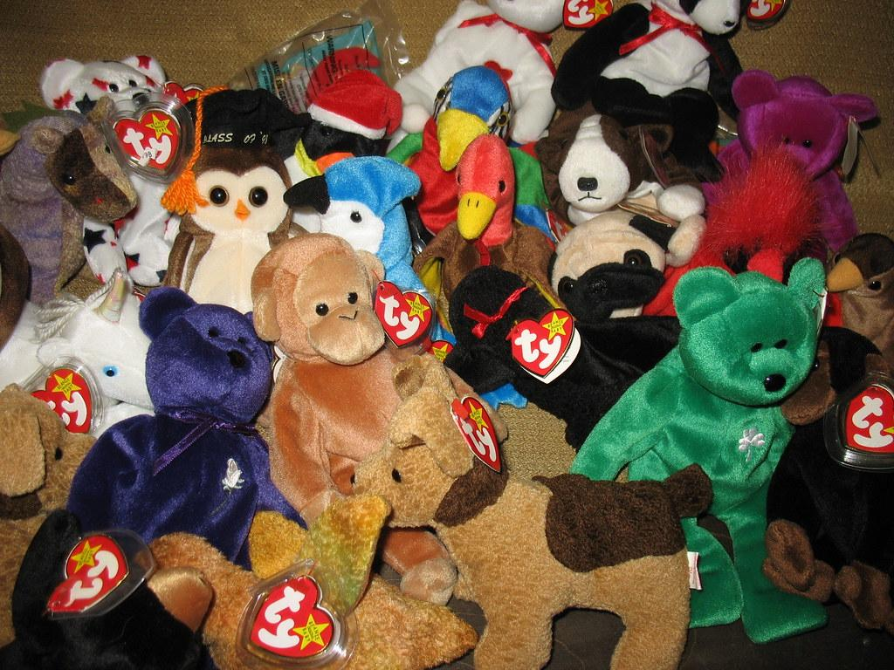
Housing Works Thrift Shops. (2007, March 23). Lot of Beanie Babies [Online Image]. Flickr. Retrieved from https://www.flickr.com/photos/housingworksauctions/432628528/

THE iCE bUCKET cHALLENGE
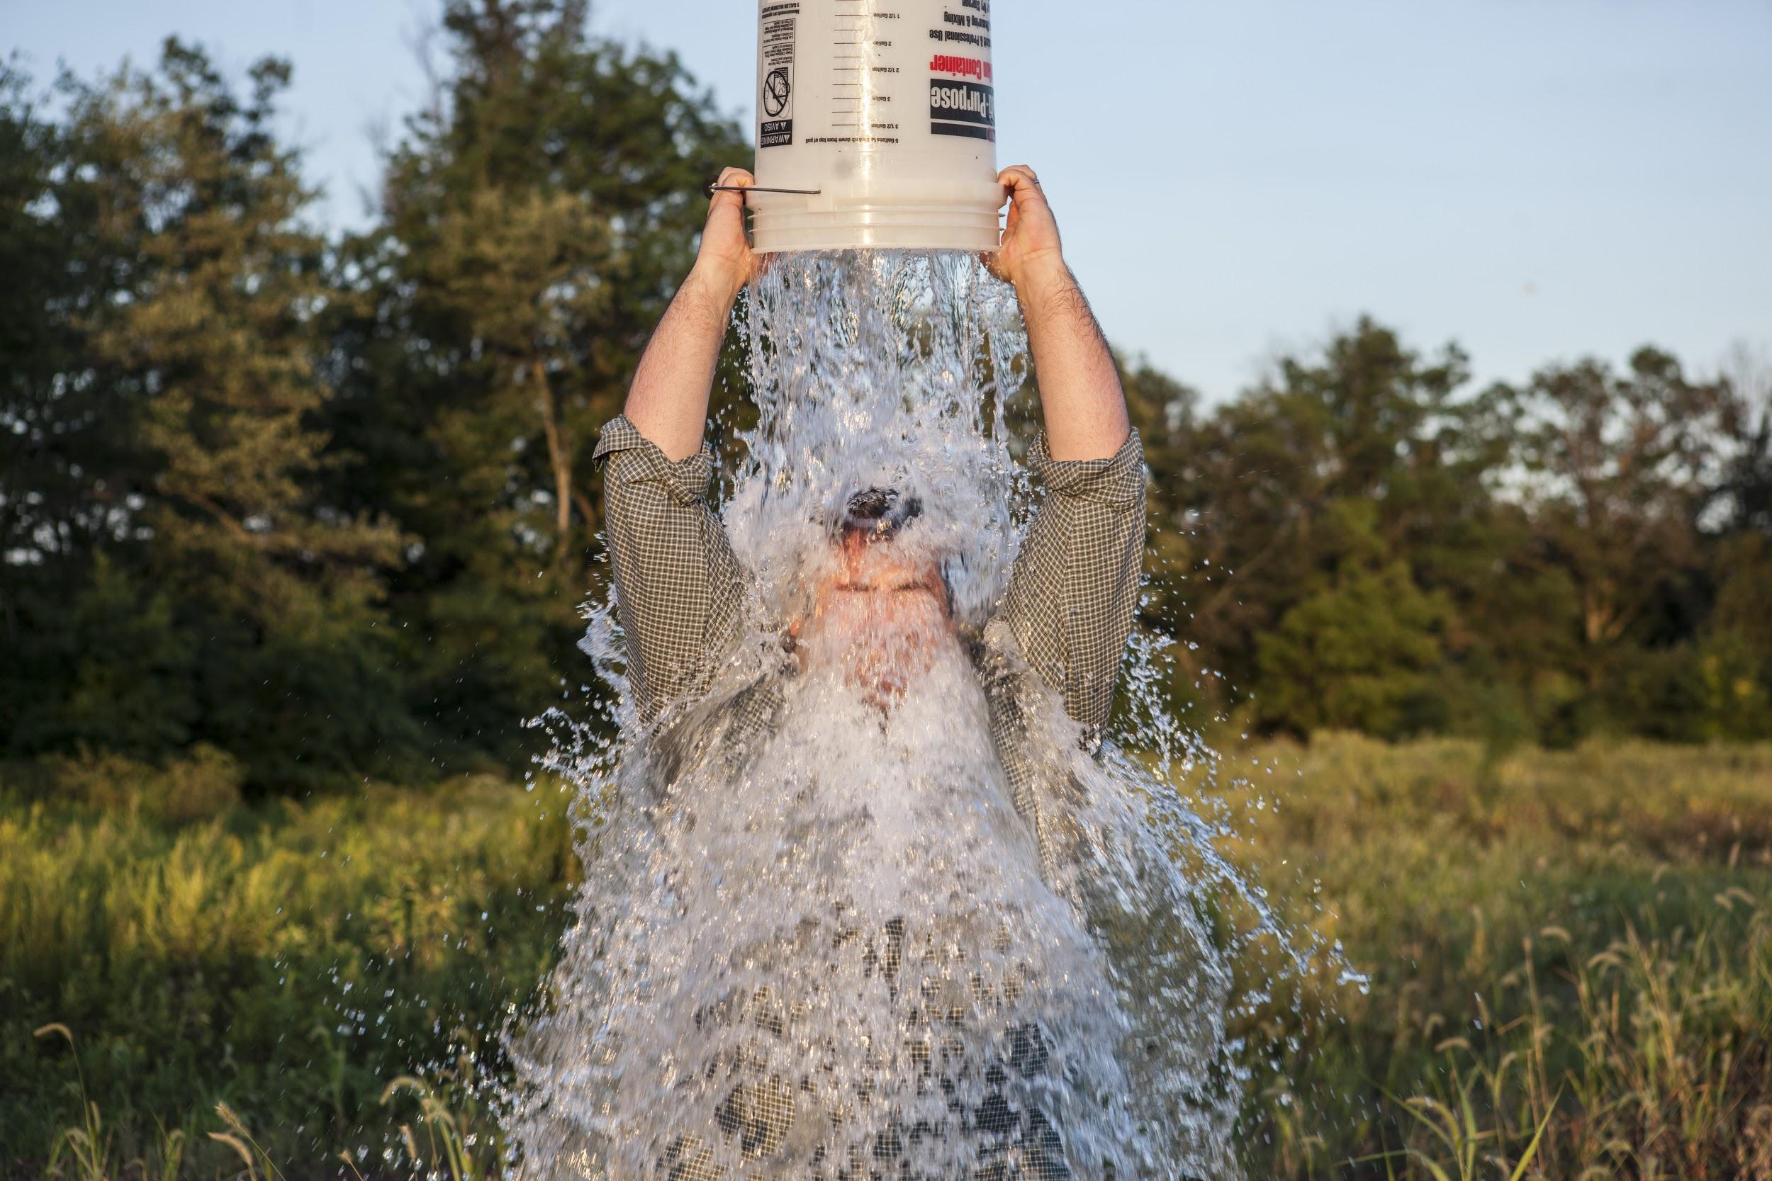
Quintano, A. (2014, August 24.). Mission Accomplished - ALS Ice Bucket Challenge [Online Image]. Wikimedia Commons. Retrieved from https://commons.wikimedia.org/wiki/File:Mission_Accomplished_-_ALS_Ice_Bucket_Challenge_(14848289439).jpg

SAGGING
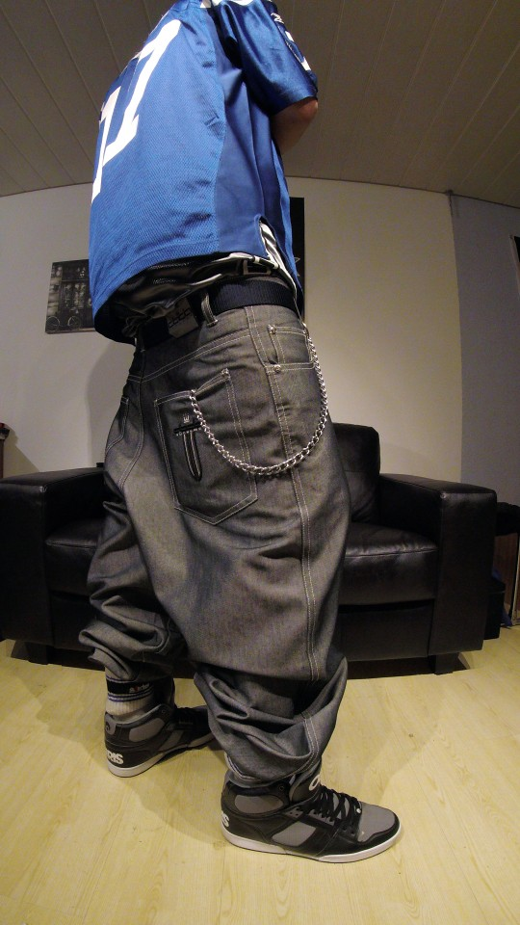
King, G. (2019, February 13). Baggy Thug [Online Image]. Flickr. Retrieved from https://www.flickr.com/photos/162055393@N02/46354178734/

fURBIES
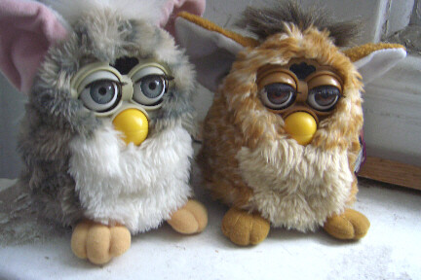
April. (2007, March 19). Furbies [Online Image]. Flickr. Retrieved from https://www.flickr.com/photos/91524358@N00/427142187/

pOGS
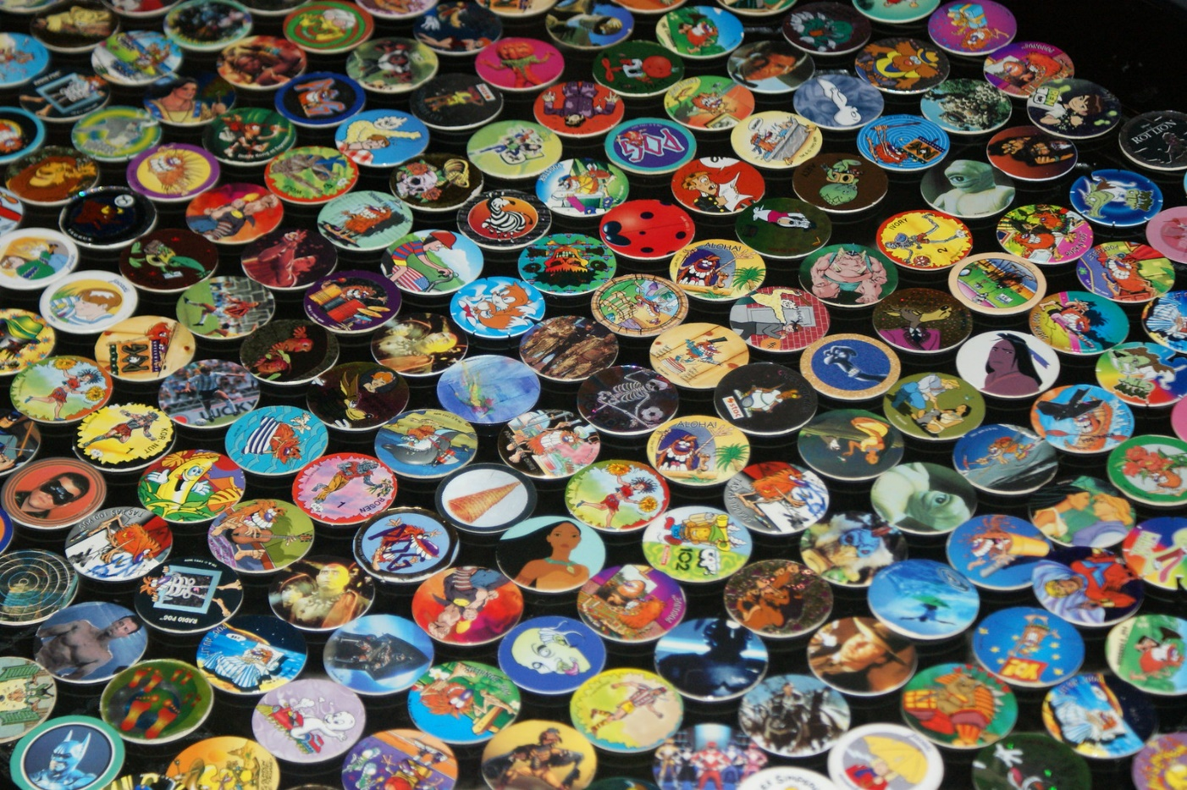
MyrFil. (2009, January 17.). Pogs [Online Image]. Flickr. Retrieved from https://www.flickr.com/photos/myrpictures/3399108617/

