Pet Rocks

Pet rocks, popular in the 1970s, were smooth stones that were given human features, especially googly eyes. People collected a variety of pet rocks with different features.

Sideburns

Sideburns were popularized (though not created) by Union General Ambrose Burnside during the Civil War (1860-1865). This style of men’s hair remained a trend throughout the 1800s, particularly with military men. The initial term for the style, “burnsides,” eventually became “sideburns.”

Goldfish Swallowing
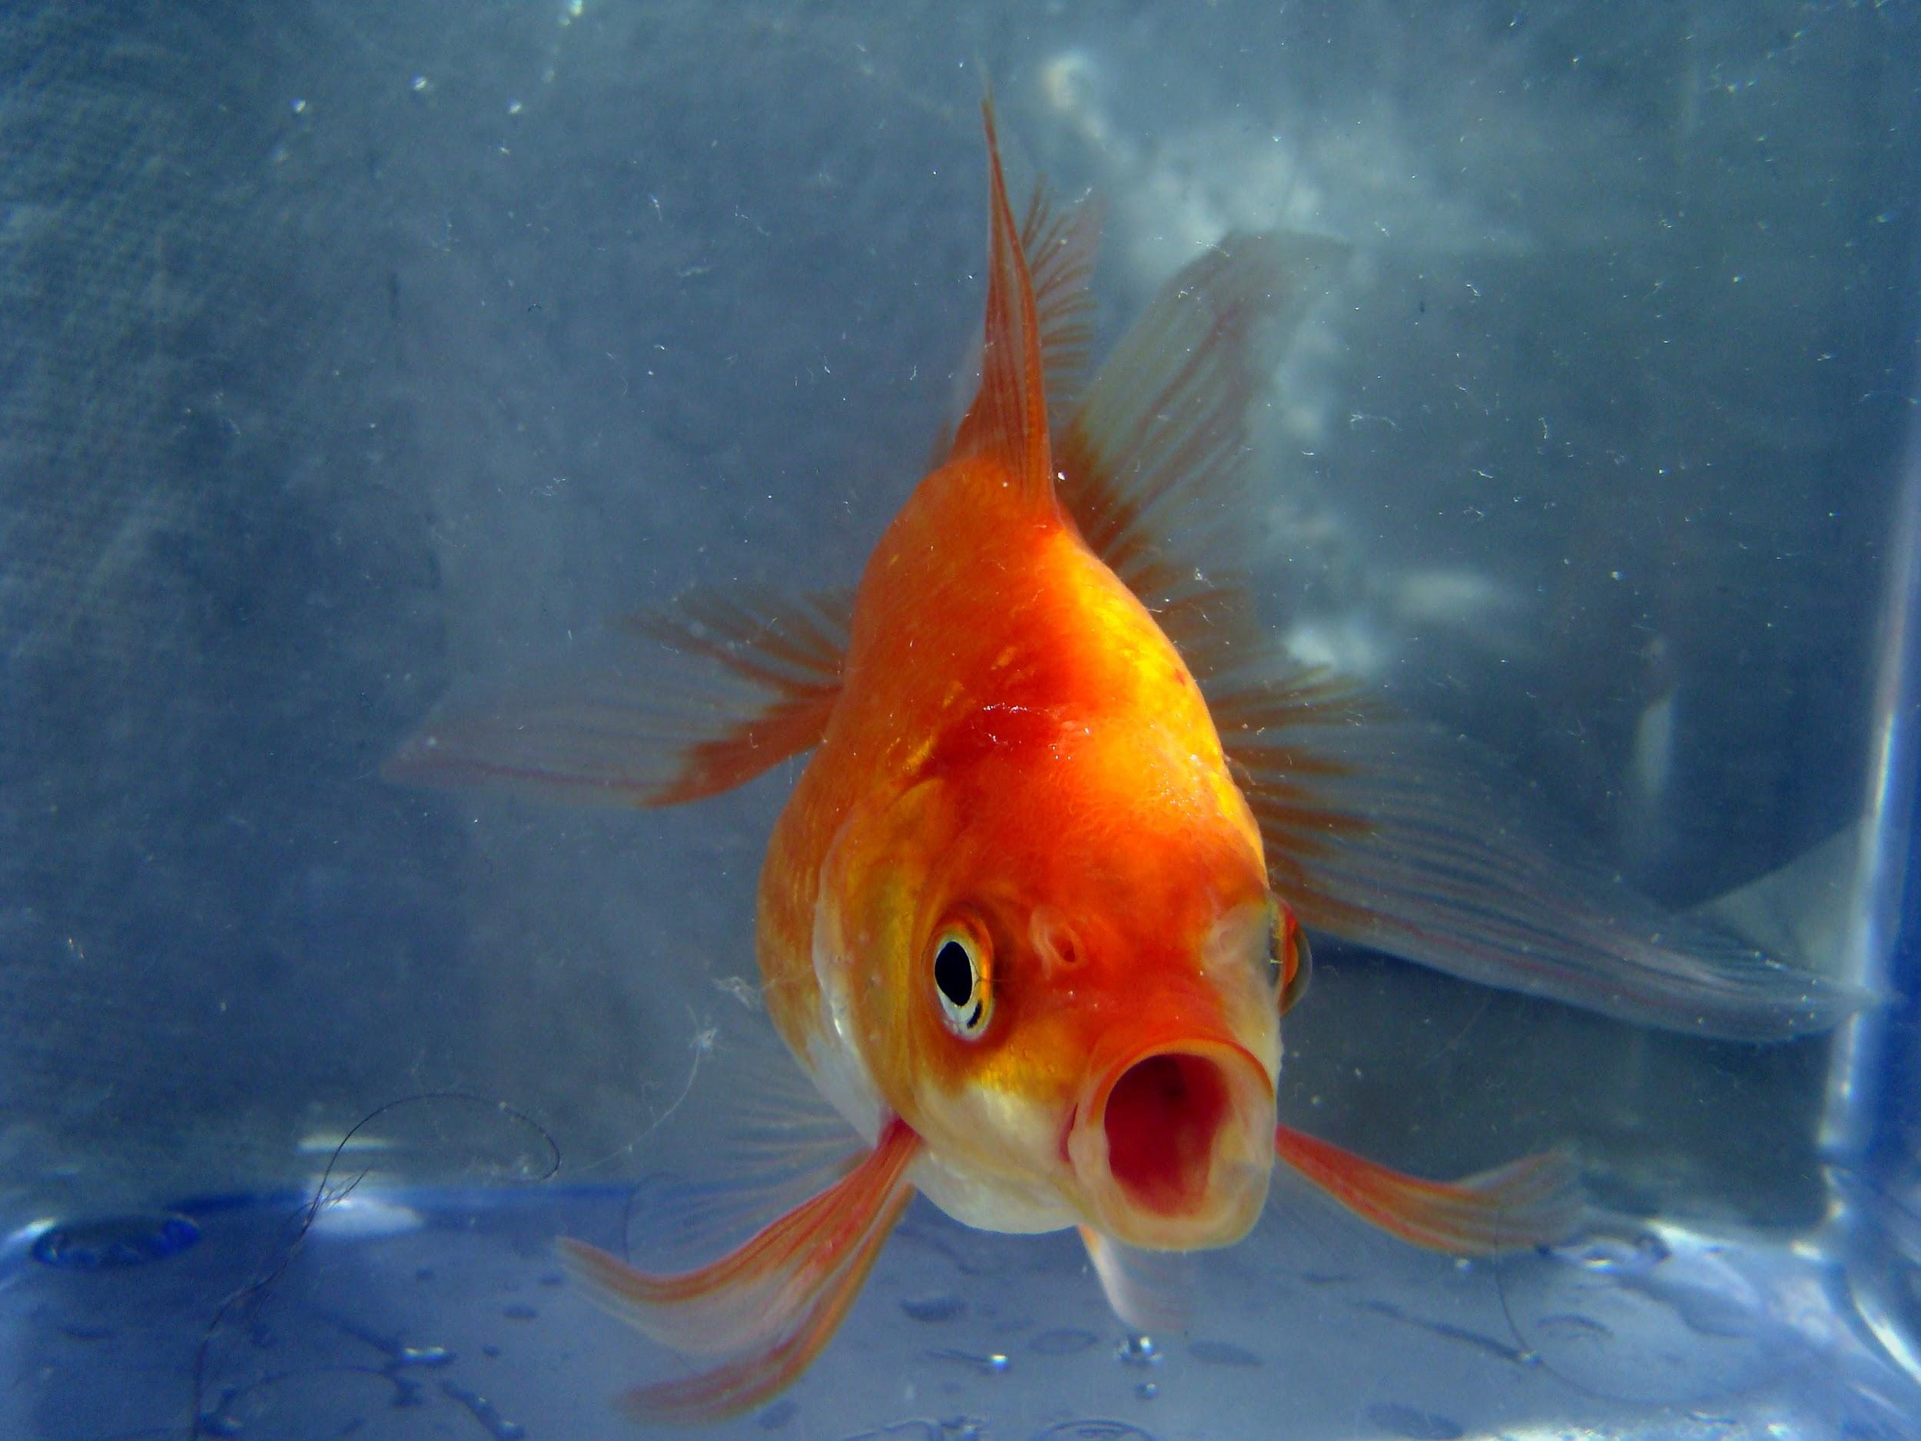
Goldfish swallowing began as a dare, when in 1939 a Harvard University freshman was dared to swallow a live goldfish. The trend grew so popular across other college campuses that by the end of April the same year, the record for most live goldfish swallowed stood at 101.

Beanie Babies
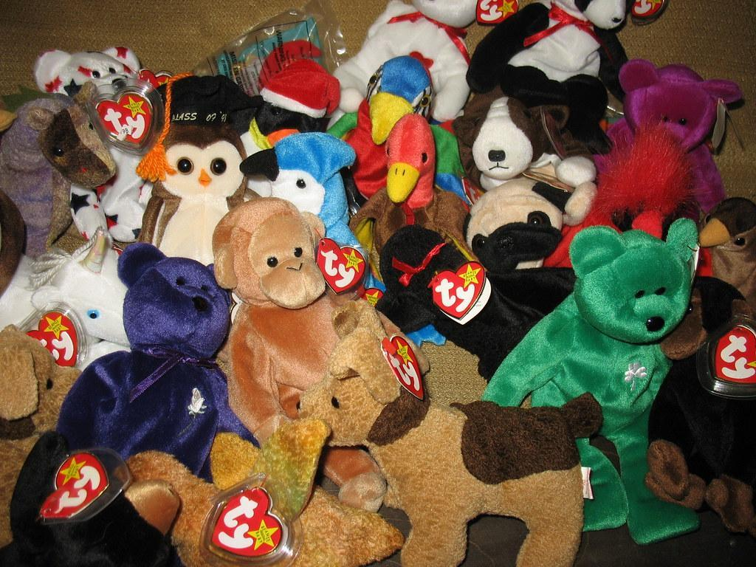
Beanie Babies were small stuffed animals. In the late 1990s, creator Ty Warner, stopped production of many Beanie Babies to create scarcity. This sparked a collecting craze. People believed they could get rich by collecting rare Beanie Babies, increasing their value further in the ensuing frenzy.

The Ice Bucket Challenge

The Ice Bucket Challenge began in 2014 as a fundraising campaign to raise awareness for ALS, a fatal ailment also known as Lou Gehrig’s Disease. The challenge encouraged a given participant to film themselves dumping a bucket of ice water on their head before challenging friends on social media to do the same. Those nominated had 24 hours to either film themselves taking the challenge, or to make a charitable donation to the ALS Association or a similar organization.

Sagging

Sagging was a fashion trend popular among young men in the 1990s and 2000s. The trend involved wearing the top of one’s pants significantly below the waist, sometimes to the point of revealing underwear. It became so popular that local governments often banned the wearing of this fashion in public places and schools.

Furbies
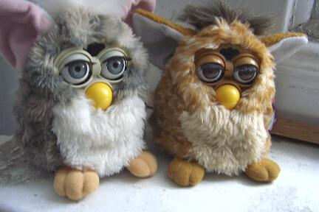
Furbies were a small robotic toy able to interact with its owner by fluttering its ears and blinking its eyes. Furbies spoke “Furbish” at first, but gradually learned to speak English. These wildly popular toys sold 27 million units in one year after being introduced during the 1998 holiday season.

Pogs
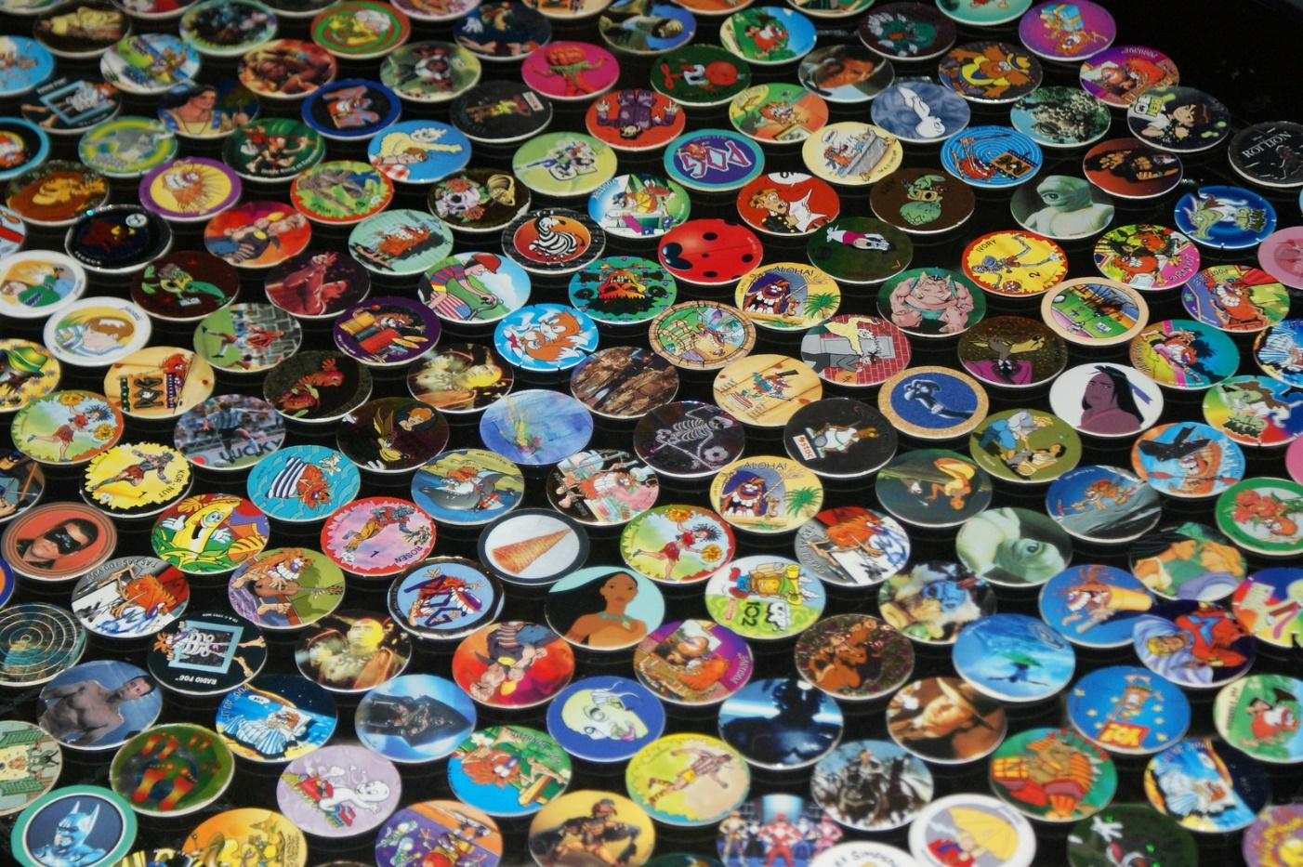
Pogs were cardboard discs with designs on one side. They were used in a popular game (also called Pogs) in the mid-1990s. The game involved players flipping their opponents’ pogs. Successful players kept their opponents’ pogs and grew large collections.

Sources:
Pet Rock Net. (2003, January 1). Pet rock [Online Image]. Wikimedia Commons. Retrieved from https://commons.wikimedia.org/wiki/File:Pet_rock.jpg
Mathew Brady. (1860-1865). Portrait of Maj. Gen. Ambrose E. Burnside [Online Image]. Wikimedia Commons. Retrieved from https://en.wikipedia.org/wiki/File:Ambrose_Everett_Burnside.jpg
Pogrebnoj Aledandroff. (2013, April 28). Butterfly Goldfish [Online Image]. Wikimedia Commons. Retrieved from https://commons.wikimedia.org/wiki/File:Butterfly_Goldfish_02.JPG
Housing Works Thrift Shops. (2007, March 23). Lot of Beanie Babies [Online Image]. Flickr. Retrieved from https://www.flickr.com/photos/housingworksauctions/432628528/
Quintano, A. (2014, August 24.). Mission Accomplished - ALS Ice Bucket Challenge [Online Image]. Wikimedia Commons. Retrieved from https://commons.wikimedia.org/wiki/File:Mission_Accomplished_-_ALS_Ice_Bucket_Challenge_(14848289439).jpg
King, G. (2019, February 13). Baggy Thug [Online Image]. Flickr. Retrieved from https://www.flickr.com/photos/162055393@N02/46354178734/
April. (2007, March 19). Furbies [Online Image]. Flickr. Retrieved from https://www.flickr.com/photos/91524358@N00/427142187/
MyrFil. (2009, January 17.). Pogs [Online Image]. Flickr. Retrieved from https://www.flickr.com/photos/myrpictures/3399108617/

