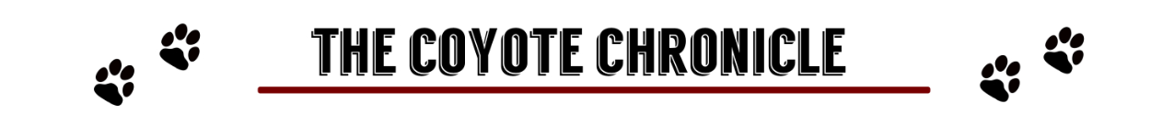

STUDENTS GIVE INTO MOB MENTALITY
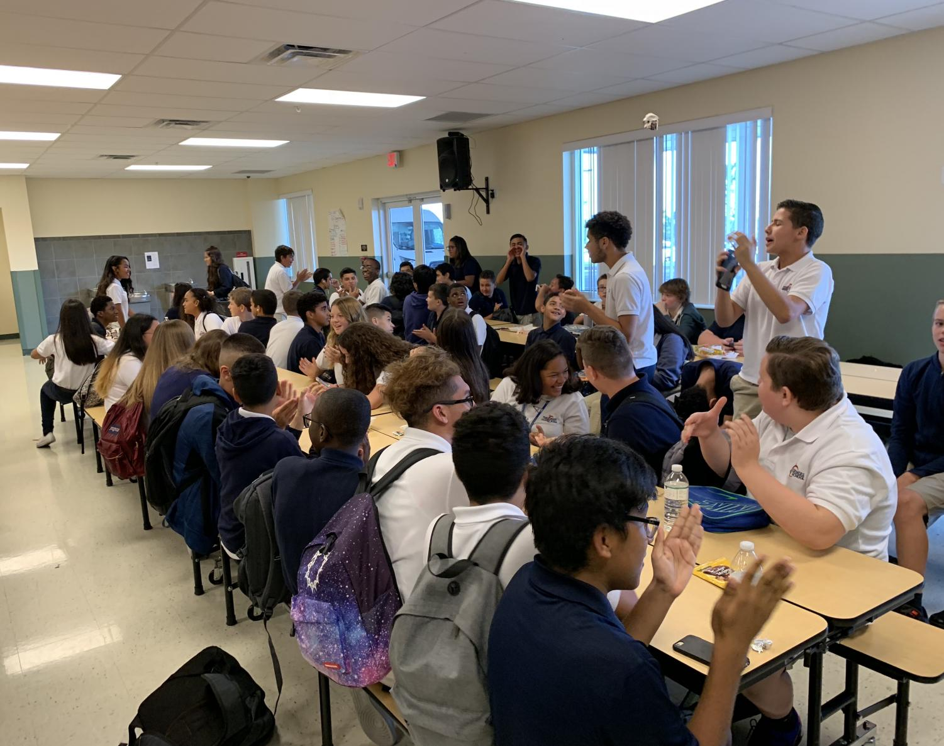
Students in the lunchroom clap along while other students sing happy birthday. (Image: Gianna Stathakis)
Gianna Stathakis, writer October 8, 2018
It is a familiar scene, students are sitting in the cafeteria during lunch, and one person begins clapping and singing happy birthday. One by one, everyone joins in. Soon enough, almost everyone in the cafeteria is singing. Some of the people don’t know who they are singing to, but sing along just because everyone else is. The act is known as mob mentality.
Mob mentality is the way people are influenced by crowds, large groups of people, or their peers and society to adopt certain behaviors. It isn’t always serious, but it can be, depending on the situation. Mob mentality can range from anything; such as watching the newest Netflix show everyone’s talking about, or intentionally changing yourself to fit in with the others. In school mob mentality is common due to students constantly being around large groups and their peers.
When a large crowd of people are all doing the same thing, it has been proven that people tend to lose their sense of self awareness, and mimic what everyone else is doing. When people lose their self awareness it can lead to rioting, chaos, and bullying.
“At lunch, all the time, every time, there’s always one person disrespecting a superior person like the deans and teachers, and then everyone else joins in” 8th grade, Zacora Smith, states.
Additional examples of mob mentality that students may have experienced include the lights being turned off during lunch. One student may start to scream causing a domino effect of screams to follow after. Talking in class is another example of mob mentality, when one person begins talking it can then trigger other students to start chatting as well.
Mob mentality is not always unintentional. At times students could be listening to the new album everyone is talking about, or going to see the latest movie, because everyone else had seen it too. On the other hand, following what others are doing can be harmful. When a new clothing, makeup, or appearance-related trend in general goes viral, people may not even like them, but end up following along because they feel pressured by other students or fear being isolated.
“It made me feel even more out of place, I felt like I wasn’t being true to myself. I’m sure others can relate, but it’s definitely a possibility where you can find a new style that you like” 8th grader, Destiny Williams, states.
Students may also be influenced by their peers bad behavior. If someone sees that their classmates thinks the person distracting the class is funny, they may begin acting the same way as an attempt to fit in.
“I finally realized that what I was doing was the wrong thing. I started to feel bad and my gut was telling me to stop. I realized that this isn’t the type of way I should behave and that I would end up being the bad guy.” Williams further stated.
Succumbing to mob mentality doesn’t only have negative effects though. In other cases, mob mentality can be the push students need to start having a positive impact on the community rather than having a negative one.
“Of course there is always going to be negative effects of picking up on other people’s behavior, but there is positive parts about it too. If a bunch of people were doing positive things, and others start doing the same, it can have a really good impact.” says 8th grade, Alia White.

Gianna Stathakis (2018, October 8). Students Give Into The Mob Mentality. The Coyote Chronicle. Retrieved from https://fcuscoyotejournalism.com/770/archive/students-give-into-the-mob-mentality/
Photo and story from The Coyote Chronicle reprinted by permission from student advisor Jennifer Araujo. This reading was originally published in a high school newspaper by Gianna Stathakis, a student at Four Corners Upper School, Davenport, Florida. Gianna served as the reporter and photographer for this news article.

