**Directions.** What do you already know about the author’s intent behind a break-up song? Complete the following prompts.

*Oversharing*

# Definition Break Down

## Inference:

## Cancel culture:

## Oversharing:

## What are some examples of each you can think of?

*Inference*

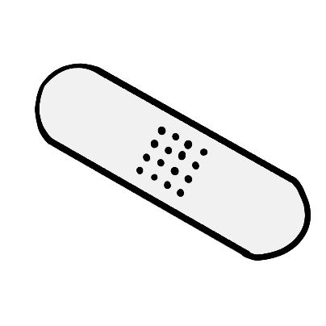

*Cancel Culture*

**Break-Up Brainstorm**

Directions. Use the space provided to brainstorm about the break-up scenario and possible features you may want to include.

10

Went viral and the principal heard about it

7

Burned the hoodie

3

One awkward hallway moment

5

“Blocked” but no drama

1

Still Friends

# Relationship Break Down

## What happened?

## Who did the breaking up?

## Scale of 1-10 how was it?

*What were some results from the break-up?*



*What were some things left “unsaid?”*



*Examples of overshare about the other person. Why do you want to share them?*

