mAPPING OUT RESEARCH
Directions. Place your example cards in the correct order based on the statements below.
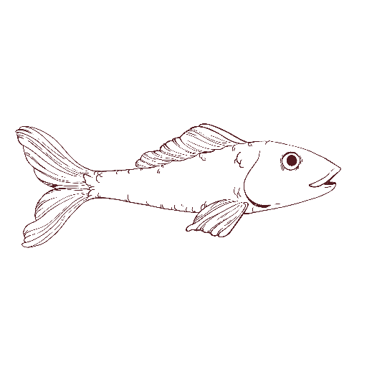
Research Question
What do you want to know?

Confounding Variable
What disrupts the relationship between the IV and DV?

Hypothesis
How can you test it?

IV

Independent Variable (IV)
What is the cause?

Experimental Group
Who gets the variable being tested?
Control Group
Who doesn’t get the variable being tested?
Confounding Variable
What disrupts the relationship between the IV and DV?
Confounding Variable
What disrupts the relationship between the IV and DV?
1. Dependent Variable (DV)
What is the effect?
Conclusion
What did you learn?
2. Dependent Variable (DV)
What is the effect?

