Creating a QR Code
Purpose: This job aid is designed to walk you through creating a QR code. While there are other ways to create a QR code, this guide is designed with QR Code Monkey in mind.

Creating a QR Code
- Copy the link you wish to convert into a QR code. |   - Generally, you can find the link in the address bar.  - Sometimes, you need to find a special link. On Google files, for instance, you select File and Share to find a shareable link.
- Next, go to qrcode-monkey.com. | 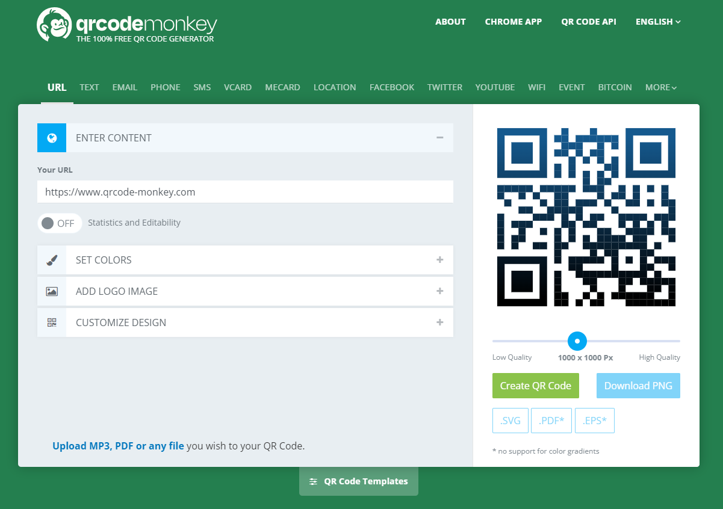
- Paste your link in the Your URL field under Enter Content. | 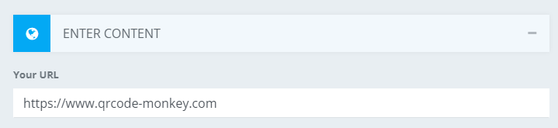
- Click the Create QR Code button, then click the Download PNG button. | 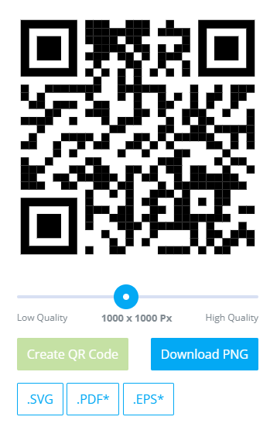
- Your window will momentarily pause to generate your QR code, then automatically copy it into the Downloads folder. | 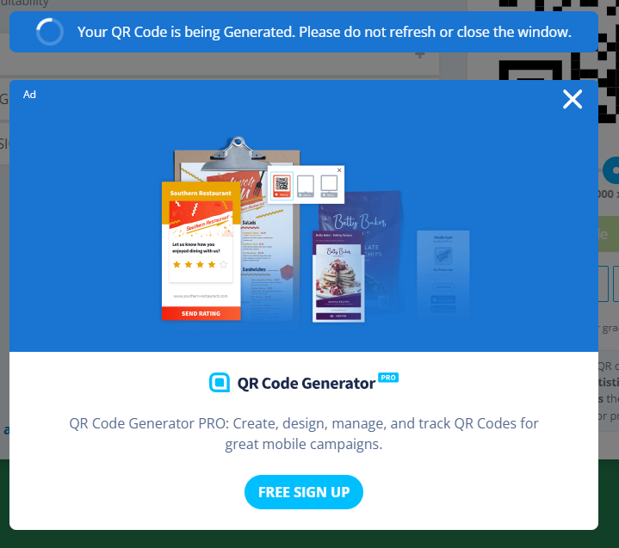
- Your file should now be ready to use. | 