Card sort: Category cards
The Silent Generation | Baby Boomers
Generation X | Millennials
Gen Z

Card sort: SORTING cards
Silent Generation
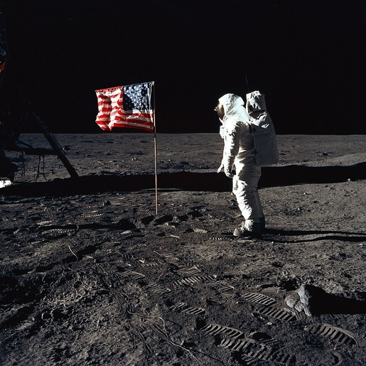 | 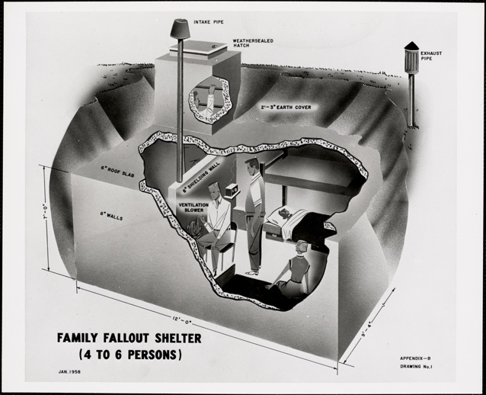
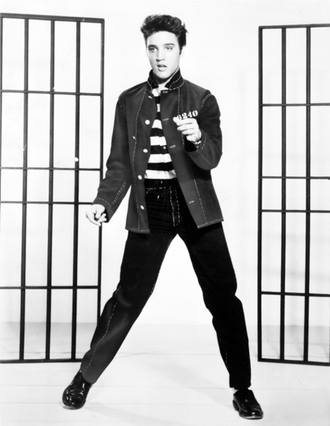 | 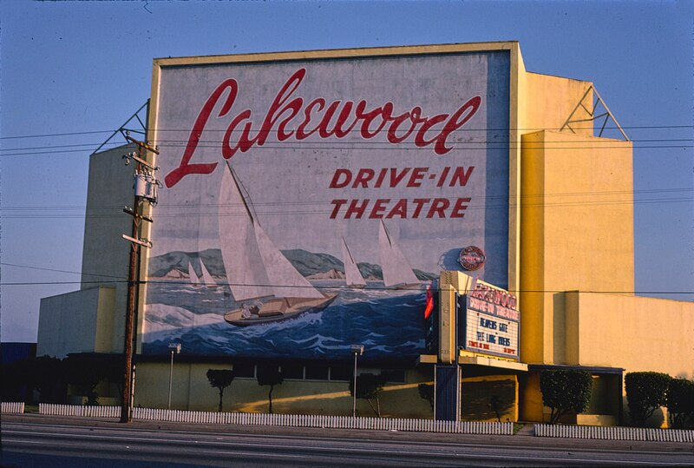
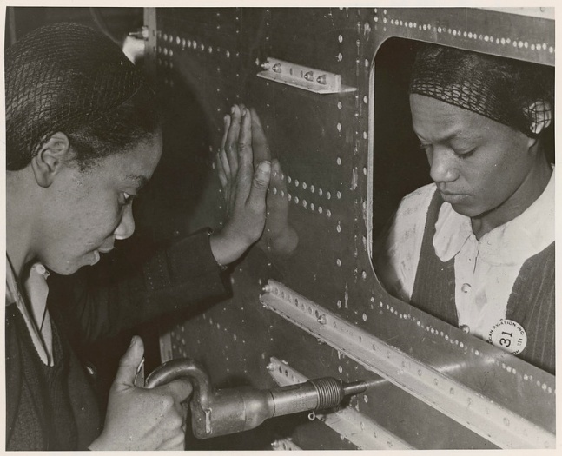 | 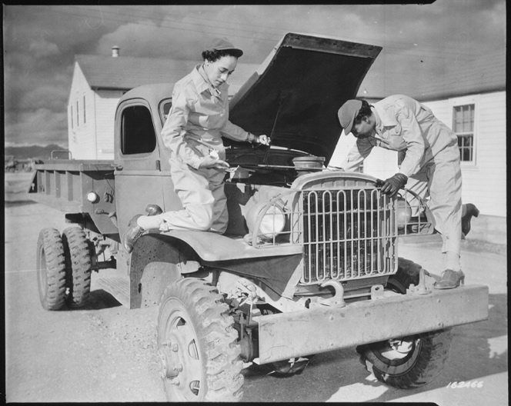

Baby Boomers
 | 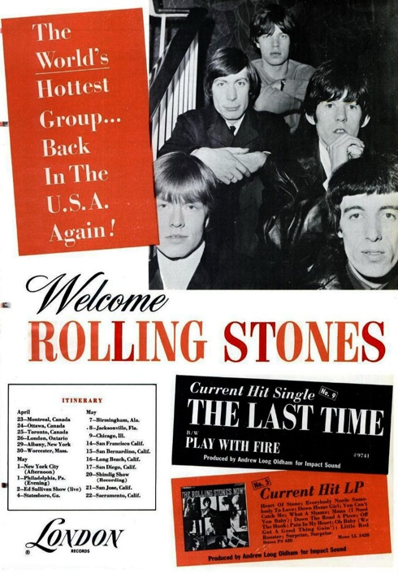
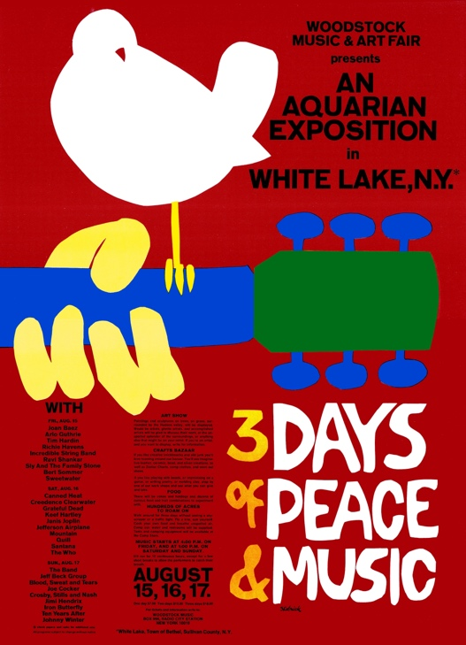 | 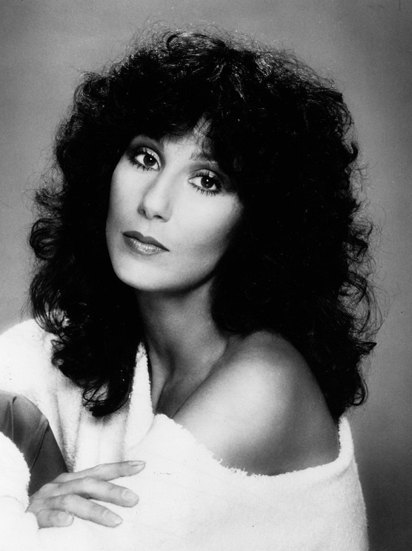
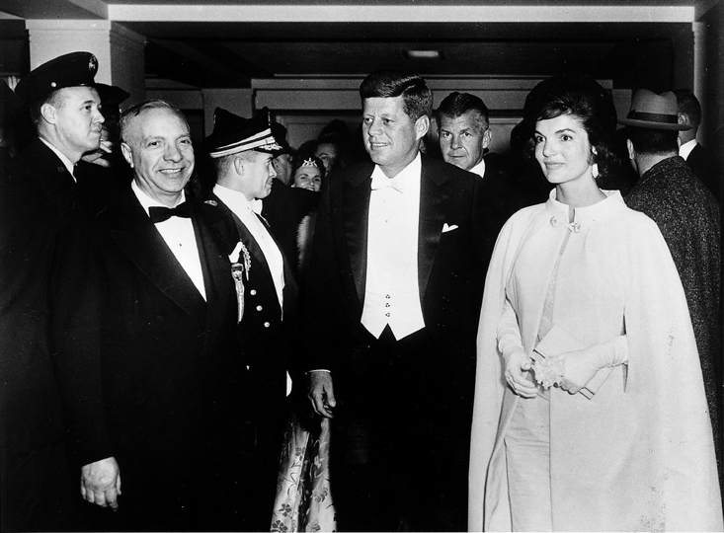 | 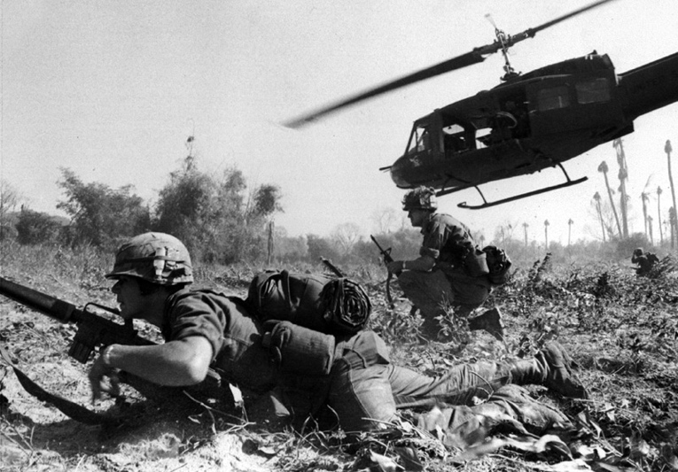

Gen X
 | 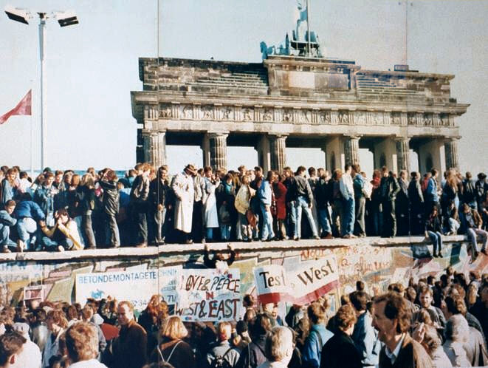
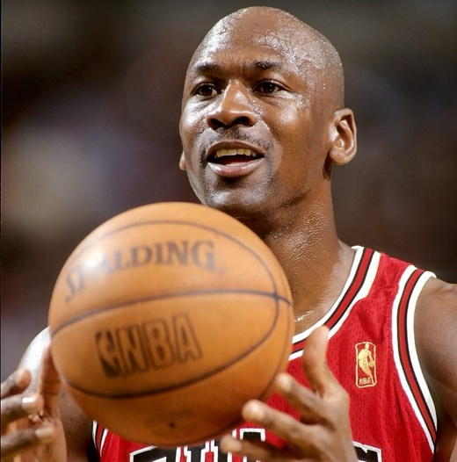 | 
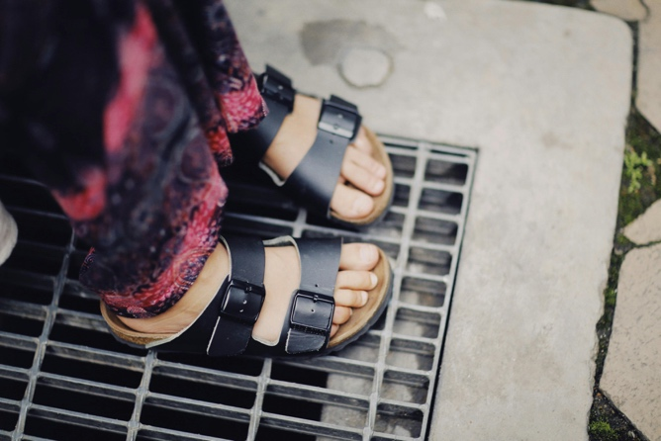 | 

Millenials
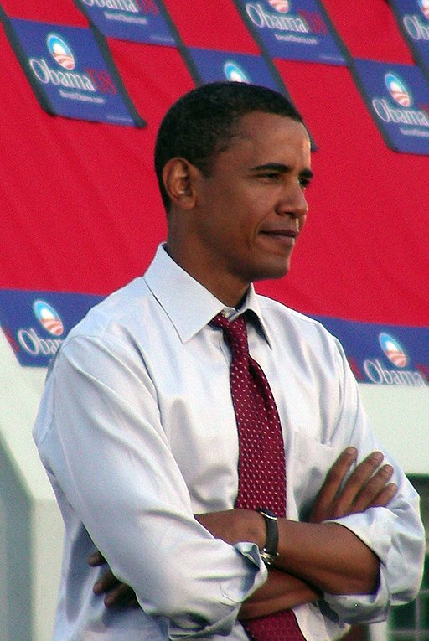 | 
 | 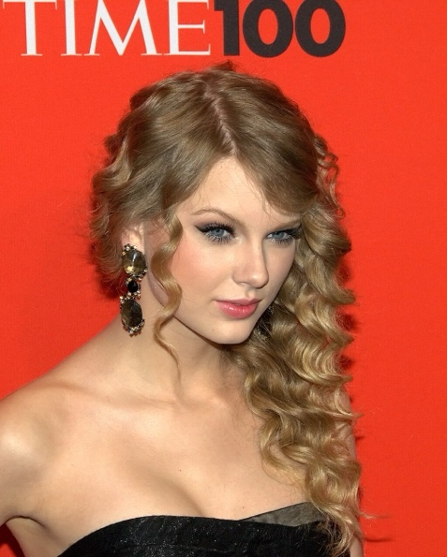
 | 

Gen Z
 | 
 | 
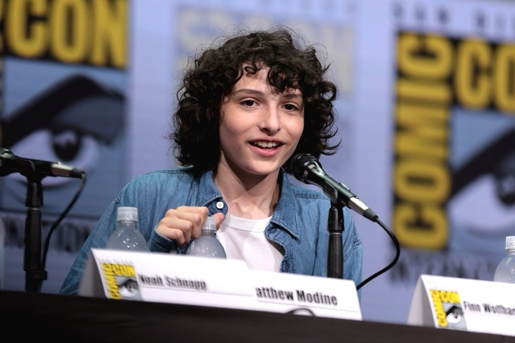 | 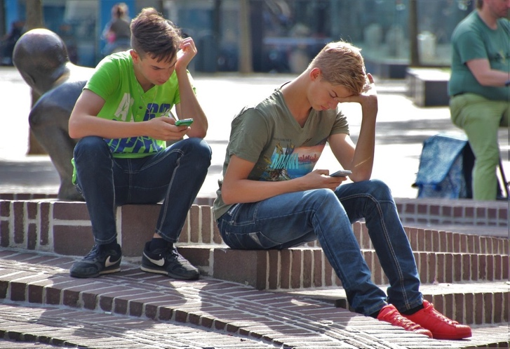

Citations
Silent Generation
Armstrong, N. A. (1969). Buzz Aldrin and the U.S. Flag on the Moon [Photograph]. Wikimedia Commons. NASA. https://commons.wikimedia.org/wiki/File:Buzz_Aldrin_and_the_U.S._Flag_on_the_Moon_(9460188482).jpg

Margolies, J. (1981). Lakewood Drive-In Theater, Lakewood, California [Photograph]. Wikimedia Commons. Library of Congress. https://commons.wikimedia.org/wiki/File:Lakewood_Drive-In_Theater,_Lakewood,_California.jpg

Metro-Goldwyn-Mayer, Inc. (1957). Elvis Presley promoting Jailhouse Rock [Photograph]. Wikimedia Commons. https://commons.wikimedia.org/wiki/File:Elvis_Presley_promoting_Jailhouse_Rock.jpg

U.S. Federal Civil Defense Administration. (1958). Family fallout shelter [Photograph]. Wikimedia Commons. Digital Commonwealth, https://upload.wikimedia.org/wikipedia/commons/5/54/Family_fallout_shelter%2C_by_the_US_Federal_Civil_Defense_Administration%2C_January_1958%2C_from_the_Digital_Commonwealth_-_commonwealth_h128rv82b.jpg

U.S. National Archives. (1943, January 1). Women working on an airplane engine at North American Aviation, Inc. [Photograph]. Flickr. https://www.flickr.com/photos/usnationalarchives/11192161613

Unknown author. (1942, December 8). Auxiliaries Ruth Wade and Lucille Mayo further demonstrate their ability to service trucks [Photograph]. National Archives at College Park. https://commons.wikimedia.org/wiki/File:%22Auxiliaries_Ruth_Wade_and_Lucille_Mayo_(left_to_right)_further_demonstrate_their_ability_to_service_trucks_as_taught_th_-_NARA_-_531153.jpg

Baby Boomers
London Records. (1965). Rolling Stones ad [Advertisement]. Wikimedia Commons. https://commons.wikimedia.org/wiki/File:Stones_ad_1965.JPG
Rock, J.

Scherman, R. (1963). Civil rights march on Washington, D.C. [Photograph]. Wikimedia Commons. National Archives at College Park, Public domain. https://commons.wikimedia.org/wiki/File:Civil_rights_march_on_washington_dc_schools.tif

Skolnick, A. (1969). Woodstock poster [Poster]. Wikimedia Commons. https://commons.wikimedia.org/wiki/File:Woodstock_poster.jpg

United States Army. (2007, February 7). Photograph of soldiers in action. https://commons.wikimedia.org/w/index.php?curid=1742068

Unknown Author. (n.d.). Cher - Casablanca [Photograph]. Wikimedia Commons. https://commons.wikimedia.org/wiki/File:Cher_-_Casablanca.jpg

Unknown Author. (n.d.). President John F. Kennedy and First Lady Jacqueline Kennedy [Photograph]. PICRYL. https://picryl.com/media/president-john-f-kennedy-jacqueline-kennedy-american-e22b5d?zoom=true

Gen X

Back to the Future. (2011). Back to the Future logo [Logo]. Wikimedia Commons. https://commons.wikimedia.org/wiki/File:Back-to-the-future-logo.svg

Demidov, A. (2021). Person wearing black and brown leather sandals [Photograph]. Pexels. https://www.pexels.com/photo/person-wearing-black-and-brown-leather-sandals-9495513/

Lipofsky, S. (1997). Michael Jordan [Photograph]. Wikimedia Commons. Basketballphoto.com, https://commons.wikimedia.org/wiki/File:Steve_Lipfosky_--_Michael_Jordan_(1997).jpg

Morris, S. (2000). Kate Moss on the cover of the May 2000 UK edition of Vogue magazine [Photograph]. Wikimedia Commons. https://commons.wikimedia.org/wiki/File:Vogue_SM.jpg

MTV Networks. (2016). MTV HD Logo [Logo]. Wikimedia Commons. https://commons.wikimedia.org/wiki/File:MTV_HD_Logo.svg

Unknown Author. (1989). West and East Germans at the Brandenburg Gate in 1989 [Photograph]. Wikimedia Commons. https://commons.wikimedia.org/wiki/File:West_and_East_Germans_at_the_Brandenburg_Gate_in_1989.jpg

Millenials

Argo, J. (1995). First responders in the aftermath of the bombing, April 19, 1995 [Photograph]. Oklahoma Publishing Company Photography Collection, Oklahoma Historical Society. https://www.okhistory.org/publications/enc/entry?entry=OK026

Compulsiveprep_8. (2009). If You Seek Amy [Photograph]. Wikimedia Commons. https://commons.wikimedia.org/wiki/File:If_you_seek_amy.jpg

realjames16. (2008). Barack Obama Fold [Photograph]. Wikimedia Commons. https://commons.wikimedia.org/wiki/File:Barack_Obama_Fold.jpg

Shankbone, D. (2010). Taylor Swift [Photograph]. Wikimedia Commons. https://commons.wikimedia.org/wiki/File:Taylor_Swift_by_David_Shankbone.jpg

Unknown Author. (n.d.). Early internet [Photograph]. Wikimedia Commons. https://commons.wikimedia.org/wiki/File:Early_internet_%28cropped%29.png

Unknown Author. (n.d.). K-pop boybands [Photograph]. Wikimedia Commons. https://commons.wikimedia.org/wiki/File:K-pop_boybands.jpg

Gen Z

Editantpv. (2024). TikTok icon [Icon]. Wikimedia Commons. https://commons.wikimedia.org/wiki/File:Tiktok_icon.svg

Crommelinck, L. (2019, August 18). Billie Eilish @ Pukkelpop 2019 [Photograph]. Lars Crommelinck Photography. https://www.example.com

natureaddict. (n.d.). Pokémon Go on phone [Photograph]. PICRYL. https://picryl.com/media/pokemon-pokemon-go-phone-computer-communication-93664e

New Zealand Defence Force. (2012). NZ Army soldier and NZLAV in Afghanistan [Photograph]. Wikimedia Commons. https://commons.wikimedia.org/wiki/File:NZ_Army_soldier_and_NZLAV_in_Afghanistan.jpg

Scholz, C. (2016). Hacker Symbol Photo - Hacking - IT - Security - magenta [Photograph]. Flickr. https://creativecommons.org/licenses/by/2.0, via Flickr. https://www.flickr.com/photos/140988606@N08/46569184374/

Skidmore, G. (2017). Finn Wolfhard [Photograph]. Wikimedia Commons. https://creativecommons.org/licenses/by-sa/4.0, via Wikimedia Commons. https://commons.wikimedia.org/wiki/File:Finn_Wolfhard_(35409222583).jpg

