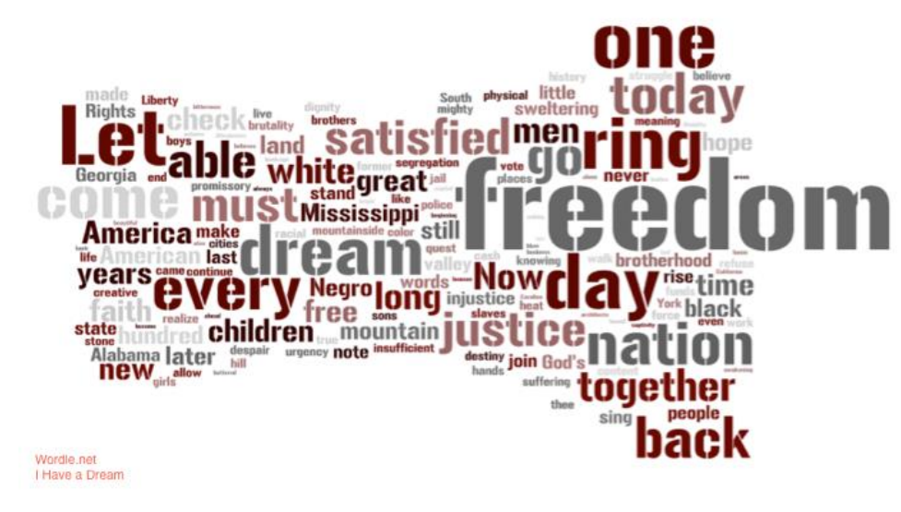
WORDLE “I HAVE A DREAM” CLOUD

