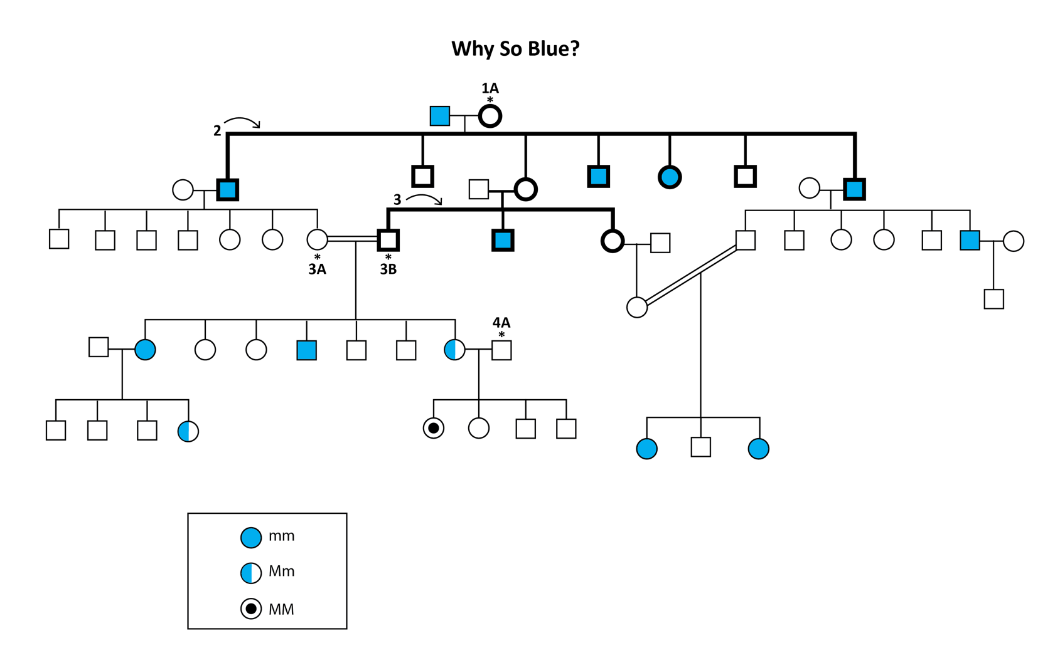
Fugate Pedigree

- What is the genotype for 1A? Mm
- What is the genotype of 3A? Mm
- What is the genotype of 3B? Mm
- What are the possible genotypes for 4A? Mm or MM
- Calculate the allele frequency for the seven Fugate siblings in the second-generation (labeled with a 2). Do not include their husbands and wives.
  - Frequency (M): 3/14 = 0.21 or 21%
  - Frequency (m): 11/14 = 0.79 or 79%
- (Bonus) Calculate the allele frequency for the three siblings in the third-generation, located in the middle of the pedigree (labeled with a 3). Do not include their husbands and wives.
  - Frequency (M): 2/6 = 0.33 or 33%
  - Frequency (m): 4/6 = 0.67 or 67%

