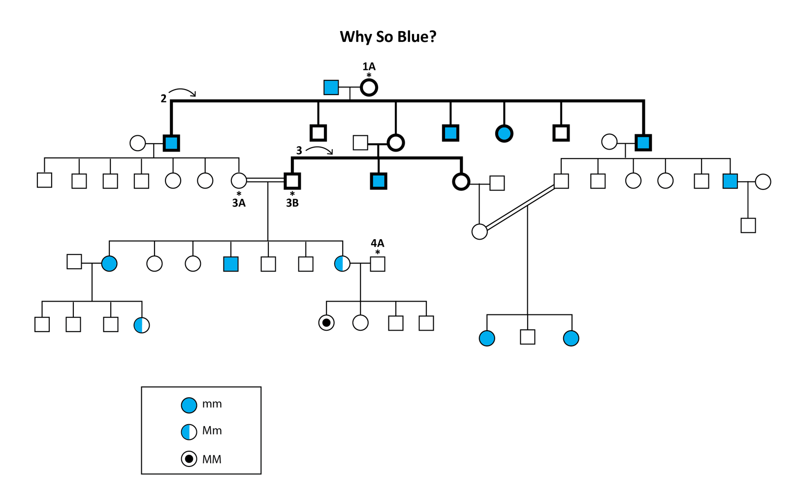
Fugate Pedigree

- What is the genotype for 1A?
- What is the genotype of 3A?
- What is the genotype of 3B?
- What are the possible genotypes for 4A?
- Calculate the allele frequency for the seven Fugate siblings in the second-generation (bold line labeled with a 2). Do not include their husbands and wives.
  - Frequency (M)
  - Frequency (m)
- (Bonus) Calculate the allele frequency for the three siblings in the third-generation, located in the middle of the pedigree (bold line labeled with a 3). Do not include their husbands and wives.
  - Frequency (M)
  - Frequency (m)

