Beauty Trends (Sample Responses)

A local beauty salon collected data on the length of customer’s hair *x*, in centimeters, and the amount of shampoo used *y*, in milliliters. A scatter plot of the amount of shampoo used and hair length revealed a relationship between the two variables, described as strong, positive, and linear. The data collected is in the table below.

|  |  |  |  |  |  |  |  |  |  |  |  |  |
| --- | --- | --- | --- | --- | --- | --- | --- | --- | --- | --- | --- | --- |
| Length of Hair (cm) | 0 | 10 | 10 | 13 | 13 | 15 | 41 | 46 | 51 | 56 | 61 | 75 |
| Amount of Shampoo (ml) | 1.1 | 0.3 | 0.2 | 0.4 | 0.5 | 0.5 | 1.5 | 1.7 | 1.9 | 2.1 | 2.3 | 1.5 |

**(a)** Construct a graph of the data that could be used to investigate the appropriateness of a linear relationship.

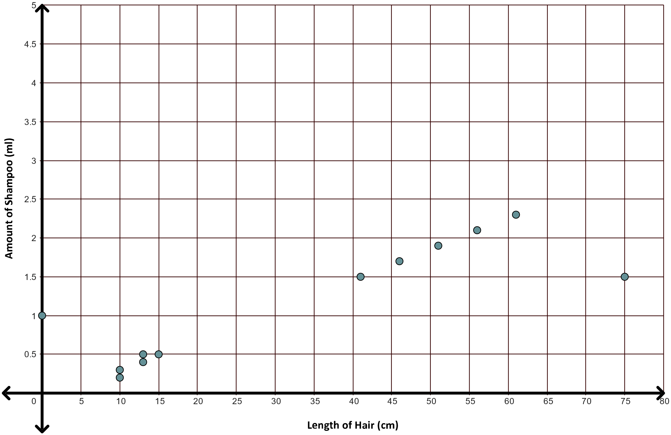

**(b)** Based on your graph, do you think “linear” is an appropriate description?

*The scatter plot displays a linear relationship because the points appear to follow a linear trend closely.*

**(c)** Interpret the correlation coefficient value, *r* = 0.849, in the context of the problem. Use what you learned today to describe the scatter plot. Be sure to explain your reasoning.

*r = 0.849 means that there is a strong, positive, linear relationship between the length of customers’ hair and the amount of shampoo used. Since r > 0, we know there is a positive relationship. Because r > 0.8, we can say there is a strong relationship; the graph supports this as the points appear to follow a line closely.*