Beauty Trends
A local beauty salon collected data on the length of customer’s hair x, in centimeters, and the amount of shampoo used y, in milliliters. A scatter plot of the amount of shampoo used and hair length revealed a relationship between the two variables, described as strong, positive, and linear. The data collected is in the table below.
Length of Hair (cm) | 0 | 10 | 10 | 13 | 13 | 15 | 41 | 46 | 51 | 56 | 61 | 75
Amount of Shampoo (ml) | 1.1 | 0.3 | 0.2 | 0.4 | 0.5 | 0.5 | 1.5 | 1.7 | 1.9 | 2.1 | 2.3 | 1.5

(a) Construct a graph of the data that could be used to investigate the appropriateness of a linear relationship.
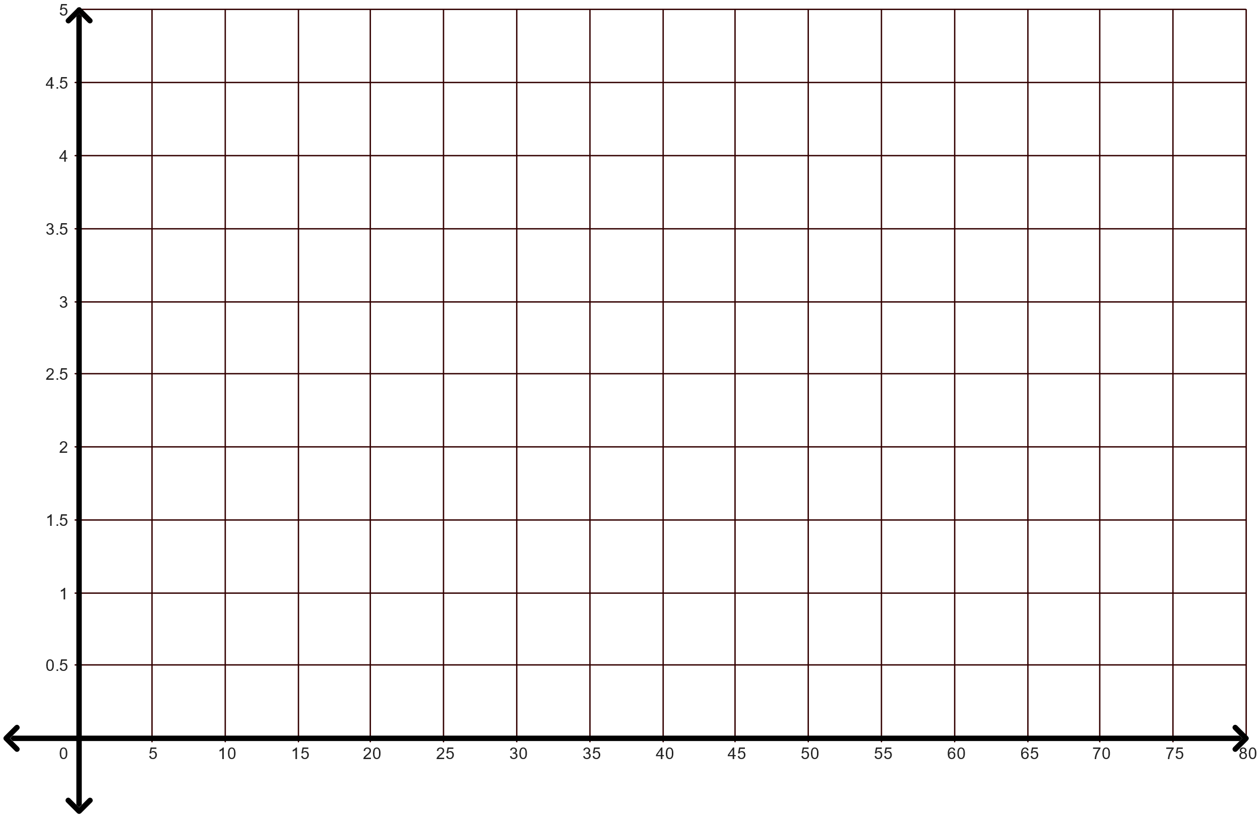

(b) Based on your graph, do you think “linear” is an appropriate description?

(c) Interpret the correlation coefficient value, r = 0.849, in the context of the problem. Use what you learned today to describe the scatter plot. Be sure to explain your reasoning.

