EXPLORE
Obtain a card with electron configurations for your group as assigned by your teacher.
Group #: ____________
For each element on your card, write the last orbital notation appearing at the end of the configuration.

What is similar about the last oribital notation appearing at the end of the configuration for each element in your set?

Locate where your set of elements should be on the periodic table.
Using sticky notes, write the last orbital notation of the electron configuration for each element in your set. Use a different sticky note for each configuration. Put each sticky note where it belongs on the poster periodic table.

Once all the groups have put up their notes, copy the whole group results in this empty periodic table:
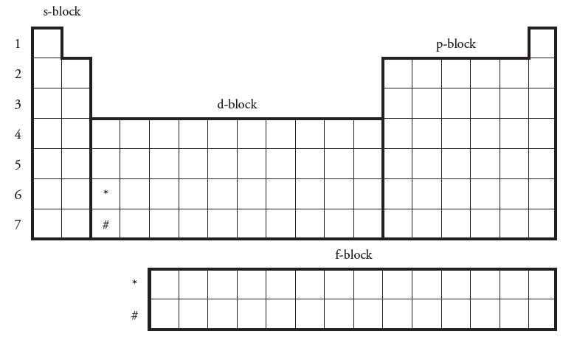
What is the relationship between the last orbital notation of the elements you have documented and the row numbers on the left-hand side of the periodic table?

What is the relationship between the “block” size in the periodic table you’ve been using and the number of electrons that will fit in the corresponding orbital name?

What is the relationship between where an element is located within a “block” of the table and the superscripted (the exponent) number appearing at the end of the electron configuration for that element?

You don’t have all of the element’s trends filled in. Do you think you can predict the last orbital notation for the elements you don’t have yet? What do you think the pattern is?

Fill in the rest of the s-block and p-block elements you don’t have.
If you were told Mn ended in 3d⁵, and Ag ended in 4d⁹, would that fit your original pattern? How would you have to change your pattern rules?

Fill in the d-block using the two elements provided in part b.
Ce ends in 4f¹, and U ends in 5f³. Fill in the f-block using this information.
Now that your table is completely filled, what conclusions can you make about electron configuration and how the periodic table can be useful?

